Model based diagnosis of acid-base disturbances in natural waters.

Graeme James Tim Apps B Sc, Dip Ed, M Ed St

Thesis submitted in fulfilment of the degree of Doctor of Philosophy
Monash University

November 2006

Faculty of Education
Monash University

Table of Contents
Declaration xv
Acknowledgements xvi
Abstract xvii
Chapter 1. Introduction 1
1.1 Background 1
1.1.1 Motivations and experiences 1
1.2 Executive summary 3
1.2.1 Background 3
1.2.2 Focus 4
1.2.3 Goals 4
1.2.4 Methods 4
1.2.5 Results 4
1.2.6 Outcomes 6
1.3 Focus 6
1.3.1 Some problems of agriculture 6
Acidification 6
1.3.2 Performance and learning in complex systems 7
1.3.3 Problem solving in agricultural systems 8
1.3.4 Acidification decision support issues and perspectives 9
1.3.5 Towards a sustainable agriculture 11
1.4 Domain / context / orientation 13
1.4.1 Why acidity / acidification 13
1.4.2 Lessons from other domains 13
1.4.3 The domain of this research project 16
1.4.4 Water management problems 18
1.5 Goals of this research project 18
1.5.1 Support for problem solving in water management. 19
Building system level understanding 19
1.5.2 Goals and complexities of this research project. 20
1.6 Guidelines / scope of research 22
1.6.1 Questions guiding the research 22
1.6.2 Constraints / scope of the research 22
1.6.3 Directions from other studies / domains. 23
1.6.4 Some roles of a learning support system 25
1.6.5 Theory and practice: Bridging the gap. 26
1.6.6 The role of explanations 27
1.6.7 Role of a domain ontology 28
1.7 Research project overview 29
1.8 Summary 31
Chapter 2. Literature Review 33
2.1 Task analysis 33
2.2 Modelling tools and methods 33
2.3 Domain concepts 34
2.3.1 Task analysis 34
Structural 36
Tasks 36
Diagnostic knowledge 36
Metacognitive or control knowledge. 37
Causal / modelling 37
2.4 Organising the knowledge base 37
2.5 Building and representing a knowledge base 39
2.5.1 Knowledge representation tools and methods 39
Concept maps / semantic networks 39
Frame representations 39
Frame based tools 41
Object modelling 42
Representing control knowledge 44
Representing causal relationships 45
2.5.2 Deriving system behaviour 47
2.5.3 Situation Specific Models and explanations 47
2.6 Approaches to problem solving under uncertainty 47
2.6.1 Medicine 48
Diagnosis in a consultative setting. 49
2.6.2 Environmental 49
2.6.3 Agriculture 50
2.7 Applications 51
2.7.1 Limnology 51
2.7.2 Aquaria / swimming pools 51
2.7.3 Medicine 52
2.7.4 Agriculture 52
2.8 Approaches to understanding natural systems 54
2.9 Key concepts in aquatic ecosystems 55
Other initiatives in understanding aquatic processes 56
Approaches to ‘clinical’ understanding of aquatic processes 57
2.10 Advances in modelling natural systems 58
2.10.1 Causal reasoning 60
2.10.2 Environmental management 60
2.11 Cognition and learning 61
2.11.1 Performance support 61
2.11.2 Cognition 62
2.11.3 Intelligent learning environments. 62
2.11.4 Professional education. 63
2.12 Acidity in water – a primer. 64
2.12.1 How pH is determined and regulated in water 64
The role of CO₂ in water 65
2.12.2 Understanding water processes through physicochemical equilibria 67
The Henderson-Hasselbalch equation 67
pH buffering processes in water 69
Oxidation – Reduction Potential (ORP) 71
2.13 pH and chemical equilibria 71
2.13.1 Disturbances of chemical equilibria in water 71
2.13.2 pH equilibria in medical diagnosis 73
Factors affecting acidity in water 74
2.13.3 Challenges in the domain 75
2.13.4 Measuring acidity in water 76
2.14 Summary 77
Chapter 3. Research Design / Methodology 79
3.1 How the research developed 79
3.1.1 Providing an interpretive framework for findings 82
3.1.2 Problem solving as modelling 83
3.1.3 Perspectives from other domains 85
3.2 Research design 86
3.3 Research questions 87
3.4 Research goals and focus 87
3.4.1 Research focus 87
3.4.2 Strategy for applying a model based approach 90
Problem solving architecture 93
3.4.3 Outline of an investigative process using causal models 94
3.5 Design-Based Research 96
3.5.1 Description 96
3.5.2 Justification 97
3.5.3 Application of the research model 98
3.6 Data collection 99
3.6.1 Case study data 99
3.6.2 Chemical and physical analysis 101
3.7 Knowledge base components and design 102
3.7.1 Associational knowledge 102
3.7.2 Causal knowledge 103
Describing causal relationships in natural water 103
Describing water health at the clinical level 104
Diagnostic knowledge 105
3.8 Prototype learning environment 105
3.8.1 Task analysis for the domain 106
3.8.2 Architecture and design of ACIDEX 106
3.8.3 Components 107
3.8.4 Development 108
User interface 109
Calculations 109
Diagnosis 110
Validation 110
Knowledge base 111
3.8.5 Summary of prototype development 111
3.9 Overview of research methods 113
Chapter 4. Results 115
4.1 Problem solving for water management 115
4.1.1 Sample data 116
4.1.2 Types of acid – base disturbances 119
4.1.3 Disturbances in which the water is more acidic than expected 120
4.1.4 Disturbances in which the water is less acidic than expected 122
4.1.5 Terminology and relationships to other studies 124
4.1.6 Summary 124
4.1.7 Major disturbances 125
Acidosis 126
Alkalosis 126
4.1.8 Mechanisms 127
Compensation versus buffering 127
Acidifying disturbances 127
Acid lowering disturbances 128
Measuring the amount of compensation 129
4.1.9 Implications 129
4.2 Identifying and describing buffer system disturbances 130
4.2.1 Strategies 130
4.2.2 Choosing a model 131
4.2.3 Multiple primary disturbances 132
4.2.4 Composite disturbances 132
4.2.5 Distinguishing between causes 133
4.3 Knowledge base 133
4.3.1 Domain concepts 133
Key processes in natural waters 134
pH – REDOX relationship 134
Factors affecting acidity 136
Some disturbances of natural water 137
Structural components 137
4.4 Summary 138
Chapter 5. Applications 140
5.1 Case studies 141
5.1.1 Case 1 – Creek 1 141
5.1.2 Case 2 – Lake 1 144
5.1.3 Case 3 – Dam 2 145
Investigation 1 146
Investigation 2 147
5.1.4 Case 4 – Dam 3 147
Investigation 2 149
5.1.5 Case 5 – Creek 2 151
Investigation 1 151
Investigation 2 152
5.1.6 Case 6 – Bore 1 153
5.1.7 Case 7 – Bore 2 155
5.1.8 Summary of results from case studies 156
5.2 Applications 157
5.2.1 Case 8 - Bore 3 Iron in bore water 158
Diagnostic strategy 159
Indicators. 160
Buffer system analysis 160
Iron related concepts 161
Initial hypothesis 163
Other findings 165
Hypothesis testing 167
Additional fact finding. 170
5.2.2 Case 9 - Dam 1 Eutrophication 170
Background data. 171
Sample data. 172
Investigation 1 173
Interpretation of the buffer system analysis. 174
Investigation 2 176
Other findings 178
Investigation 3 179
Investigation 4 180
Domain concepts 180
Dam 1 summary 180
5.2.3 Case 10 - Creek 3 Eutrophication 181
Investigation 1 182
Investigation 2 183
Creek 3 summary 184
5.2.4 Summary of results from applications 184
Outcomes 185
Chapter 6. How ACIDEX Works 187
6.1 Deployment 187
6.2 User interface 188
6.3 Knowledge base 190
6.3.1 Knowledge base interface 193
6.3.2 Knowledge base structure 193
6.4 Case studies 195
6.5 Orientation 196
6.5.1 Findings 196
6.6 Diagnosis 198
6.6.1 Initial diagnosis 198
6.6.2 Reasoning 199
6.7 Explanations 200
6.7.1 Situation Specific Models 200
6.7.2 Functional modeller 203
6.8 Summary 204
Chapter 7. Conclusions 206
7.1 Findings 206
7.1.1 A framework for diagnosing buffer system disturbances 206
7.1.2 ACIDEX as a learning and management tool 209
7.2 Perspectives 211
7.2.1 Reflections on the research strategy 211
7.2.2 Implementation of a learning support system 213
7.2.3 Limitations of the diagnostic method of ACIDEX 215
Buffer system model 215
Mappings 215
Reasoning 216
7.2.4 Knowledge base 217
7.2.5 Approaches to diagnosis in complex domains 218
7.2.6 Environmental issues 219
7.3 Lessons and outcomes 220
7.3.1 Implications for carrying out and interpreting water tests 220
7.3.2 Contribution to educational practice 220
7.3.3 Contribution to domain theory 221
Postscript 222
Glossary of key terms and acronyms 223
References and Bibliography. 226
Appendix A 236
Background to chlorination 236

Figures
Figure 2.1 Representation of disease concepts, causes and structural units. 40
Figure 2.2 Representation of a causal link as a process changing a state. 46
Figure 2.3 Main buffer system components and reactions in water. 65
Figure 3.1 Orientation to problems in managing water quality. 90
Figure 3.2 Components of ACIDEX showing data flows and processes. 108
Figure 4.1 Bicarbonate buffer system nomogram for a selection of natural waters. 117
Figure 4.2 Buffer system nomogram for calculated pH > actual pH. 120
Figure 4.3 Buffer system nomogram for calculated pH < actual pH. 123
Figure 4.4 pH - REDOX phase diagram for natural waters. Adapted from Langmuir (1997). 135
Figure 5.1 Dam 2 showing extensive floating vegetation. 145
Figure 5.2 Dam 3 showing submerged community and yellow / brown colour in water. 148
Figure 5.3 Overflow from a dam on Creek 2. 151
Figure 5.4 pH – Eh stability diagram for iron in natural waters. Adapted and based on calculations from Evangelou (1998). 163
Figure 5.5 Initial diagnosis for brown staining on tap for a water sample. 164
Figure 5.6 Extended diagnosis for brown staining on tap for a water sample. 167
Figure 5.7 Preliminary situation specific model for a water sample from a bore. 168
Figure 5.8 Mechanism for explaining staining in a bore water sample containing iron. 169
Figure 5.9 Dam 1 with water at intermediate level. 171
Figure 5.10 Graph of Turbidity & Conductivity for Dam 1 over approximately 3 years. 171
Figure 5.11 Creek 3 showing covering of Azolla. 181
Figure 6.1 The knowledge base module in ACIDEX allows flexible searching. 191
Figure 6.2 Class structure for the ACIDEX knowledge base. 194
Figure 6.3 Case studies module in ACIDEX showing data and initial diagnosis for Bore 3. 195
Figure 6.4 Findings module in ACIDEX with findings invoked for Bore 3. 197
Figure 6.5 Diagnose module of ACIDEX shows expected findings for a condition. 199
Figure 6.6 A simple explanation system using object representations. 202
Figure 6.7 Explain module in ACIDEX showing causal links to established conditions. 203

Tables
Table 2.1 Adaptation of the ICTA Model (Ryder and Redding 1993). 35
Table 2.2 Characteristics of typical natural waters reflecting increasing eutrophication. 55
Table 2.3 Effects of eutrophication in lakes and streams. Modified from Smith, Tilman et al. (1999). 56
Table 3.1 Application of a Design-Based Research framework to the research project. 98
Table 3.2 Code names and samples for locations studied in this research project. 100
Table 3.3 Design of ACIDEX – summary of criteria and stages. 112
Table 4.1 pH buffer system data for samples from a series of natural waters. 116
Table 4.2 Theoretical primary and compensating changes for waters more acidic than expected. 122
Table 4.3 Theoretical primary and compensating changes for waters less acidic than expected. 123
Table 4.4 Summary of main and compensating effects that change acidity in water. 125
Table 4.5 pH buffer system disturbances and mechanisms for waters more acidic than expected. 126
Table 4.6 pH buffer system disturbances and mechanisms for waters less acidic than expected. 127
Table 4.7 Some natural processes and mechanisms that potentially change pH. 136
Table 4.8 Environmental processes affecting pH in water. 137
Table 5.1 pH buffer system data from Creek 1 for low and high flow conditions. 142
Table 5.2 Primary and compensatory pH buffer system changes noted for Creek 1 under flooding conditions. 143
Table 5.3 Primary and compensatory pH buffer system changes noted using an alternative model for Creek 1 under flooding conditions. 143
Table 5.4 pH buffer system data from Lake 1. 144
Table 5.5 pH buffer system data for Dam 2 for normal height and after heavy rain. 146
Table 5.6 pH buffer system data from Dam 2 showing changes on standing for 24 hr. 147
Table 5.7 pH buffer system data from Dam 3 representing day and night conditions. 148
Table 5.8 Primary and compensatory pH buffer system changes noted for Dam 3 during the night period. 149
Table 5.9 pH buffer system data from Dam 3 taken reflecting seasonal and rainfall conditions. 149
Table 5.10 Primary and compensatory pH buffer system changes noted for Dam 3 after heavy rain. 150
Table 5.11 Primary and compensatory pH buffer system changes noted for Dam 3 after heavy rain using an alternative model. 150
Table 5.12 pH buffer system data from Creek 2 samples taken from a dam on the creek at the surface and at 5m depth. 152
Table 5.13 pH buffer system data from Creek 2 for low and high flow conditions. 153
Table 5.14 pH buffer system data for Bore 1 for a fresh sample and a duplicate exposed for 24 hr. 154
Table 5.15 pH buffer system data for Bore 2 for a fresh sample and a duplicate allowed to stand for 29 hr. 155
Table 5.16 Primary and compensatory pH buffer system changes noted for Bore 2 after allowing a sample to stand for 29 hr. 156
Table 5.17 Diagnostic data from Bore 3. 159
Table 5.18 Summary of the main changes in Dam 1 between seasons. 172
Table 5.19 Summary of samples taken from Dam 1. 173
Table 5.20 pH buffer system data from Dam 1 under flooded and normal conditions. 173
Table 5.21 Primary and compensatory pH buffer system changes noted for Dam 1 due to flooding using a RHS model. 175
Table 5.22 Primary and compensatory pH buffer system changes noted for Dam 1 due to flooding using a LHS model. 176
Table 5.23 pH buffer system data for samples taken from Dam 1 when an algal bloom was present. 177
Table 5.24 Primary and compensatory pH buffer system changes noted for Dam 1 during daytime with algal bloom present. 178
Table 5.25 pH buffer system data for samples taken from Dam 1 taken 12 months apart in early Autumn. 179
Table 5.26 Primary and compensatory pH buffer system changes noted for Dam 1 12 months apart in early Autumn. 179
Table 5.27 pH buffer data from Creek 3. 182
Table 5.28 Primary and compensatory pH buffer system changes noted for Creek 3 over daylight hours. 183
Table 6.1 Summary of interface functions in ACIDEX. 189

Declaration

This is to certify that
(i) the thesis comprises only my original work towards the
PhD except where indicated,
(ii) due acknowledgement has been made in the text to all
other material used,
(iii) the thesis is less than 100,000 words in length,
exclusive of tables, maps, bibliographies and
appendices.
(iv) This project was approved as conforming to the NHMRC guidelines by
the Standing Committee on Ethics in Research Involving Humans,
Monash University on 21 March 2000, approval number 99/386.

-------------------------------------------------------
Graeme James Tim Apps

Acknowledgements
I would like to thank my supervisors Dr Sue McNamara, Dr Leonard Webster and Dr Geoff Romeo for their ideas, support and guidance through the project. I would also like to thank Sue Mathews and David Mathews for reviewing the manuscript.

Abstract
Soil and water acidification and its impact on environmental and agricultural sustainability is a worldwide problem. However understanding causes and managing acidification is hampered by lack of frameworks that recognise the complexity of components and interactions. Our knowledge of agricultural and environmental processes is often limited to descriptions of factors and effects. This is partly because there are few methods and frameworks for problem solving in this field that reason on the basis of how a system works. Further, in the environmental field there are few examples of methodologies that integrate reasoning about causes with knowledge of the structure and components of systems. However environmental problems sometimes share some similarities with diagnostic problems in medicine because of similar types of factors, uncertainty and complexity. This thesis draws on this similarity to further investigate a model for development of a water diagnosis methodology.

The concept of acidification provides a useful focus to this research not only because of its inherent importance to water quality and agriculture but because it is a concept that may be usefully described in similar terms to a medical condition. A suitable problem solving framework and strategy that supports both operational goals and the design of performance and learning support systems is described. This is based on an architecture that primarily emphasises directed data collection, construction of situation models, causal reasoning and review.

Development of a diagnostic method is underpinned by an analysis of the pH buffer system of a number of water samples that shows that the bicarbonate buffer system equilibrium model as described by the Henderson-Hasselbalch (H-H) equation has the potential to identify some key types of acid-base disturbances.

An Electronic Performance / Learning Support System (EP/LSS), a type of computer program called ACIDEX is an outcome of the research. It is described and is available for download. The key function of ACIDEX is to provide an initial diagnosis of any buffer system disturbance for a water sample. ACIDEX supports development of simple Situation Specific Models (SSMs) and causal explanations. It does this by integrating a separate knowledge base of common and structural knowledge of aquatic systems with a reasoning strategy that allows the user to explore a diagnostic strategy of hypothesis construction and testing.

Investigations within a number of case studies successfully demonstrate the applicability of the knowledge based problem solving schema advanced and the computer application ACIDEX. In some case studies the buffer system analysis revealed disturbances that would otherwise not have been obvious. A low level analysis of the pH buffer system can provide the building blocks for a more extensive causal understanding in natural waters in much the same way that it has been previously used in medical diagnosis. The biggest challenges for further advancement include construction of a larger more coherent knowledge base, interfacing between user and automated program and integration of more competent reasoning strategies.

The methodology of this research is that of Design-Based Research (DBR). The DBR methodology was chosen because it supports the study of learning in context through design and construction of learning environments. This method supports a cyclical process of prototype development that includes design, implementation, testing and review. The practical outcome in this case, ACIDEX demonstrates both the advantages and difficulties of a knowledge based approach and as such becomes a significant research tool.

Chapter 1. Introduction
What approach should be taken to design a ‘learning assistant’ in the form of a Electronic Performance / Learning Support System (EP/LSS) to help people understand and deal with problems such as management of natural waters? This is the central question of this research project. Natural aquatic systems fall under the category of what are sometimes described as complex systems. Biological systems, it can be argued represent the pinnacle of development of complex systems.

In this research project a method is proposed for learning about processes in natural waters which can be applied to any aquatic system. It is underpinned by a type of ‘causal’ model designed to encompass some aspects of system structure, function and behaviour. This in turn informs the design and development of an EP/LSS for students and practitioners and others involved in water quality management and conservation.

Background

Motivations and experiences
The focus of this research has been motivated by a number of experiences over several years. Three particular experiences stand out because they illustrate difficulties that may arise in dealing with complicated environmental problems.

During a short period in the 1970s the researcher was employed as a member of a small team to survey animal populations including fish and amphibian populations widely throughout Victoria. Part of the objective was to relate species and populations to habitat to form the basis for conservation policy. We tried to use prior knowledge where it was available about the ‘biology’ or habitat requirements of different species. Some of the habitat descriptions we used didn’t adequately describe the variation actually seen. To complicate matters we noticed that we were not dealing with natural habitats but many altered even degraded aquatic habitats.

Surveys were conducted which collected a large amount of data on habitat conditions across parameters which were mostly qualitative, descriptive and anthropocentric but that seldom included chemical or physical parameters. Often collected data tended to be descriptive and fragmented with no clear framework for addressing particular issues. The result was that these surveys provided relatively little evidence to understand the causes and effects of environmental change on distribution of species.

Several years later during the 1980s the researcher was involved in growing plants in a wholesale production nursery. At that time soil-less growing mixes and artificial fertilisers were being embraced by the nursery industry. At various times the researcher was challenged by perplexing plant growth problems such as, some varieties seemed to be hard to grow in soil-less mixes. One of the main tools available was information on deficiency symptoms. However these were often not adequate because what was often observed were problems not explainable by simply identifying nutritional deficiencies. In any case the challenge was in the ‘how and why’ of soil-less mixes to enable better management decisions.

In the early 2000s the researcher started a business carrying out soil and water testing. One of the biggest difficulties with soil testing is interpretation of the results. Not only in terms of what the actual figures represent but the implications for plant growth in that soil. The knowledge base of soils is complex and detailed and sometimes overwhelming and it is often structured in a way that doesn’t help very much when the practical question is for example ‘what do I have to do to make zinc more available to plants (in a particular soil) at the same time balancing all the other nutrients?’ The same problem exists in water testing where a question might be ‘what is causing bacteria to grow to nuisance levels in my water supply?’

More recently the researcher has focussed on water testing mainly for agriculture and farm water supplies. Most people want straight forward answers like ‘Is the water suitable for drinking or some other specific purpose’, or ‘Can the water be treated and what kinds of filters or treatments are needed’? Both of these types of questions are not easy to answer. Water quality can not be reduced to a simple set of criteria because of the number of variables involved (including sampling factors and end use) and interactions. Designing water treatments requires an understanding of the processes that have brought the water to that point so that they can be ‘undone’ or prevented from occurring. There is usually no simple correspondence between problems and treatments.

The common theme through these examples is lack of well developed guidelines and frameworks for dealing with problems involving many factors.

During other postgraduate work the researcher was introduced to ideas from instructional design theory and became interested in work designed to take these ideas into areas where it was considered important to be aware of mental models, problem solving strategies and task analysis.

In this research project the researcher decided to focus on soil and water acidification because it is a recognised environmental / agricultural problem with even more serious long term effects than salinity. The aim was to find ways to bring together relevant scientific theory with appropriate educational strategies and goals to provide a way to solve practical problems through the design and development of an EP/LSS.

Executive summary

Background
This research developed from experience in dealing with complexity in plant growth problems, trying to assess aquatic habitats and in water test interpretations. Understanding problems in agriculture and the environment is sometimes limited because methodologies for dealing with problems involving multiple factors are not available.

Advancement in sustainable farming and environmental management depends on developing methods to integrate scientific and common knowledge with systems level thinking. Similar problems exist in other fields and some precedents exist for methodologies for analysis of problems in complex biological systems. Examples are primarily from the medical field.

Focus
The focus of the research project is on understanding some key environmental processes at a causal level with the unifying theme ‘acidification’. It is an important issue particularly in soils and in terms of its properties as a ‘eco-physiological’ process it appears to have parallels with some well known medical conditions. Studying acidity concepts in water can help to understand acidification in soils not only because of similarities in the chemistry but because the systems are often interconnected.

Goals
A primary goal of this research project is to advance practice in designing and developing EP/LSSs for complex systems. Some of the ideas reviewed include recent studies in the cognition / education field that have argued for the importance of knowledge models and situation specific models.

Examples of performance support tools that take into account the nature of the knowledge base and support for learning and review are mostly absent in agricultural / environmental fields. Common practice in management of acidity more usually involves treating symptoms with little focus on causes. By comparison management of difficult medical conditions often involves a diagnostic component and a focus on the whole patient / system.

Methods
The research methodology for this research project is that of Design-Based Research. This method supports an iterative cycle of planning, design, implementation and review to provide research based evidence within a framework which integrates theory and practice. An EP/LSS is a key product of this research project because the goals are underpinned by the view that situation models are an emergent property of a knowledge model and in some sense represent a type of competence model.

Results
This research project starts by reviewing research into understanding natural or complex systems and reviews approaches to diagnosis and management in a related field - medicine. Some domain concepts and practices in the domain of acid-base disturbances in natural waters which is the test domain are identified. Findings include that even though the limnology and aquatic chemistry literature is extensive most information is not structured to support diagnosis and causal reasoning. However practitioners working on problems of similar complexity in other fields are assumed to widely use qualitative or causal reasoning.

A new problem solving schema is presented which focuses on defining and understanding a problem. The method takes into account some recent educational perspectives that emphasise the importance of causal reasoning and knowledge models rather than reliance on a strict definition of expertise. A method is proposed for using an analysis of the primary pH buffer system equilibrium status in water to provide an initial diagnosis. The diagnostic model is described along with a preliminary terminology and all assumptions. The method is derived from a similar approach used in diagnosis of cause and effects of some diseases. Preliminary results indicate that analysis of buffer system disturbances can be used to account for some recognized causes of pH change in natural waters.

An architecture for a computer based application is described which has four main components, user interface, diagnostic function, situation modeller and knowledge base.

A prototype EP/LSS is described and presented for evaluation. It demonstrates a useful methodology for deploying an application from the internet, one benefit being that the program and its accompanying knowledge base can be upgraded centrally. The total application serves as a practical example of the integration of a diagnostic system with an ontology / knowledge base. In addition the prototype represents a concrete example of a system that implements a causal modelling approach.

A number of case studies are presented to show how the application works and to act as a preliminary test of its applicability. The system is able to support the development of simple situation specific models.

Outcomes
One of the main findings of the research was a better understanding of the protocols for establishing communication between components of a problem solving architecture. Amongst the findings presented is that a diagnostic and explanation method based on establishing causality helps to refine the definitions and concepts useful for defining impaired or clinical states.

More broadly the strategies outlined in this research project for dealing with complexity in environmental and agricultural systems have the potential for bringing together different approaches to agriculture production and sustainability. This can be achieved by providing the tools to utilise underlying or common information and to test concepts and practices. Specific implications of the results for water testing, environmental education and professional education are outlined.

Focus
The focus of this research project is on acidification in an agriculture context. Given its significance this research attempts to better understand it with a view to advancing methods of reducing its impact through the provision of new approaches to working with problems related to soil and water acidity and acidification.

Some problems of agriculture
Agricultural practices have had many unintended effects on soil and water quality. Pitman (1995) has argued that reduction in crop diversity, poor use of fertilisers and disruptive tillage regimes have often resulted in soil degradation including nutrient pollution of waters. Often soil degradation goes unnoticed because its effects are masked by tillage and fertiliser application.

Acidification
Soil acidification is an insidious threat to agricultural production in Australia. Is has been ranked amongst the most serious threats to agricultural production in Australia (Australian Heritage Trust 2002). Acidification of soil and water is something clearly recognised by agricultural researchers. It impacts many enterprises such as production horticulture, aquaculture and hydroponics because the underlying processes may be common to many soil – water systems. Acidification can occur in the soil and in water bodies like lakes and rivers. Significantly, soil and water systems are interconnected both in terms of underlying chemistry and management impacts.

Performance and learning in complex systems
It is a challenge to develop problem solving methods and importantly instructional methods for complex, dynamic systems.

Complex systems are characterised by large numbers of interactions and emergent behaviour. Examples of complex systems include the human body, other biological systems and agricultural systems. Adding to the difficulty in dealing with complex systems is that they can also be described as changing, complicated and perhaps never completely understandable. However progress can be made in understanding complex systems by using multiple perspectives that focus on the interactions between components.

Recently an entire edition of the journal Science was devoted to issues in the emerging field of complex systems research. In their overview article Gallagher and Appenzeller (1999) characterised the field. In summary:

- The properties of complex systems are not fully explained by an understanding of their component parts.
- Reductionist approaches are characterized by intra-disciplinary approaches to explaining how systems work. While this approach provides real results it tend to result in information overload and often a too narrow perspective that sometimes tries to explain function in terms of low level mechanisms.
- Insights can be gained into how complex biological systems function (specifically in the context of cell biology and molecular biology) where researchers from different disciplines for example computer science, physics, engineering and biology focus attention on how components interact.
- Some effects only emerge when the connections and interactions between components is studied.
- Some behaviours can only be understood (from an example in the context of bacterial microbiology) by modeling the complex interactions between components.

Support for performance and learning for working with complex systems has been an ongoing challenge in Instructional Systems Development (ISD) theory. ISD methods are best at handling more tractable, well defined topics where solutions can often be described in terms of simple relationships, rules and procedures.

Problem solving is usually more than ‘computing’ an answer. Some aspects to tackling a problem are: starting points, goals, strategies, use of scientific and conceptual models, role of causal and process models, metacognition, inferring methods, reasoning using first principles and heuristics, and concept formation including misconceptions. Studies on expert versus novice abilities give insights into how expertise can be recognised although the problem still remains of how expertise can be explained. There are still significant questions remaining on how ‘expertise’ or understanding develops. Many recent studies have recognised the importance of cognitive models and have emphasised the role of cognitive support for learning especially where problems are complex. These constitute some of the major issues in constructing a performance support system.

Performance and Learning Support Systems (P/LSS) represent a learning paradigm which recognises the complexity aspects of systems, the importance of cognitive processes in performance, the useful integration of computer technologies and of course that performance and learning are connected. A goal of this research project is to help advance the development of P/LSS in the field of environmental management particularly aspects relating to management of acidity and acidification in natural waters and soil.

Problem solving in agricultural systems
Because the results of this project could be applied more widely to agricultural systems (to hopefully promote more sustainable practices) it is useful to look briefly at some broader sustainable agriculture issues. Agriculture differs from other disciplines because it deals with the integration of relatively independent sub systems like atmosphere, water and biota. System level behaviours for example like homeostasis, regulation and diversity may not be easily apparent to practitioners. Some of these concepts are emergent properties, that is they reflect the ‘behaviour’ of systems under particular conditions.

It is probable that in many cases management solutions in agriculture are often applied using relatively limited understanding of interactions and behaviour. Sometimes understanding is based on simple statistical models of correlation and association. As an example, low soil nitrogen measurements are sometimes used to justify application of nitrogen fertiliser (especially in cropping systems) without an effort to identify or take advantage of, or apply alternative sources such as those from within the normal nitrogen cycle. Developing good agricultural production design would appear to also require a much broader understanding of relationships or much better application of system behaviour models.

An approach used in a comparable discipline, the medical field, to deal with complex problems includes an imperative to diagnose an abnormal condition. Diagnosis is not so much like coming to a ‘correct’ conclusion but is more like developing and testing sometimes opposing hypotheses. This recognises that problem solving in complex systems is (largely) more about building a better understanding of a problem.

Challenges in applying systems based problem solving strategies to agriculture include addressing these questions and issues:

- What are the implications of changing strategies?
- Can change to a sustainable system be accomplished strategically? How can principles be converted to practice.
- Can general principles be applied under specific (local) conditions, and constraints?
- How to design management systems which suit local conditions for example, climate, natural variation et cetera.

Acidification decision support issues and perspectives
The management of acidity for biological sustainability (of farming systems) requires an understanding of complex processes. Present approaches are inadequate, evidenced by continuing decline in soil fertility, although other social / economic factors may be involved.

For example, lime is often used to offset acidity in water and soil and is sometimes given as a first line of attack. Management changes other than changing to acid tolerant crops are often considered secondary. In some ways actions can be seen as reflecting the underlying user’s model. In this case the scientific approach is limited by the lack of a causal model. Technological solutions tend to treat issues in isolation because of a lack of conceptual framework reflecting systems approaches.

Acidification could be productively thought of in terms of what is known in medicine as a disease model consisting of symptoms, dysfunctional states and causes. Thus it may be profitable to look to medicine for insights and approaches helpful for understanding acidification. Already it is known from studies of human health and diseases that models need to consider dynamic and process aspects as well as structural aspects. Such disease models need to incorporate a ‘causal’ element to enable explanations to be constructed.

A number of practical questions about acidification could be asked (or should be asked) by practitioners. What is the potential for acidification? Is acidification an actual issue affecting agricultural production and water supply? How is acidification actually affecting water supplies and what are some of the key processes that are either affected by or are helping to regulate acidification? What management implications, for example changes in practice are there for reducing or reversing acidification?

To put this problem solving approach in perspective the researcher makes the following assessments about some of the key issues in educational and management aspects of soil and water acidification.

- Acidification is a complex concept which does not equate to static measures of acidity.
- Already a body of theory exists specifically in ecological studies about mechanisms which underpin assumed cause and effect relations in areas such as nutrient cycling and pH relationships.
- Traditional management approaches emphasise simple cause and effect type models. The overall approach is to rely on a ‘reductionist’ understanding of soil and water that is to build more and more detailed, mostly descriptive models.

- Agricultural models have to integrate with environmental models.

- Both holistic and reductionist approaches ultimately rely on the same diagnostic data for example pH, nitrogen content et cetera.

- Methods incorporating causal models provide automatic feedback or review capability. Contrast this with traditional methods which emphasise treatments outside a causal framework.

- Given all of the above, directions from other disciplines such as medicine have shown the value in adopting approaches like diagnosis and hypothesis testing. These require a different approach to building a working knowledge base.

Towards a sustainable agriculture
There has been a growing interest (in Western cultures) in alternative agriculture mainly in response to perceived problems with an ‘industrial’ approach (Altieri 1987). Some of the goals of ‘organic’ farming overlap with those of ‘alternative’ farming.

Sustainable agriculture is an approach which focuses more on the sustainability of the whole production system. This can be contrasted with ‘prescription’ agriculture which tends to be mostly aimed at optimising production. Most prescription agriculture assumes a relatively direct relationship between inputs and production relying mostly on correlation models.

A framework for adoption of sustainable principles has been provided (Magdoff, Lanyon et al. 1997). Generally these focus on understanding underlying causality so that management practices can support complex strategic goals. For example, closing of nutrient cycles to prevent losses, effective utilisation of available nutrients, and diversification in practices to capture and hold nutrients. However some approaches to prescription agriculture have also invoked causal models, the difference being in the goals.

Many existing works, for example, Altieri (1987), highlight the issues in understanding biological systems and achieving sustainability goals in agriculture. Usually problem solving and management in an agricultural context can be seen as working towards a balance of ecological, economic and social goals. To complicate matters, because of the complexity of such systems, the goals of solutions and strategies may be only to achieve an optimal or acceptable design or outcome.

Traditional scientific knowledge mostly provides the structure, terminology, descriptions of mechanisms and associations but cannot be used directly to provide problem solving tools. This reflects a largely ‘descriptive‘ approach. This is especially true in soil and water science where even though a large research literature is available it generally emphasises structural knowledge. How can the large amount of scientific knowledge be used to form the basis of functional models and be integrated with higher level domain theory? The challenge is to organise this so it is useful when solving real world problems. The shortcomings of using a traditional scientific approach to environmental management have been noted see (Likens (1998) and Jørgensen and Müller (2000).

What is the place of ‘scientific’ information? Taken alone, the scientific approach which is often built on a statistical analysis of relationships between factors is unable to account for (reason with) incomplete knowledge or provide causal interpretations.
There may be a gap between reductionist knowledge which is mainly structural and which includes pools, pathways and sizes and compiled or associational knowledge. Similar conclusions have been reached elsewhere, for example, Spector and Davidsen (2000). One suggestion is that better object models and the use of functional and dynamic models may help to better integrate knowledge resources.

Domain / context / orientation

Why acidity / acidification
This study of acidification by modelling assumes (and builds on) a number of facts and propositions about the nature, importance and relevance of acidification to water health. Acidity is a complicated problem which affects many other biochemical processes, for example, nutrient availability. It is important in chemical and biochemical systems. It may have many causes and effects which interact and which may be difficult to precisely determine or measure.

Acidification is a process which is known to occur in soils and may well be a factor in many natural waters. It may be difficult to recognize or detect because its progress is slow and insidious. Significant side effects are its impact on plant production, for example, nutrient transformations and availability and biochemical transformations in water. Acidity and pH management may be a factor to consider in water supply and waste water management but it may not be seen as a primary goal by managers. Further acidification as a process may be difficult to understand because it is an abstract level concept and process which encompasses many sub processes.

If a problem solving framework which provides a good knowledge base and a way to work on typical problems related to acidity is developed then this can be applied to related problems like nutrient management, water treatments and water and soil management.

Lessons from other domains
Whilst a great deal of theoretical and descriptive chemistry is available, little progress has been made in establishing theoretical foundations for causal analysis of disturbances to chemical processes in natural waters.

Studying similar problems in other areas such as diabetes, a complex problem much studied in medicine may offer a useful perspective to this study. Methods for diagnosis and treatment of this common and important medical problem has implications for developing a better understanding in other areas, such as possible control and management of acidification.

Like diabetes, soil and water acidification is presumed to act through a disruption of normal, in this case ecophysiological processes. But in both cases there may be many causes, and significantly many serious consequences. There may be many implications for looking at soil and water acidification and its effect on nutrient and materials cycling and other system functions. Even though it may be early to suggest, treatment of acidification is likely to cover a range of options extending away from ameliorative treatments, for example, from liming to other management strategies depending on the underlying cause.

In medical diagnosis and diagnosis of water quality problems, the information that is gathered as findings, whether they are tests or observations, are the end result of many interacting processes. For example, there are several reasons why ketoacidosis (a condition affecting the acidity of blood) appears in patients. There is a need to look for further evidence, for example, alcoholism and diabetes are both implicated in this change in blood electrolytes. As will be seen later, if yellowing of leaves is noticed the first goal is to show which nutrient is lacking (or whether there is another problem, perhaps a disease), then try to explain why that deficiency has occurred. In a sense it should be possible to explain how that problem has developed in that patient or plant. Doctors already know and recognise the key indicators of diabetes. At least they can tell if something is wrong. Explaining what is causing the problem is another matter.

Building a picture of how the main problem has developed means identifying sub problems including intermediate or associated states, diseases or problems. Deciding on which tests to carry out means knowing what factors are important. A good example is testing blood sugar levels to establish the condition of diabetes.

Another interesting medical problem which has certain similarities to the study of acidification is the detection and treatment of hypertension, see McWhinney (1989). For example there are many factors, including patient state and experience of doctor, which can change the actual blood pressure measurement made. There are also many internal compensating effects in the body.

McWhinney (1989) has identified issues in the detection and treatment of hypertension that make detection and treatment difficult. These include causes that are often only identified by statistical correlation and treatments that are subject to uncertainties and may take various forms, from lifestyle management to drugs.

The complexity of problem solving methods in medicine is well documented (Spector and Davidsen 2000). Medical practitioners are thought to utilise a variety of inferring methods and these need to be considered in any intelligent learning environment. Problem solving and development of learning tools is complicated by the extent of the goals, for example, diagnosis of constrained topics, predicting outcomes, treatments, management, system design and model testing.

Associated with each defined clinical state is a set of conditions, including age and health status, nature of symptoms (includes the conditions, severity, frequency, timing, location etc), associated symptoms, precipitating and aggravating factors, ameliorating factors, physical findings and diagnostic studies (recommended further diagnostic tests or investigations).

Many traditional texts describe clinical states and diseases but place less emphasis on the symptoms actually described by patients. Seller (1993) outlines a diagnostic strategy where, given a set of 34 common symptoms it is possible to account for more than 80 percent of the problems general practitioners commonly see. Thus a physician who has mastered the differential diagnosis of these symptoms should be able to accurately diagnose nearly all common complaints (those most often seen in outpatient settings).

No matter what type of diagnostic strategy is adopted there are usually two main components. First draw up a list of possible causes (usually the quicker the better), and secondly, put each possibility to the test by collecting further evidence for each specific case. Associational type models have a great advantage in helping to arrive at an initial diagnosis. The process is then to refine an initial diagnosis by examining the patient history, physical findings, and then carrying out further diagnostic tests.

The key differences between medical and agricultural practice which limit how domain independent theory can be transferred between the two is that agricultural theory focuses on population, community and ecosystem components rather than at the level of the organism.

It is important to understand the role of abnormal or disturbed states. A key assumption is that in the ‘problem solving as modelling’ approach a good starting point is interpretation of abnormal or disturbed conditions. It might be considered, for example, how applied models can account for an observed variation or change in otherwise normal or predictable conditions, for example, a change in pH when alkalinity is stable.

The domain of this research project
The subject area for this research project is processes related to acidity and acidification in aqueous or water, environments. This can mean water, for example, in a farm dam or river, or the water which is part of the soil, that is, the soil solution. More specifically the domain includes the way processes and the chemical composition of water is influenced by changes in factors such as pH and REDOX potential. Because the concept of ‘health’ may be difficult to define precisely for water, this research project works towards understanding the processes that affect acidity in surface and ground waters.

Many processes which take place in the soil solution and which affect soil health and soil functions are similar to those in natural waters because the underlying chemistry is very similar. Processes which take place in the soil solution are important to soil health and sustainable management so the findings of this research project on water based processes in general should be applicable to broader soil management problems. Aquatic systems are often viewed as comprising the water component and the substrate component. For example the cycling of many nutrients and metals in water is controlled and balanced by chemical processes in the water body and in the adjacent substrates. Wetlands are environments (of great importance to water treatments and amelioration of agricultural impacts) where the distinction between aquatic and soil systems is blurred.

The domain of this research project can also be seen as disturbances in physicochemical equilibria, particularly those regulating acid-base and REDOX behaviour and its consequences. This can include water management issues like water quality planning, water treatments, using water quality to monitor environmental factors such as acid input, changes in composition of the air and temperature and climatic changes.

This research project draws heavily on theory and findings from the fields of limnology and aquatic chemistry and to a lesser extent on soil science. The principles underpinning chemical processes in water are applicable to water in many situations. For example, in another type of aqueous solution, the blood, clinical understanding and diagnosis of some diseases and electrolyte disorders is largely built on an understanding of acid – base chemistry. In environmental systems such as rivers, dams, and in the water which is an integral part of the soil system, even though there may be considerably more variability than that seen in blood, some progress can be made with this approach. (See p 78 for some comparisons of the pH chemistry of natural waters and blood.)

There is a great deal of theoretical knowledge of water chemistry. This allows sophisticated modelling to predict for example the final distribution of chemical components in a body of water given starting conditions and a few assumptions. Jensen (2003) provides a good treatment of aquatic chemistry using a chemical modelling approach. However these approaches are usually only applicable in either very simple situations or rely on fairly bold simplifications, for example reducing the number of environmental factors to consider. Sometimes values like total inorganic carbon can be assigned or set. Then, with a range of equilibria relationships they can be used to predict the distribution of species (components) in a body of water.

The approach of Jensen (2003) however does not provide what might be called a ‘clinical’ understanding of how water quality works or what can go wrong. More of a causal understanding of problems is needed so methods can be found to deal with them. It is more useful in the context of this research project to identify any of the principles, theories and relationships which may be useful for determining whether a system has been disturbed and then offer a way to interpret the causes of those disturbances.

Water management problems
Water is constantly in the news at the moment with the main issues being quantity and quality. Broadly, increased demand for water and increasing human impact has reduced both quantity and quality of water supplies. This is particularly true of regional and local water supplies but has even impacted Australian city water supplies. Problems include increased salinity, levels of synthetic organic chemicals such as pesticides and increased bacteriological load. Other problems which originate at different locations and under different conditions include increased plant nutrients, increased turbidity, increased algal growth and increased organic matter loadings. Many of these interact and the effects may be complex. Hence the need for a system level understanding of processes.

Goals of this research project
This section sets out what is to be achieved in this research project and the specific goals in terms of practical outcomes for example a partial model based diagnostic explanation framework.

Practical outcomes are centred on a model based EP/LSS for investigating water quality, particular where the underlying etiology or cause is a disturbance in the acid-base regulatory system. Some of the findings will relate directly to water management issues. The research starts by focussing on some problems in water quality and then looks at implications for environmental management in other areas. One of the broad practical problems which this research project encounters is understanding the effect that natural disturbances and management can have on availability of plant nutrients, both in water and soils. Therefore some of the findings in this research project are applicable to the soil environment.

This research project describes the development of a prototype diagnostic and explanatory system for problems in the domain of water and soil water / soil solution management. Focus is on problems related primarily to acid-base balance and abnormalities in water. Some of these may be caused by or may lead to acidification. The prototype is named ACIDEX. ACIDEX represents a problem solving architecture based on a causal modelling approach. The name ACIDEX can be seen as being derived from ACIDification EXplainer.

This research project proposes an approach for working with water based problems (related to underlying charge / electrolyte balance) which incorporates reasoning and explanatory capabilities. In recognition that the domain contains a large number of interactions and relationships and that the goal may be to know aspects of how things work rather than rely on purely associational or statistical knowledge, the prototype supports a system level / model based understanding of processes and is grounded in a low level, first principles causal representation and analysis.

Support for problem solving in water management.
The approach taken in this research project is a practical one, to support problem solving in a practical or ‘clinical’ context. That is, to provide support for working on real life problems where conditions are not ideal, information may be incomplete and pressure exists to achieve practical timely outcomes. Some of the findings should benefit further understanding of how people deal with complex systems and to provide some practical advances in developing learning support systems.

Building system level understanding
Our understanding of issues in water quality and soil fertility management is currently built on a large body of knowledge. This is often structural or descriptive, incorporating components, flows and pathways; mainly quantitative simulations based on mathematical approaches; associations based mainly on statistical correlations; and a range of strategies based on various philosophies of management.

A test of understanding is first whether this knowledge can be applied easily to practical 'in the field' type problems (akin to what are termed ‘clinical’ problems in medicine) and secondly, whether this information be used to solve management type problems which require us to test ideas before they are implemented, to build overall understanding of situations and allow testing of established ways of thinking about complicated problems?

The requirements for building a system level approach may include:

- Establishing properties of normally operating systems. There may be a difficulty defining or establishing what is normal. Normal function can be understood at different levels but probably can never be completely understood.
- Building an understanding of abnormal function. To do this, some type of ‘causal’ understanding has to be built. Included is at least a vocabulary of function and malfunction. Some researchers, for example, Altman (2001), suggest an ontology for the domain. The theory being that because all systems, particularly biological systems, operate and interact at different levels of scale, an ontology which defines components and interactions at a conceptual level can help to make necessary connections between different sub systems so their interactions and outcomes can be best understood.
- Developing a multi level and flexible causal model capability.

Goals and complexities of this research project.
Some goals encompassed in the knowledge based approach used in this research project are:

- To develop a methodology and framework for problem solving in the domain of water quality, extendable to soil management by judiciously focusing on chemical composition and transformations related to acid-base equilibria and REDOX conditions. To use the framework to inform development of a performance support system useful for helping people work on water quality problems.

Some sub goals are to develop:

- A methodology for detecting and describing abnormal or changed conditions in terms of first principles causal knowledge.
- A method to evaluate likely causes of an observed problem.
- An understanding of 'clinical' level concepts and their relationships.
- A prediction system to simulate or infer new states or directions.
- A system to help propose and evaluate management interventions.
- A diagnostic / problem solving approach which will bridge the gap between theoretical understanding of relationships and understanding of how specific situations develop.
- A system which will facilitate explanation of any conclusions.
- A system which will allow for self checking and validation.
- Trialling of a planning and design / development methodology for this approach. The proposed models and outcomes require an iterative and incremental approach which will build and test models at various levels of sophistication.
- A methodology for understanding more complex aqueous systems (meaning aquatic or water based natural systems). It will be first applied to surface waters, with the aim of extending it to the soil solution in a mineral soil. The somewhat confusing term ‘soil water’ is used to describe the aqueous or water component of soils.

The aim of this research project is to provide a framework which can be applied to a variety of problems which have their origin in acidity / biochemical cycling or nutrient aspects of water and soils.

Some possible applications are:

1. Assess the threat or impact of changes in acidity to the water quality of some natural waters.

2. Explain the origin and impact of an abnormal value for a dissolved metal in water. An example is levels of iron in water and even iron deficiency and toxicity effects in soils. Although iron is mainly made available through REDOX reactions, the consequences of changes in pH through pH – REDOX relationships is of interest. Diagnosis of the cause of the problem and explanation of how iron problems develop under different conditions can be included.

3. Explain how the availability of a plant nutrient such as nitrate or phosphate is changing the biology of a natural water.

A key goal of this research project is development of a suitable knowledge base to support decision making and problem solving. Much of this will be causal knowledge designed to build an understanding of system function. Rather than present an analysis of performance in the domain, this research project will concentrate on building understanding of the domain by:

- Building a knowledge base of concepts and their connections.
- Identifying particular inferring strategies used to deal with the knowledge base.
- Characterising the tasks and goals involved in developing deeper system level understanding.
- Identifying components which can be considered ‘clinical’ or diagnostic knowledge. For example identifying or constructing concepts representing dysfunctional states, their signs and the ultimate causes. Again, these concepts will be represented in an object hierarchy system. A distinction will be made between 'clinical' and scientific knowledge.

Guidelines / scope of research

Questions guiding the research
The basic questions guiding this research are: Can a methodology based on causal models be developed and demonstrated that supports a diagnostic form of problem solving for disturbances which affect the acid-base buffer system in water?

Constraints / scope of the research
This research project will present a methodology which acknowledges the incompleteness of current understanding of the components, behaviours and interactions within complex natural systems but nevertheless attempts to provide a useful ‘operational’ position. In medicine, practice is often a balance between understanding more about a problem and doing something to alleviate that problem. This approach then builds a framework which can be improved, expanded and refined.

In order to develop the ability to ‘operate’ usefully an accessible way to understand complexity is needed, not by simplifying complexity but by providing some type of functional model. Alternatives are extensive causal networks or quantitative simulations. Neither of these have the flexibility to cope with a variety of different situations and both may be computationally expensive. A type of ‘just in time’ approach which provides behaviours only as needed may be a suitable middle ground.

Directions from other studies / domains.
Dealing with acid-base and blood gas abnormalities is a significant part of medical practice and theory. Martin (1999) has provided a detailed analysis of the role of blood gas analysis in diagnosis and Patil (1981) has outlined and demonstrated a diagnostic method based on analysis of acid-base disturbances in blood.

The main limitations in applying the approaches used in these studies to natural waters are:
- Causal relationships in chemical equilibria of natural waters are less well known.
- Normal conditions are less well defined in natural waters. (For a discussion of the main differences see p 78).
- The components and some mechanisms involved in regulating pH in the two systems are different.

The main buffering mechanism which is the carbonic acid / bicarbonate system is adequately described for blood by the first dissociation reaction of carbonic acid to give hydrogen and bicarbonate ions, but the mechanisms mediated by organ systems are more active than passive. By contrast, in natural waters the second dissolution reaction that acts to provide additional buffering is more significant.

However processes regulating pH in natural waters are assumed to be by comparison, more passive than in the body. In natural waters carbon dioxide moves between the air and water in an exchange process regulated largely by partial pressure gradients. The equivalent or similar (reversible) process in natural waters that removes H⁺ ions and replaces them with bicarbonate ion is the dissolution of calcium carbonate in natural minerals.

Although recent diagnostic approaches in medicine still acknowledge the role of the bicarbonate buffer system, ideas and approaches are changing as new evidence and strategies emerge. For example, additional parameters are now considered important in analysis of blood (see Discussion p 225). Ionic composition and the role of organic acids in blood is better understood, thus giving another layer for interpreting acid-base criteria. However there is still considerable complexity in blood acid-base problems, for example, issues arising through multiple simultaneous disorders and compensating mechanisms.

There are significant structural and functional differences and similarities between physiological / body systems and environmental systems. Much of the rationale for this research project is based on the premise that similar approaches to those used in medicine should work in environmental management. Although medical / physiological systems and agricultural systems are distinctly different, problems can be compared from the perspective of complexity of knowledge base, degree of development of understanding of processes, experience in management and strategies for diagnosis and treatment of problems. Soil and water systems are uniquely complex, on a par with physiological systems, although one deals with the organ systems in a body and the other with interactions between populations and communities in the environment. However recent studies for example Ulanowicz (1997) and others (see Chapter 2 Literature review paragraph 2.8), have suggested that ecological systems may be even less predictable and tractable than physiological systems and therefore require different approaches to their management.

The practice and theory of medicine is built on a somewhat imperfect view of human physiology. In spite of the fact that there is an enormous wealth of experience and knowledge about normal physiology and disease, mistakes can still be made or at least uncertainty can remain about treatments. For example, up till recently, stomach ulcers were considered to be mainly caused by stress. This was until an association was found between ulcers and a bacterium Helicobacter pylori (Ingham 2005). Since then treatment for stomach ulcers has included antibiotics. Similarly many approaches have been made to the treatment of obesity. Each is based on a particular view of the causes of the obesity. Therefore treatments have taken distinctly different approaches from counselling to hormone therapy, diets, fat reduction surgery and stomach stapling.

Some roles of a learning support system
A goal of this project is to design and provide an example of a performance support system which facilitates learning. Design for such a system is not prescriptive but can best be expressed as a series of design goals. Some of these principles overlap with design goals for intelligent learning environments. The approach used in this research project is underpinned by the view of Clancey (1988) that ‘constructed’ learning environments must really be based on an understanding of competent performance.

For a diagnostic system some of the principles or functions that should be met are:

- Analysis - getting to know the system, its structure, components and how it works.
- User to have access to domain facts, examples and expert knowledge.
- Experimentation - running through a scenario, for example an intervention.
- Guided search for causes of a malfunction.
- Providing a way to express a differential diagnosis – that is, providing alternative scenarios and plausible understandable explanation(s) at the required level of detail.
- Suggesting starting points or identifying missing or critical data for example measurements.
- Maintaining or tracing the problem solving path for review. Hence offer alternative or more promising approaches.
- Providing ways for testing or evaluating a decision or strategy.

Some more extensive principles include:

- Providing ways to extend the domain knowledge base.
- Providing representations of system function or behaviour.

A performance support system should also reflect associated models of the target system (at least) to provide :

- Prediction – predicting the development of a system and assessing or predicting the effects of changing a particular input. To be able to extend prediction more generally in terms of system behaviour and function for example, stability, diversity and resilience.
- Helping in managing the problem solving process and required knowledge, including requests for further information, outline results or progress, provide hints.

Theory and practice: Bridging the gap.
Practitioners in a variety of fields are likely to develop ‘clinical’ or operational concepts that emerge from the context of their work. The challenge for researchers is to develop ways to link this operational knowledge to ‘scientific’ knowledge to help practitioners solve new problems and to help learners develop this operational knowledge more efficiently.

For example an issue in medical education has been how to integrate ‘clinical’ knowledge and ‘scientific knowledge’ (Patel, Arocha et al. 1999). Clinical knowledge includes knowledge of diseases and associated findings. One theory of how practical expertise develops is that of knowledge encapsulation (Boshuizen and Schmidt 1992). In this theory, expertise develops through training and clinical experience by subsumption (meshing) of concepts and associations. This eventually leads to the ability to explain or understand a situation by using a smaller number of key associations that account for most of the available evidence. However this theory does not take into account the role of mental models as facilitators. Part of the conclusion of Patel, Arocha et al. (1999) is that mental models have a greater role for learning within more complex domains where, for example, the basic physiological theory is more remote from the observations and findings.

The role of explanations
Through this research project some emphasis is placed on viewing the diagnostic process as ultimately providing a coherent explanation of how a situation has developed. In addition when a problem is solved (in this case specifically, a diagnosis) it is important to justify the theoretical perspective on which the proposed solution was based. When the domain is itself very complex, irregular or unpredictable, it may be difficult to analyse, explain or model such systems (see Prem 1995).

An explanation is a way to reasoning about conclusions, or, given a particular representation, explanations can be seen as trying to establish possible relationships. In a ‘disease’ model this might be seen as how well the model explains observations and measurements.

There are many ways to construct explanations, ranging from formal logic to causal networks. Some earlier examples in medicine have used causal probabilistic networks as a form of reasoning. A good example has been in diagnosis of cardiac disease (Long 1989) where the representational tool is a network of physiological states connecting patient findings to major diseases. There are some important lessons from this example. The goal is to trace the development of the individual patient’s problem so that ‘how the problem has developed’ and ‘what is causing it’ can be explained. Then it may be possible to see more clearly where interventions may be most appropriate and if there may be any consequences of interventions. Because it is almost never possible to completely define the patient’s exact condition, for example, the exact values of physiological variables, inferring must incorporate heuristic methods particularly to establish the differential diagnosis or weighing up of possible causes.

By contrast, in production rule (if ‘something’ then ‘consequence’) systems, explanations may be a form of resolution from data to hypothesis or backwards from known or goal states to evidence. Broadly, as points in a continuum from ‘no model’ to deeper causal models, justifications or explanations may be seen as pattern based, rule based or model based.

Explanations can be made by accessing the underlying scientific knowledge base but usually this is limited to explaining how the underlying structure or processes contribute to sub functions.

'Explanation based learning' is an AI construct to show how learning can take place (see Patterson 1990 p 427). The central idea is that 'explanation is a deductive proof of how the (new) example satisfies the goal concept definition’. This is like explaining an hypothesis based on observations, or how the hypothesis accounts for the observed signs or measurements. In this way explanations can seek to make explicit the intermediate steps between hypothesis and observations. Over many examples an explanation can then be generalised. The more factors which can be accounted for a given example, the better the explanation.

The strategy adopted in this research project supports the idea that learning can be seen as a generalisation of explanations. This is done by creating, in the mind, higher level abstractions of concept and relations.

Role of a domain ontology
An ontology is essentially a formal and therefore consistent representation of the semantics of a domain. Ontologies have received recent attention partly because of the need to prevent fragmentation and confusion when information is shared over data networks such as the internet and because of the evolution of knowledge based approaches in areas like medicine.

Domain ontologies can therefore support activities like web based training and sharing of resources. They can facilitate development of knowledge based resources because they provide a focussed interface to domain knowledge.

A domain ontology could be seen as largely an “artificial intelligence” concept more suited to tractable domains, for example, requiring a series of definitions or simple structural relationships. Building a ontology to support inference and diagnosis may be more challenging. However at least a preliminary ontology in the area of water management may be useful, particularly for defining and describing newer concepts to assist problem solving at the ‘clinical’ level.

As yet there has been little progress in developing ontologies in the domain of water management. However a example similar to the present research project and in the field of waste water management has been provided (Ceccaroni, Cortes et al. 2004), but there is still no uniform scheme for describing disturbances in water in a way similar to clinical disease descriptions (see p 108).

The semantics of the domain include, for example, terminology, descriptions and physical relationships between structural components. Some widely used medical ontologies, for example, the Systematized Nomenclature of Medicine, are designed to provide uniform disease descriptions and terminology.

There would seem to be no prima facie reason why an ontology used to capture the more structural relationships in a system should not include a range of aspects such as beliefs, rules, associations, evidence, case data or heuristics. In this way an ontology starts to become a knowledge base with the boundaries partially blurred.

Research project overview
This research project describes the development of a model based diagnostic and learning environment for problems in water management where the underlying implicated process has to do with acid-base balance. Some results may be helpful in understanding soil acidification issues.

Chapter 1 Introduction; provides the background to the research focus and some of the original ideas and approaches which formed the basis of the final project. It describes the types of challenges in problem solving in the domain and the practical goals of the research project.

Chapter 2 Literature review; describes key references which have contributed to the theory and tools for orientation to working within complex domains and to the thinking involved in studying water problems. It also provides a primer on the water chemistry which underpins much of the subsequent reasoning and analysis.

Chapter 3 Research design; describes the principles, tools and methods for gathering together knowledge from different sources and at different levels of resolution. It describes some of the useful ways to organise and represent a knowledge base so that it can support a model based diagnostic approach. It also describes ways of constructing and representing structures to reason about and explain disturbances to natural systems. The design is based on applying a problem solving methodology so this chapter contains a suggested model based schema for addressing complex problems and an architecture for a computer based tool for implementing this methodology. The design goals, and justification for a computer based application are also described.

Chapter 4 Results; provides empirical data from a range of natural waters that describe the status of the pH buffer system. The chapter then describes the structures, analysis and reasoning strategies to support a model based approach for working with some prototypical and case examples. It identifies mechanisms, foundation concepts and causal building blocks within the concept of pH buffer system disorders. The chapter describes how low level causal models can be built using analysis of the pH buffering system and then extended by drawing on domain concepts held in an accompanying knowledge base. It discusses and defines the assumptions which are used in the selection of initial working hypotheses and in situation specific models which are developed.

Chapter 5 Applications; describes the application of this model based schema and knowledge base to a short series of case studies. They demonstrate a diagnostic strategy using pH buffer system data, and associations from the knowledge base to propose likely causes for observations or findings. In some of the cases the diagnosis is extended by using causal knowledge to create an explanation of how particular situations have developed.

Chapter 6 How ACIDEX Works; shows the inner workings of ACIDEX, a prototype diagnostic and learning tool and describes the strategies and assumptions used to work on the sample problems. It also shows how structural knowledge contained in a knowledge base is used to underpin the inferring process in the sample problems. The goal of ACIDEX is to integrate structural and causal knowledge to arrive at a causal map which makes sense at the observable level.

Chapter 7 Conclusions; reviews the research strategy and methodology used, highlighting difficulties, gains and lessons learned. It also reviews the prototype ACIDEX, highlighting some of the issues raised and looks at how the outcomes can contribute to education, practice and to broader knowledge about the domain.

Summary
Even though a large amount of information and experience has been accumulated in the agricultural and environmental field, examples of continued environmental degradation are evidence that new approaches are needed for designing more sustainable systems.

Solving problems in areas such as water quality, plant growth and environmental management is difficult because these types of problems often involve many interacting factors which have to be understood at a systems level. Describing a problem solving approach for complex systems can be essentially seen as a design for competence and this requires defining a learning support system. Criteria for a learning support system should include defining clinical conditions, accommodating complexity and understanding causality at different levels of resolution. To achieve practical outcomes it should support goals including search for information, constructing suitable representations, prediction, review and diagnostic problem solving. Also in practical terms any new method for supporting learning should integrate with existing approaches and importantly incorporate existing scientific knowledge and experience.

Acidification is a problem that has some structural similarity to some well-known medical conditions. One way to better understand a process like acidification is to model the interactions between pH and chemical and biological processes. In the medical field pH is used this way and although the two domains differ in many ways, much of the underlying chemistry is similar. Medicine also provides examples of diagnostic strategies aimed at understanding causality that also offer ways to explain how a problem has developed. The concept of a performance and learning support system is a useful paradigm because of its goals in supporting practical operational outcomes. The design goals of a suitable EP/LSS can be informed by the goals of sustainable agriculture as well as ‘patient centred’ approaches in medicine and by research on medical problem solving that identifies some of the challenges and constraints in successful diagnosis.

In this research project the focus is on water quality problems as the test domain with the goal of developing theory that is applicable in different contexts. This approach is supported by evidence of the reciprocal links between water and soil environments.

Chapter 2. Literature Review
This research project articulates a new approach to addressing issues in environmental management and importantly, in learning. In doing so it draws on a diversity of perspectives and these are reflected in the literature review. Few practical examples exist of ‘causal’ model based approaches to problems in environmental management. The literature review includes methodologies for domain analysis and data management, relevant examples from other domains, particularly medicine, current practices in practical settings, philosophies and strategies for understanding complex systems and educational design for learning in complex domains.

Task analysis
Task analysis for performance in domains where a causal understanding is required is not simply building a list of “learning objectives’ or procedures. For more complex problems an understanding of the nature of the problems is needed as well as an insight into the concepts and mental representations that students or practitioners use to work on those problems.

There are not many helpful frameworks to assist with data collection and knowledge base development for performance and learning in complex domains. But one useful contribution has been the Integrated Cognitive Task Analysis (ICTA) Model (Ryder and Redding 1993).

The ICTA Model is particularly useful for building an understanding of problem solving in complex domains because it not only assists in understanding the knowledge requirements for tackling difficult problems, but tries to identify the difficulties likely to be encountered in reasoning processes. It also places emphasis on understanding the user’s mental representations and problem solving processes.

Modelling tools and methods
Some guidelines are available on the process for building up a system model, see Rumbaugh, Blaha et al. (1991) in particular. The goal is to identify the components necessary to achieve the goals, for example, a working system, then build in hierarchies. This is usually an iterative procedure.

Domain concepts
How can an initial knowledge base be built that represents both a common view and understanding of a topic? Initially a concept map of component concepts can be built. The simple method is to examine selected text excerpts to identify the components and relationships expressed. From a cognitive perspective it may be useful to more broadly determine the types of knowledge available, its limitations, its structure et cetera.

Building a robust understanding of the task environment is, of necessity an incremental and iterative process. This reflects the nature of understanding in dealing with complex subjects and is supported by tools such as object oriented modelling.

Task analysis
The Integrated Cognitive Task Analysis (ICTA) Model Ryder and Redding (1993) is a methodology that can provide guidelines for orientation to understanding performance and problem solving in complex domains (see p 34).

The ICTA Model provides a useful framework for understanding the knowledge, skills and mental models people use to carry out particular tasks. The method considers skills, knowledge structures and mental models at an ‘orientation’ or descriptive level and again at an “expert” level and then at a level which attempts to describe how tasks, strategies and knowledge evolve over time. One useful aspect is that the ICTA Model suggests that it is important to understand how people acquire and build their own mental models. An adaptation of the ICTA framework is summarised in Table 2.1.

The orientation phase of the ICTA Model helps to understand how broader knowledge for example, more traditional scientific knowledge relates to a person’s understanding of a problem and their ability to apply problem solving strategies. The ICTA Model can be seen as including an iterative component so that by revisiting findings, more detail and robustness can be built into any models.

Table 2.1 Adaptation of the ICTA Model (Ryder and Redding 1993).
 | Structural knowledge | Procedural | Strategic / Heuristic approaches | Mental models
Orientation | Domain concepts and terms. | Skills and procedures used. | Significance of executive functions | Evidence of mental models.
Expert performance | How are domain concepts structured? | Mapping / applicability of skills to tasks. | What expert strategies are used? | Describe expert model
Development / Time / Process | Examine changes in all components as performance increases. |  | Identify broad heuristics and mental models applied to the system as a whole.

One aim is to identify the information which can be useful either to:

1. Provide an explanation of causality in terms of the mechanisms involved, or

2. Provide a perspective which can help us to better understand particular processes. For example, the concept of entropy helps to understand how some chemical reactions proceed.

A formal 'cognitively based' task analysis is challenging for any complex environment. Previous examples (see Ryder and Redding 1993) have dealt with tasks where the goals are more easily defined and the known and expected behaviour of the environment is more constrained and orderly. However for environments with complex relationships between components, where goals are defined in terms of understanding the system, a detailed cognitive task analysis is mostly unrealistic. A universal starting point for a cognitive task analysis is a review of the domain concepts, semantics and structures, some understanding of the nature of decision making, some analysis of typically held mental representations or understanding of domain function and behaviour.

Not many studies have attempted to provide frameworks for system level, model based decision support in environmental problems. There are good examples to draw on specially from the medical field. Here, considerably more time and effort has gone into providing decision support for difficult areas such as acute care and managing diseases like hypertension and diabetes. Some examples are mentioned in the Literature review section.

The ICTA Model broadly categorises types of knowledge that people use to carry out tasks within a particular domain. To build a EP/LSS to assist with diagnoses the knowledge types of the domain itself need to be identified. A useful way is to separate knowledge into structural, task, diagnostic and causal knowledge. This can be largely seen as an extension of the structural component of the ICTA Model.

Structural
Structural knowledge includes:

- Terminology, for example definitions.
- Objects, states (temporal aspects) and processes. Included here are the links between these concepts, and even properties of concepts and links.
- Concepts and theories.

Tasks
- Task knowledge is knowledge of the steps, procedures and goals required to achieve an outcome. In the context of this research project this includes the goals of water management.

Diagnostic knowledge
Diagnostic knowledge is the knowledge required to define ‘clinical’ conditions as a prerequisite for problem solving. It may include:

- Associational knowledge. This is often seen as common knowledge, rules of thumb or connections built up through experience working with particular problems. In this research project it is important to identify associational knowledge because it can be used as the basis for constructing initial hypotheses to account for observations or findings. Associational knowledge can be derived statistically but often may be more or less obscured within a person’s thinking.
- Knowledge of concepts like clinical states, abnormalities or malfunctions.

Metacognitive or control knowledge.
This is knowledge about how to tackle a problem, for example, how to assess the importance of information and select from alternative strategies. In some ways this knowledge overlaps with executive and strategic knowledge defined in the ICTA Model.

Causal / modelling
Causal knowledge includes:

- Causal models or relations. Causal knowledge is hard to define even though it is assumed that people all implicitly use causal knowledge to function satisfactorily in a normally complex world. A simple way to represent causality is to say that something (a process) happens at a time (an event) to cause a change (a state change). Causal knowledge can be used to form qualitative models which help to anticipate consequences by showing what is ‘most likely to occur’ next.
- System behaviour. This includes concepts like evolution and self organisation that are largely emergent properties of systems.
- Scenarios. A scenario is like a situation specific model constructed to explain the sequence of events leading to a particular state.
- System state. The system state is a snapshot of parameter values at any time without regard for how or when that situation has developed.

Organising the knowledge base
Object oriented representation of underlying structural knowledge is a key methodology identified for this research project. Object oriented representation is an accepted key methodology in medical knowledge base representation (Senyk, Patil et al. 1990). Development of representations usually requires an iterative approach because of the complexity of some problems. The initial hierarchical framework and relationships between concepts can be progressively refined according to the needs of the problem.

General guidelines for object oriented development have been presented elsewhere in this research project but Patterson (1990) and Senyk, Patil et al. (1990) present detailed guidelines and examples.

However not many examples exist of the use of this strategy to represent problem solving knowledge in the environmental field. In summary, strategies used to build object representations include these steps:

- Start by identifying components and group these into a hierarchical structure.
- Continue to refine this structure by identifying higher order or abstract concepts, subsumed concepts and sub concepts which represent more specificity. In the present context these may include observations, treatments, causes and pathoecological states.
- Identify concepts as objects, processes or states. Identify relations which serve to link hierarchies. These can be of many types.
- Identify concepts better classified as interventions, pathoecological conditions, treatments, observations, actions and tasks.
- Break knowledge structures into functional units according to the goals of the problem. Examples may be to represent a treatment scenario or process, a diagnostic strategy or an explanation network.
- Identify normal and abnormal conditions and states to build representative networks.

In practical terms the representations useful for planning are frames and semantic networks.

However a number of other approaches to knowledge representation exist. Horn (1989) describes a variety of representation methods including, rules, patterns and schemas. However object representations provide a stable platform for integrating other methodologies and have been applied for problems of similar complexity to environmental management problems.

Some approaches to knowledge base development use a multifaceted or hybrid approach that draws on different representations.

Building and representing a knowledge base
There have been some significant studies, particularly in medicine where the aim is to build knowledge structures to support diagnosis and reasoning about diseases. For example, a three tiered causal model to link observations to ultimate diseases or malfunctions has been described (Senyk, Patil et al. 1990).

Developing a knowledge base to support reasoning in any domain is necessarily a complex task. It is already known that, for example, in the medical field a variety of diagnostic strategies are usually brought to bear on a given problem. But what knowledge do practitioners use and how can it be represented so that domain models can be built to test ideas about problem solving in that domain? It is probable that doctors reason by using a variety of knowledge types. These seem to include first principles ‘physics and chemistry’ knowledge as well as associations between diseases and symptoms and some understanding at a higher causal level.

Knowledge representation tools and methods

Concept maps / semantic networks
Concept maps are useful for representing domain concepts particularly in an orientation phase where concept types can be mixed and approximate relationships defined. Concept maps have however been used in medical education Mahler, Hoz et al. (1991) to allow trainee doctors to review their own performance by comparing their diagnostic strategies to that of an expert diagnostician.

Frame representations
Frames are an artificial intelligence construct. A frame is defined for a concept. It has a name, properties and values if possible, or at least the methods to get those values, and methods or behaviours which act on those properties. Frames provide the generalised structure for later actual examples. Some frames are defined at a more abstract level. Frames are a widely accepted representation method especially in the medical field.

There are different points of view about whether concept hierarchies defined as frames should be mixed or separate. In a mixed hierarchy a disease network would include causes, physical structures, processes etc. In the early stages of knowledge base development for soils problems it is expected that hierarchies will be mixed. Ultimately the goal is to build separate but interrelated networks. Separate networks should better allow integration across subject areas.

Figure 2.1 shows how disease concepts, causes and structural units can be represented and linked within a network to support higher level analysis and problem solving. A causal network showing concepts useful in problem solving can be overlaid on this network. The advantage of this approach is that ‘clinical’ conditions can be defined independently of situation.

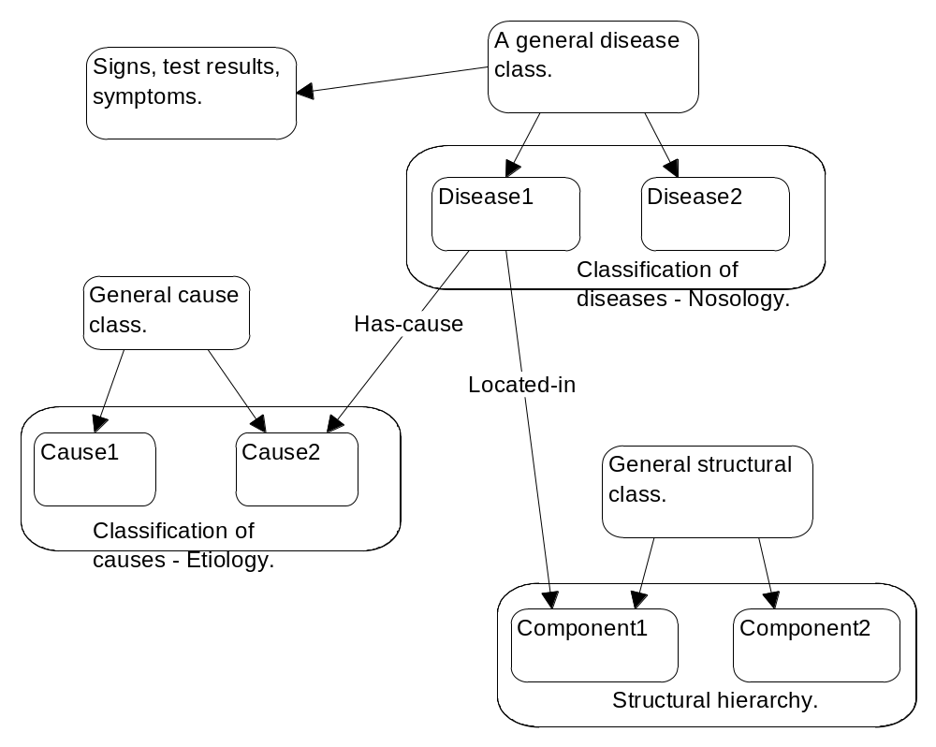
Figure 2.1 Representation of disease concepts, causes and structural units.
In water management for example, an ‘acidosis’ can be defined independently of an actual situation where it may occur thus retaining the generalisation of an acidosis concept. It may be possible to derive specific properties by inference using the concept hierarchy, then derive interactions "on the fly" (dynamically). MESICAR (Horn 1989) is an example of a medical expert system which infers over structural hierarchies to look for possible sites of a problem, given observed findings.

Frame based representations are the representations which underpin much of object oriented methodology and are therefore suited to this research project. They have been successfully used in medical diagnosis (see Seller 1993).

Frame based tools
Protégé -2000, an open-source knowledge modelling platform developed by the Stanford University Medical Informatics Group, (Knublauch 2003) is a computer based, frame based representational tool which allows the user to construct object hierarchies including associational and reified links (links represented as independent objects). Protégé also allows representation of relationships by aggregation of classes of objects (component classes).

Protégé is implemented in the Java language and can be extended through an accessible Application Programming Interface. Java has many advantages as a representational language not only because it supports object methodologies but because it facilitates deployment of applications in intranets and the internet. The foremost value in Protégé is as an ontology editor. Protégé allows the user (given prior analysis) to represent the structural components and relationships in a domain. Protégé facilitates development of ontologies so that they can be extensible and available to other applications. The Protégé ‘community’ is large and there is a growing number of applications in diverse fields with many in the life sciences.

The adoption of a knowledge base editor with the capabilities of Protégé in this research project means that it is practical to extend theory into practice. The benefits are in better understanding the specific knowledge engineering process, having a shareable knowledge base resource for students and other researchers and having a practical research and operational tool.

There is a need for easy to use tools and methods suitable for instructional designers. Protégé fills this need well because of its capability to represent knowledge structures and because of its intuitive user interface. Whilst Protégé is strong in its ability to represent structural relationships, it has limitations characteristic of frame based representations, namely difficulty in making detailed inferences. Some of these limitations have been addressed by a variety of add-ins which implement various “problem solving methods” or paradigms. There are other general issues worth noting about frames and object representations. Inferring using frames is generally difficult but more importantly frames provide limited support for developing dynamic or behavioural models.

Object modelling
Object oriented analysis is an evolving methodology with tools and guidelines continually being developed. One outcome of this research project may be some practical approaches and examples for educational media developers to use in analysing and representing domain concepts.

An object modelling approach is adopted for representing the knowledge base in this research project. Rumbaugh, Blaha et al. (1991) have outlined a number of principles for knowledge structuring using object oriented approaches. Cook (1992) has also outlined design principles for object representations particularly in terms of representing expertise. Some properties and advantages of object representations are:

- Associations can be modelled as reified links. Object oriented methodologies support organisation and representation of components, hierarchical links, properties, temporal and functional aspects.
- Object, dynamic and process models are interrelated. They usually show the structure and interactions of a system and can show progression but are not by themselves able to show or explain behaviour.
- Causal links can be superimposed on other structures and within other models by associating processes to states or attributes.

Object oriented design provides a flexible methodology for defining structural knowledge. Patterson (1990) provides design guidelines for constructing object knowledge models. Generally the first step is to identify the objects in a system, then describe their properties. The next step is to look for ways to represent relationships. Some relationships flow naturally from inheritance described by classes and sub classes but some relationships between components have to be described explicitly.

Structural knowledge describes components and their structural relationships. Included are structural (components and their relationships), functional (processes and their relationships) and dynamic (system states and their time relationships) aspects. Many object oriented design methodologies used to analyse problems in other disciplines have adapted this framework.

More recent efforts (for example in the medical field) tend to emphasise inheritance based structural representations. It is also possible to model links, for example, associations by object related methods.

Guidelines exist for modelling and simulation methodologies which are considered important for this research project. For example, Rumbaugh, Blaha et al. (1991) (object oriented methodologies), Beynon-Davies (1993), Russell and Norvig (1995) and Rothenberg (1989). A convenient methodology for modeling behaviours could be: objects - actions – conditions, but generally dynamic and time based systems are difficult to model qualitatively.

Typically many descriptions of soil processes, for example, Rapp (1983) use compartment and flow models. These models are very close in structure to object models which show the components and connections within a system and can therefore be used as a starting point for object models. These descriptive models show structural aspects such as compartments, pathways and flows. The nitrogen cycle is often portrayed in this way. However key processes such as mineralisation and nitrification can be shown superimposed on this structure. As an example see the treatment of Brady and Weil (2002 p 547). This example serves as a guide for building a knowledge base.

One way to extend these largely static models is by representing aspects of nutrient or materials cycles as components, processes and states. It may be possible to create links to other observations or concepts such as malfunctions or atypical states and identify points of focus of interventions and management strategies. However experience from the medical domain suggests that artificial intelligence AI techniques of most value are semi qualitative (influence) diagrams, causal networks and frame based representations (this point is extended further elsewhere).

The usual view of the nitrogen cycle, for example could be seen at best as an abstracted scientific model. If the model is not structured to support problem solving or does not convey system properties, then it may lead to a ‘too literal’ interpretation of relationships and causes (see the discussion on conceptual models and the limitations of reductionist approaches to understanding system behaviour (Altman 2001)).

It should be possible, by applying good object oriented design, to develop these models further to incorporate further functional and time aspects. Their predictive and explanation function could therefore be enhanced.

A variety of knowledge representation methods are used in applications elsewhere and these are potentially available to this study. Rule based methods have been used to define semantics in some earlier medical applications. These methods are most useful where the domain relationships can be relatively easily described. But they are less applicable for systems where there may be very many poorly defined relationships. Probabilistic causal networks have been used to represent causality but are essentially an AI construct limited by computational resources and inflexible design. Artificial Neural Networks (ANNs) are primarily data oriented approaches that are suited to discerning patterns in data. Although ANNs have had particular application in medical and agricultural systems, their greatest shortcoming as far as application in learning tools is that they cannot be used to express causality or to explain their findings. It is beyond the scope of this research project to develop models based on pattern recognition techniques.

Rumbaugh, Blaha et al. (1991 p 152) have provided guidelines for preparing object oriented models. This methodology is appropriate for models representing structure, processes and time relations and therefore is applicable to this research project.

Representing control knowledge
Task knowledge includes selection of goals and encompasses metacognitive aspects, for example, strategies and planning. Examples are selection of strategies to develop a solution. Some theory on these issues is available, for example, guidelines for building task representations in Deutsch, Carson et al. (1994, p 62). Plans can be expressed in associational networks.

Representing causal relationships
Causal relationships or causal links can be formally defined in AI planning theory language. Any step in a planning sequence has preconditions to be fulfilled if that step is to be implemented. If S₁ and S₂ are steps in a planning sequence and S₁ provides the preconditions for S₂ to be implemented, then it can be written S₁ causes S₂ (Russell and Norvig 1995 p 347). However in practical terms, causal relationships have to be defined more flexibly, particularly for the type of domain analysed in this research project.

Causality is a rather abstract concept and is often reduced to or expressed in terms of probabilities or associations between events. In this research project causal relationships are meant to represent some underlying mechanism which will go some distance towards explaining how one situation develops from another.

As an aid to problem solving, the approach most suitable in this research project is to integrate causal relations into a three tiered structure. At the lowest level are test results, measurements and observations. These are called findings in medical terminology and are the indicators of a disease or abnormal state. At the top are any concepts that can be identified as ultimate causes. The task is to explain how the findings have been caused. The intermediate concepts are any processes and states which need to be invoked to explain the causality. These can include dysfunctional or abnormal states, equivalent to a disease in a medical context. This approach has been articulated for a medical domain (Senyk, Patil et al. 1990). Structural knowledge of the system under study can be developed in parallel and linked to provide the where, how and when aspects of the causal representation.

Long (1992) has built examples of qualitative models in the domain of problem solving cardiac haemodynamics. These structures are essentially causal networks. His final models have been built on a substantial research base. By contrast this research project has no prior results.

Causal relationships can be qualified in the way that gives them more flexibility in application. If A causes B then B isn't always caused by A. A may only be one cause of B. Also A may always, or only sometimes cause B (Senyk, Patil et al. 1990). The qualifiers 'sometimes', 'always', 'often' or perhaps even 'never' can be used to express the strength of the relationship.

Using object methodology a causal link can be represented as a process changing a condition or state. A process usually results from some event. For example an event might be a rainstorm, the process it creates is ‘adds water to a dam’ and the result is a change in water level. The final causal link can be expressed as “adding water to a dam causes the water level to rise”. This representation provides a useful way to develop a scenario and to explain how something has happened. If events can be put into a logical sequence then the processes that accompany those events may account for the overall change between start and finished state. Figure 2.2 shows a simple way of representing a causal relationship. Essentially any assumed change of state or a new condition is caused by some process mediated by an event.

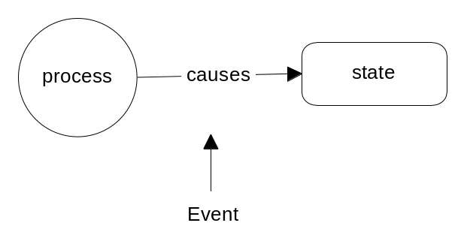
Figure 2.2 Representation of a causal link as a process changing a state.
In practice some compromises must be made to represent causal knowledge. Some simple causal models look like scenarios, combining states, conditions and processes. For example, Senyk, Patil et al. (1990) have developed a causal model to help explain the origin of jaundice in patients. Part of their causal model is built on (a sequence of) assumptions that a given condition will lead to or cause another condition.

The knowledge structures which underpin causal reasoning are essentially semantic networks.

Deriving system behaviour
Because of the inherent complexity of most natural systems, a style of inferring which derives behaviour from a functional understanding needs to be applied. Contrast this with the approach often used in biology in which function has often been inferred from structure, for example, a structure that looks like a wing will probably function like a wing. However inferring function from structure may have its limitations. What is more useful to know is, what are some future properties of a system and, how something will work based on what can be understood of its function.
In addition a new type of inference called consequence finding Sticklen and Chandrasekaran (1989) may prove useful in dealing with newer systems where there is not a lot of experience with cases or typical patterns, for example investigating water quality. Here a particular scenario or condition might be assumed, some possible factors may be introduced and, based on a deeper level causal analysis using basic scientific understanding, some likely consequences might be generated. Now it should be possible to compare expected and observable conditions and make an assessment about what has really taken place and then revise initial understanding.

Situation Specific Models and explanations
A Situation Specific Model (SSM) has been previously described in this research project as a type of localised explanation of how a ‘situation’ or overall state has developed. For the purposes of this research project an initial situation specific model can be viewed as a snapshot of a situation, that is what the status is of a situation at any given time. However some inferring can then be made about how that situation has developed by tracing a sequence of events, each event denoting a process that acts on or changes a state. The final SSM may then be viewed as an explanation. Inherent in this view are some complex assumptions about causal representations that are required to build a SSM. Some of the difficulties in representing causal relationships have been described previously (see p 46) .

Approaches to problem solving under uncertainty
This section broadly examines some approaches used in medicine and other related fields for dealing with decision making where the situation consists of many factors and interactions.

Medicine
Many examples exist of knowledge base development in medicine to support diagnosis and treatment for a variety of illnesses. The medical field exemplifies all the characteristics of complex systems including incomplete information, interacting factors and the necessity to generate and test hypotheses as well as sometimes establishing expedient diagnoses. Deutsch, Carson et al. (1994) have provided a comprehensive review of examples of applications in the medical field which have used knowledge based approaches to diagnosis and treatments. As such this text provides a rich source of ideas, examples and principles for understanding complex systems. One specific example of a diagnostic system for diseases of joints has been provided (Horn 1989) and because of its practical approach to linking causal and associational knowledge, has been influential in helping to formulate goals and approaches in this research project.

Some approaches to problem solving under uncertainty in medicine have emphasised the context of the problem. This approach accommodates information from a variety of sources to facilitate diagnosis and treatments. Examples include lessons from the treatment of diabetes and hypertension (Whinney 1989).

A number of approaches to diagnosis can be found in the medical literature. One perspective is the ‘generate and test’ perspective. Here the user focuses on a set of possible diagnoses, often termed differential or alternative diagnoses. The idea is then to work backwards through the causal net to find if all required or partially required indicators are present. One way to generate one or more potential hypotheses is to use heuristic methods to examine findings which could be considered essential, strong indicators or indicators which exclude a given hypothesis. (several references outline these types of approaches). Torasso and Console (1989) outline causal network approaches to problem solving, including heuristic methods for generating hypotheses. Other methods are assumed to involve an initial abstraction phase where the user (usually a physician) arrives at an initial hypothesis by an “expert” matching of observations with prototypical diseases (Patel and Ramoni 1997). Several other inferring methods are outlined, for example Deutsch, Carson et al. (1994). Long (1992) has used a combination of heuristic and probabilistic methods on a causal network in the domain of heart disease.

Diagnosis in a consultative setting.
A detailed outline of problem solving in a consultative setting can be found in Rogers and Biggs (1993). The examples used show an important aspect of problem solving in (medical) practice. This is that often the physician will start with a working hypothesis and may implement treatment relatively early to avoid the risk of intervening too late. Some of the initial diagnosis is built on a classification of diseases and even on a classification based on gross anatomy or origin of the problem (not the cause). In time the diagnosis may become more refined as the causes become more apparent. Alternative or differential hypotheses are proposed as a way of minimising the chance that an alternative explanation has been overlooked.

McWhinney (1989) describes diagnosis in a clinical setting. He shows by using examples that diagnosis must take account of a broad range of factors, not just those which would be considered 'textbook' or scientific. Further examples illustrate the problems of practical diagnosis, for example, where measurements themselves can be highly variable. This book provides some very good examples of common disease 'conditions' and how the practitioner recognises the social and population factors as well as the relevance of the problem to the patient. A discussion of hypertension provides a useful framework for this research project as many of the characteristics of hypertension in patients mirror the impact of acidification concepts in water. This approach to diagnosis and treatment provides a useful perspective for this research project.

In a similar way, Cox (1999) has provided a detailed view of a patient centred approach to disease diagnosis and management. In particular he outlines many of the challenges the doctor has to face and the options he has when dealing with complex problem solving tasks.

Environmental
During literature searches the researcher could find very few examples of the use of causal reasoning in diagnosing environmental problems. Recently one new approach to diagnosing the effects of environmental chemicals on aquatic organisms has been advanced (Suter, Norton et al. 2005). The authors propose an inferring system to determine the mechanism for how organisms are affected by chemicals so that appropriate management measures can be implemented. In this model based approach the authors have drawn on different sources of information, including empirical studies, associational data, clinical diagnostic data and generalised cause and effect relationships.

Agriculture
Searches for examples of decision support or performance support systems in agriculture also revealed that few use qualitative or causal reasoning. Most examples were found to be simulations designed to provide a predictive capacity and are based on assumptions about the links between factors and their importance. They also assume that most starting data is initially available. Empirical or experimental studies provide most of the data.

For example, COMAX is an expert system (rather than a performance support tool) in cotton production (see Plant and Stone 1991). However this example is based mainly on a quantitative simulation model.

Recently a major simulation model for soil pH under Australian conditions has been described by Hochman, Braithwaite et al. (1998). The simulation essentially provides an acidity budget for a chosen cropping situation by taking into account the contributions of a range of factors including leaching, nitrogen dynamics and soil organic matter dynamics, plant uptake and lime pool. Effects of soil pH buffering are factored in using empirical relationships. As such, this model has the capability to initialise or predict some of the parameters of future causally based models.

The research perspective in agriculture in particular is dominated by a reductionist approach. Modelling and simulation is mainly aimed at predicting consequences based on empirical data. Therefore there is limited scope or capability to be able to predict or infer new information. Some attempts have been made to alter educational and training perspectives with a holistic view of agriculture (see Literature Review).

Applications
This section briefly examines some examples of systems level thinking and understanding of acid-base behaviour in related fields of study.

Limnology
Many of the ideas which underpin this research project have been recognized for a number of years. For example, in the early 1950’s Franz Ruttner, in one of the first major contributions to the science of limnology (Ruttner 1963), described the carbon dioxide / bicarbonate buffer system and the carbonate dissolution system and noted that on some occasions an imbalance occurred in the expected equilibrium between components. At that stage and in fact for most of the time since, very little progress has been made in understanding equilibria as a diagnostic tool, hence the focus of this research project.

Many resources in limnology and aquatic chemistry outline or list broad factors affecting water quality or list processes controlling water chemistry. Many of these are a good starting point for building causal understanding.

However there is no explicit rendering of qualitative or causal knowledge organised in a way to support a diagnostic approach. As an example, the occurrence of blue-green algae has been noted many times in many aquatic situations. A considerable amount of knowledge is available which connects in a qualitative way the algae and other physico-chemical data and observations but a formal framework or organisation of this type of knowledge is not available.

Aquaria / swimming pools
It is not surprising that the major applications of acid-base equilibria theory outside medicine have been made in practical fields such as the aquarium industry and the swimming pool / spa industries. The main management goal is to keep the pH of water within chosen limits, primarily to facilitate chlorination. The main tools are addition of CO₂ to lower pH and addition of lime to raise pH. Sometimes even mineral acids like hydrochloric acid are used by pool managers to lower pH. Most of the theory which underpins these goals is, for example, based on a relatively simple application of the H-H equation. For example, buffer system nomograms have been used to calculate the expected missing value if the other two are known. Implicit in this approach is the assumption of steady state conditions. The manual for swimming pool maintenance produced by the US Army (Department of the Army Headquarters 1986) is a comprehensive document with emphasis on disinfection of swimming pools. The authors recognise that pH is relatively difficult to control and may be influenced by many factors, but they don’t use any framework for understanding pH behaviour, relying instead on a simple strategy of adjusting pH with acid or alkali additions to keep it within a required range.

Medicine
In the medical field an important earlier work (Patil 1981) helped to establish an investigative framework for diseases which impacted the blood pH buffer system. This research proposed and described a diagnostic method which used as indicators, the types of disturbances to the acid-base buffer system in the blood.

Since then efforts to understand and treat blood gas and electrolyte disorders which closely involve consideration of blood pH have evolved. Diagnostic strategies now take in a wider variety of factors including for example ionic balance (Martin 1999). If anything these studies highlight the need to develop open and extensible frameworks which can adapt to and incorporate new information and methods.

Agriculture
Recently some newer ideas about ecological systems have been applied to agriculture in an attempt to find more systems based perspectives. To slow the trend towards industrial agriculture a practical method using numerous 'elegant' knowledge based solutions adapted for specific situations has been proposed by Jackson and Piper (1989). Implicit in their work is the view that these knowledge based solutions may make explicit some of the otherwise hidden connections, some of which may negatively impact farmers and rural communities.

Relatively recently attempts have been made to develop an ecological perspective for agriculture in an attempt to promote sustainable production systems. A significant contribution has been made by Altieri (1987) who provides numerous examples and principles for an approach to agriculture called agroecology which mostly emphasises a systems approach.

Some authors have proposed production systems based on a systems or functional / process view. These include a form of sustainable agriculture called permaculture Mollison (1988) and a form of gardening based on ecological principles Whitby (1981).

One of the recent significant contributions to systems thinking in agriculture has been Bawden and Macadam (1991). In this the authors describe a ‘soft systems methodology’ the key components of which are a framework which links systems theory, domain concepts and conceptual domain models to responsible and appropriate real life constraints and goals. An iterative process which establishes relationship between reductionist and soft system models has been suggested for example Pearson and Ison (1987 p 120). However, currently there is still a dependence on inferring in biological systems through statistics or by probabilistic models Altman (2001).

There is some evidence that reliance on reductionist models (interpreting them too literally) leads to relatively short term and often inappropriate responses. Pearson and Ison (1987 p 119) for example show that (in soil pH management), liming has an ameliorating effect but does not necessarily solve the problem. Pearson and Ison (1987) is a relatively conventional agriculture text but the fact that the authors introduce discussion of integrating qualitative causal models into agricultural decision making is significant.

A key issue in this thesis is the role of knowledge engineering in poorly structured, uncertain and incomplete domains such as agriculture. Given that a majority of agricultural knowledge may be textually based and is largely qualitative as opposed to quantitative or data rich, a point of entry is the analysis of textual information.

Some early contributions were especially influential in providing inspiration and ideas for this research project. Notably was a work comprising many sub articles on simulation, artificial intelligence and modelling (Widman and Loparo 1989). Its main focus was on the possibility of developing and applying qualitative modelling techniques to problems in complex domains including medicine.

There is much theory on analysis of models which has been available for this research project, for example, for a discussion of models of body systems see Deutsch, Carson et al. (1994).

An early inspiration for this research project was work on the development of conceptual models to aid understanding in mechanics (Reusser 1993).

Approaches to understanding natural systems
There has been an increasing acknowledgement and awareness amongst scientists that ecosystem or natural resource models which use simple cause and effect relationships can lead to simplistic and inadequate solutions. A number of researchers have investigated causal relationships at different levels. Some of these approaches are described below.

Rapp (1983) and Vitousek (1983) have contributed substantially to understanding natural and agricultural systems by linking more traditional descriptions of nutrient budgets to investigations of the factors that sometimes cause those cycles to be disrupted.

Borsuk, Stow et al. (2003) have recognised, for example, the tendency of researchers to attempt to describe ecosystems in all encompassing and detailed prescriptive reductionist models. These approaches do not take into account the complex interrelationships and dynamics in natural systems. In response they have adopted a causal network approach in which the goal is to make predictions on a realistic spatial, temporal and functional scale.

Stewart and Robinson (1997) have illustrated the problems associated with agricultural management practices based on consideration (optimisation) of single factors.

Recent advances in ecological theory, for example, Jørgensen and Müller (2000) has centred on the emergent properties of systems, for example, uncovering relationships and issues to focus on, or uncovering new relationships through application of models and research. Interestingly some terms like ecophysiology and even pathology have been used while describing ecosystem function.

More recently Ulanowicz (1997) has articulated a view called ascendency theory which has the potential to allow complex ecological systems, in particular the size and organisation of systems, to be described in information – theoretic terms. His theory also encompasses a view of ecosystems as self organising systems and supports applying a causal view at a variety of levels. Implied in his theory is that ecosystem studies require a conceptual view as opposed to a more “causally closed” view. Interestingly Ulanowicz (1997) suggests that previously vague concepts like “eutrophication” and ecosystem “health”, concepts relevant to this research project may at least be approachable, and quantifiable by taking a higher level view.

Key concepts in aquatic ecosystems
There are few descriptions of ‘clinical’ states or disturbances for natural waters but one, eutrophication, is a concept that broadly describes a process of degradation in water. It is sometimes used to describe what happens in water when the water body is subject to nutrient overload. Eutrophication is thought to be a natural process that is
often sped up by human influences which increase the input of plant nutrients.

Waters are often classified on a continuous scale from oligotrophic, mesotrophic, eutrophic and hypertrophic. Table 2.2 shows a classification of the trophic status of water based on the critical criteria of nutrient inputs, algal biomass and transparency.

Table 2.2 Characteristics of typical natural waters reflecting increasing eutrophication.
 | Oligotrophic | Eutrophic
Nitrate inputs | Low | High
Phosphate inputs | Low | High
Algae biomass measured as Chlorophyll a | Low | High
Transparency | High | Low

Smith, Tilman et al. (1999) have provided a summary of the evidence that eutrophication is caused by nutrient overload and that much of this additional input is an unintended consequence of disruption of the nitrogen cycle for example through increased use of nitrate fertilizers.

However eutrophication is a complex process where the outcomes are difficult to predict because of interactions between components and feedback factors. Table 2.3 summarises some of the observed effects from eutrophication showing the far reaching effects on other characteristics and functions. For example, increased nutrient input has an initial effect on algal growth but ultimately disrupts the structure and function of aquatic and other ecosystems because the effects are propagated along causal paths. One of these effects is lowered transparency that has a negative feedback effect that reduces algal growth (Kay 2000).

Table 2.3 Effects of eutrophication in lakes and streams. Modified from Smith, Tilman et al. (1999).
Increased algal biomass
Shift towards undesirable algal species that can produce toxins
Raised pH and depletion of oxygen
Increased turbidity
Reduced aesthetic qualities
Taste, odour and increased water treatment difficulty
Initial higher production of upper food level species
Potential for fish kills
Harmful diel (daily) fluctuations in pH and dissolved oxygen
Disruption of flocculation and chlorination treatments

One of the implications of increased algal growth in eutrophic waters is the increased uptake of carbon dioxide that accompanies photosynthesis. This is a research area of some interest because of the implications for carbon dioxide cycling and global warming. However it remains that cultural eutrophication essentially has a negative impact on water quality.

Other initiatives in understanding aquatic processes
Another initiative important to this research project is the potential use of pH – REDOX behaviour in water to explain key aquatic processes. For example, recently the concept of REDOX potential has been used in a direct way to help explain nutrient and material transformations (Dodds 2001). Changes, imbalances, levels or conditions outside normal ranges, for example a REDOX / pH imbalance, can be regarded as a malfunction or perturbation, or an abnormal state. In a diagnostic method the goal is to show how these conditions have an ultimate cause. However experience of researchers has shown that REDOX equilibria and behaviour in natural systems is more difficult to interpret. By contrast a single relatively straightforward set of reactions mostly control the pH buffer system in natural waters and the body.

Approaches to ‘clinical’ understanding of aquatic processes
In the medical field the goal of diagnosis is generally to understand how physiological systems react under stress and the causes and implications of those changes. The ‘clinical’ knowledge that underpins diagnosis has to define and describe malfunctions and abnormal states. There is some evidence that natural systems exhibit behaviour similar to physiological systems and therefore there is potential for describing disturbances in natural systems using clinical criteria.

Under completely ideal conditions natural systems like soils and water tend to have intact nutrient and materials cycles. For example, many processes tend to either produce or consume acidity but these usually balance so there is no net change due to internal processes. This has been shown clearly for forest soils (Binkley and Richter 1987). Although natural systems may resist change for example, by buffering, when the system is stressed beyond its capacity to compensate, changes to pH and acidity can occur. For example it has been suggested that loss of nitrate in soils by leaching can lead to acidification because the natural charge balancing mechanisms are disrupted (Sumner 1998).

In the field of water quality management there are many problems likely to be encountered. Some symptoms (and problems) may be obvious or may be sub clinical or difficult to identify. A problem may be acute, for example, a severe deficiency, or chronic for example, poor growth or yield. Some measurements may indicate states, for example, dissolved oxygen levels. In this case a symptom such as low dissolved oxygen in the soil solution may cause a further problem of iron solubility or may be the consequence of another problem. The ultimate cause, for example, may be waterlogging.

A problem may only be recognizable, say in water quality, once it has revealed itself perhaps as a plant growth problem. However a soil or water problem that manifests itself as a plant nutritional problem may have completely different possible causes. For example, ultimate causes may broadly fall into mechanical, disease or nutritional but sometimes, as with plant nutrition, each may cause much the same symptoms that indicate, for example, a nutrient deficiency. Some causes may be secondary and more than one may be present. Complicating factors also include the way the problem manifests itself. Notably, observations or findings may be indistinct, qualitative or may be common (to different causes) symptoms.

Even though there may not be an identifiable disorder, it may be useful to know what the current status is or what issues exist, for example, the state of eutrophication of water. At other times more or less distinct or defining symptoms may be observed or a major disturbance which is altering the system in some way may be apparent for example acid mine drainage or nutrient runoff.

Advances in modelling natural systems
Recent approaches to developing sustainable solutions for environmental problems have emphasised the need to develop problem solving models which extend the underlying scientific theory. Traditionally emphasis has been on reductionist type models which rely heavily on quantitative simulation by capturing statistical or mathematical relationships in series of connected equations. Implicit in these approaches is that systems are definable more in terms of linear causality but these types of models shed little light on how systems behave and how they interact.

Some authors have articulated a systems approach which emphasises system wide behaviour (see Jørgensen and Müller 2000). Here ecosystems are variously described as types of self organising processes, information systems, cybernetic systems, energetic systems, hierarchical systems, self organising holarchic open systems and dynamic networks.

An important point made by Jørgensen and Müller (2000) is that for models to be useful in providing insights into higher level ecosystems properties, they need to be not too complex but to represent the key elements and interactions of the studied system so as to reveal emergent (or holistic) properties. The synthesis of knowledge required may be obtained through models which, together with analysis, will be able to more completely explain system properties.

In a practical example, using a novel approach Regier and Kay (1995) have explained the progress towards eutrophication in the Great Lakes Basin in North America. They believe that ecosystems can be viewed as a collection of interacting subsystems. The overall behaviour of the total system, in this case a series of lakes, changes when the connections between components are rearranged as a result of increasing disturbance so that the system settles into a new pattern. This can be quite dramatic and is not explained through simple causal / functional relationships. They have advanced their theory to help bring together existing knowledge about the Great Lakes so that future management decisions can be better applied.

Recently some works in limnology have introduced the notion of ‘process’ as an extension of structural aspects. Thus the nitrogen cycle (and other cycles) have been shown, not merely as a series of components and flows, but as oxidation - reduction processes (Dodds 2001). One great advantage is that the reader or student of limnology now has a causal basis on which to understand what is happening during, for example, transformations within the nitrogen cycle.

In summary and returning to the notion of complex systems, these are some of the properties of complex systems and consequently ecosystems that need to be remembered in dealing with management problems. Complex systems behave in a way that usually can’t be described by looking at individual components. It could be said that behaviour (say in ecosystems) results from the interactions between components. Ecosystems are ever changing with inflow and outflow of energy, information and materials. This means that they can’t always be expected to be in equilibrium (an idea important to the strategy of this research project). Whilst many components interact and operate at a neighbourhood level, for example, nutrient uptake, photosynthesis and predation, some effects, such as that resulting from turbidity operate at a higher level and affect many components. Negative feedback effects may be seen, such as those exemplified in predator / prey relationships. Positive feedback may also occur, such as the release of CO₂ causing atmospheric warming which results in even more CO₂ release.

Causal reasoning
Causal models are an attempt at providing models of system behaviour. Causal relationships are most effectively resolved where complexity is constrained, for example, as in a machine or electronic device. In this way causality is built through an understanding of the function of various parts. Doyle (1987) has described the process and methods for deriving a causal model of a familiar mechanical device.

Traditional computational models of complex systems are recognised as being descriptive and analytical. They suffer from a lack of ‘understanding” of system level behaviour so that explanations are often only seen in isolation. In an attempt to provide computational models with an ability to synthesise new information and build a system level understanding Langley (2004) has proposed an extension of the computational approach suited, for example to biological systems, which relies on a collection of process models to explain observations and predict future behaviours.

The ‘inductive process model’ approach of Langley (2004) attempts to provide quantitative relationships within a more qualitative structure, to validate models in terms of actual observations and to capture the dynamic aspects of complex systems. In this approach the future value of variables (perhaps viewed as states) can be determined by applying suitable processes from given starting points.

Environmental management
Ceccaroni, Cortes et al. (2004) have described an application that integrates a domain ontology with a decision support system. The domain is waste water treatment and the system has been successfully field trialled. This example is one of the closest to this research project. The researchers have been able to bring together previously developed case-based and rule-based reasoning tools with an ontology on cause and effect relations in wastewater plants.

One of the key motivators for this research project is the need to go beyond traditional chemical engineering approaches to problem solving in what are known to be complex environmental systems. For the ontology they have relied on ‘expert’ knowledge or ‘experience’ to capture knowledge about underlying functions of different groups of microorganisms. The user experience is designed to support data collection, diagnosis, implementation of plans and learning and the whole process is controlled by a type of supervisory structure.

Recently Prevost, Tranouez et al. (2004) have advanced a methodology for modelling aquatic ecosystems that recognises the complexity of such systems and the holarchic nature of their organisation. The methodology is designed to reduce the dependence on phenomenological knowledge whilst providing for a behavioural view of a system. An ontology that acts as an interface to subject experts is a central component of their models.

Cognition and learning
This research project draws on ideas from recent research which highlights issues in teaching and learning about complex systems. The examples come from areas such as cognition, artificial intelligence, education and systems theory. Some of these studies are mentioned later in this Chapter. Together they provide guidance for designing and implementing learning environments for complex topics where the focus is on understanding the cognitive aspects of learning and supporting performance, including the development of ‘expertise’.

Performance support
This research project draws significantly on ideas from the theory of performance support systems This theory guides the development particularly of computer based aids to learning by defining the expected results of the program.

It was Gery (1991) who coined the phrase Electronic Performance Support and who believed that (paraphrased) “we do not need more technology but new ways of looking at things”. A framework for the possible roles and goals for a learning environment for supporting user problem solving has been outlined in this research project on p 26.

The performance support model for intelligent learning environments originated in more structured training environments and hence retains a perspective that a learner model can be adequately defined. However the model is a sound starting point for designing a computer based learning environment because it encapsulates the key functions of supporting the learner in practical settings. This research project places less emphasis on defining a performance model (an understanding of how people perform on tasks) and more emphasis on understanding a competence model designed to facilitate outcomes in real life situations. For practical purposes the computer learning environment that is a product of this research will be referred to as an Electronic Performance and Learning Support System or EP/LSS to include an emphasis on a ‘learning’ support function.

Design of a performance support system must be underpinned by some type of analysis of the task environment. There are two distinct approaches to the analysis task and this helps to understand the approach used in the current research project. One emphasises performance and tends to be underpinned by a study of ‘expert’ ways of working on a particular problem. Another way is to emphasise domain knowledge itself and integrate this with a suitable cognitive model. Outcomes are validated in terms of performance which can be viewed as the ability to build a coherent model of a situation.

Cognition
Some key findings which underpin this research project have included emerging teaching and instructional strategies which emphasise cognitive aspects of learning. For example, Clancey (1997) has described the role of situated cognition, support for problem solving in realistic situations, and support for hypothesis formation, explanations and evaluation. Previously, Clancey (1988) has advanced a concept of expertise that emphasises the development and application of cognitive models.

Intelligent learning environments.
This research project has been influenced by some ideas from work on intelligent learning environments where the emphasis has been on supporting the cognitive processes of the learner. For example (Reusser 1993) has described how a conceptual model in mechanics was implemented in a computer learning tool. This study is an important example of a learning environment that starts with an understanding of the beliefs, knowledge structures and reasoning that a student uses to work on particular problems. The study program provided experiences which allowed students to apply causal reasoning to anticipate the future state of a mechanical system.

Another example was a novel learning environment in electronics which provided a system wide causal representation of behaviour White and Frederiksen (1990). The design was built on an understanding of students’ concepts of how certain aspects of electronics worked. But the program was set up so that students could experiment with electronic circuits and in doing so test their own ideas. An important idea was that causal understanding (building blocks which described interactions between components) could be used to generate a type of qualitative system level
understanding.

Spector and Davidsen (2000) have emphasised the need to provide system models at different levels to support learning. The knowledge base or knowledge structure in a domain has a critical role in supporting learning. Clancey (1989) argues that ‘the role of a ‘knowledge base’ is to encode a model of a part of the world’. The user of a program is then guided to develop a situation specific model through interaction with the knowledge base. This changes the emphasis, previously common in many learning support programs, particularly in medicine, which emphasised ‘expertise’ in the user and established expert knowledge in the knowledge base.

Professional education.
A EP/LSS for professional education has to support learning while the practitioner is mainly concerned with the immediate application of knowledge. The main challenge is in providing a mechanism that enables the practitioner to integrate new experience and knowledge.

McWhinney (1989) raises some key issues regarding professional and ongoing education of medical practitioners. Some findings are: keeping up with developments is difficult; good medical knowledge develops from clinical experience and significantly, the doctor needs some framework through which to assess his/her learning and practice.

Acidity in water – a primer.
It is important to review some of the underlying chemistry theory used to explain how pH is regulated in water based environments because it outlines and includes many of the assumptions on which disturbance models ultimately have to be built. It can also serve as a refresher or primer of some basic science.

How pH is determined and regulated in water
Acidity in natural surface waters such as lakes or rivers, underground water, water which is a part of the soil system, or even water in a beaker in the laboratory, results primarily and normally from dissolved carbon dioxide in the water which produces hydrogen ions. But the level of acidity in water is determined and regulated at least and to a large extent, by 3 important processes:

1. Additions of carbon dioxide by diffusion from the air or from other sources. This carbon dioxide dissociates to form weak carbonic acid which subsequently provides a level of H⁺ and bicarbonate ion. The reverse process sees carbon dioxide returned to solution and usually to the air.

2. Regulation of H⁺ ion by chemical weathering and dissolution processes which create a pool of bicarbonate ion. This pool then can be reduced when required to resupply H⁺ ion.

3. Chemical equilibria which tend to create stable and usually predictable relative concentrations of the products of the other processes namely H⁺, bicarbonate and disassociated carbon dioxide.

By far the most important regulator of acidity in natural water is the bicarbonate buffer system. Acidity can be usefully and mostly understood in terms of the interactions between dissolved carbon dioxide, bicarbonate ions and hydrogen ions. The bicarbonate buffer system attempts to maintain a particular balance between the amounts of all three of these components in water. This provides a useful way to understand and interpret what is actually seen in natural waters.
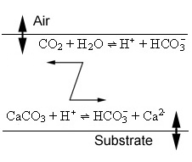
Figure 2.3 Main buffer system components and reactions in water.

Figure 2.3 shows the two main reactions responsible for maintaining the pH buffer system in natural waters. Carbon dioxide dissolves to form bicarbonate and H⁺ ions. Some of the H⁺ dissolves calcium carbonate from the surrounding rock and substrate. This reaction adds to the bicarbonate in the water and also releases calcium ions (part of water hardness). This is a dynamic reaction and can go in forward or reverse according to external factors but usually (in theory) it comes to an approximate equilibrium, thus maintaining a relatively stable pH.

The role of CO₂ in water
This section encapsulates some of the understanding of the connection between CO₂ and pH. It highlights aspects which can be used to build an understanding of pH regulating processes as well as points at which understanding is not complete and shows how this affects the ability to use this knowledge to solve real problems. Key points are:

- Water can hold a large amount of CO₂, mostly as intact CO₂ molecules. This is the CO₂ pool used by plants for photosynthesis.

In this research project this form of CO₂ will be called ‘dissolved’ CO₂ although the term is loosely used elsewhere in the literature and can mean dissociated CO₂ . This can lead to some confusion.

- Only a small proportion of CO₂ molecules (about 0.25%) actually dissociate ultimately to form aqueous carbonic acid, a weak acid. This happens in two stages and an intermediate step is a type of loose association between CO₂ and water molecules. Because it is difficult to distinguish between this partly dissociated (aqueous) CO₂ and carbonic acid they are by convention, called H₂CO₃ (aqueous) or 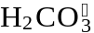 and by convention, the reaction is simplified to one overall step described by a dissociation equation.

Chang (1981) has provided a detailed discussion of the equilibrium constants involved for these reactions.

- There is a time delay between CO₂ dissolving in water and appearing as aqueous carbonic acid and the same applies for the reverse reaction.

The amount of CO₂ dissolved in water is theoretically related to the amount (the partial pressure) in the atmosphere (Henry’s Law) but water can end up being under or over saturated with CO₂ for different reasons, for example, if production or consumption within the water exceeds replacement or removal capacity. Movement of CO₂ into and out of this pool happens slowly, both from the atmosphere and from internal chemical processes such as respiration and produces CO₂ on a timescale of hours. This time becomes much greater if water is cut off from the atmosphere, for example, in deep lakes, in underground aquifers or soils.

- Aqueous carbonic acid dissociates in two stages to form H⁺ ions. The first stage produces most H⁺ ions and is the most important one to consider.

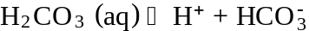 (2.1)

This dissociation, as with many other chemical reactions, proceeds far enough so that a balance or equilibrium between sources and products is achieved. Roughly speaking, very little carbonic acid actually ends up as H⁺ ions. Bicarbonate concentration is smaller than aqueous carbonic acid by a factor of about 100.

• The second dissociation reaction for aqueous carbonic acid is:

(2.2)

Carbonate concentration is smaller than bicarbonate by a factor of about 1 million. If pH is lower than about 8.3 then carbonate concentration is likely to be very low and can be safely ignored in equilibrium calculations (Chang 1981, p 321). The vast majority of surface waters at least suitable for drinking or irrigation fall below pH 8.3.

Because it is difficult to distinguish chemically between some of the intermediate products of the dissociation of CO₂, a simplification is often made in which the dissociation is described by the following equation with pK_{a} of 6.38.

(2.3)

This simplification, both for the initial dissolution of CO₂ and the subsequent dissociation of aqueous carbonic acid, has important consequences for understanding acidification behaviour. First it provides a connection between the amount of CO₂ dissolved in water and the acidity (measured as H⁺ ions). This means that measuring the carbonic acid by neutralisation with a base is actually getting a measure of the amount of dissociated CO₂. Secondly, the equilibrium reaction involves the dissociation of CO₂ which includes a time lag, that is, the reaction does not proceed or re-establish balance instantaneously. This reaction and its reverse is thought to take place on a timescale of minutes (Stumm and Morgan 1996). Therefore it gives a ‘window’ through which factors affecting the bicarbonate equilibrium in water can be investigated.

Understanding water processes through physicochemical equilibria

The Henderson-Hasselbalch equation
The theory of chemical equilibria and chemical kinetics may provide the key to understanding the how and why of water chemistry and represent a useful tool on which to base a deeper causal understanding of water health and quality. This research project has drawn on the considerable existing body of knowledge of water chemistry, equilibria and kinetics. A good example is Langmuir (1997).

The Henderson-Hasselbalch (H-H) equation is derived from the equilibrium constant equation for the dissociation of any acid and its conjugate base (Chang 1981). For the bicarbonate system it is convenient because it expresses pH in terms of bicarbonate and dissociated CO₂. Thus it provides a simple way to evaluate a theoretical pH for a given situation. (Chang 1981, p 330) has provided a detailed explanation of the derivation of the Henderson-Hasselbalch equation.

If applied to the bicarbonate equilibrium in water it shows how pH is related to the dissociation constant K and the ratio of Carbonic acid, the acid to bicarbonate, the base.

For the first stage dissociation of aqueous carbonic acid the H-H equation is:

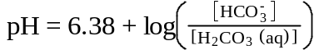 (2.4)

where [ ] indicates Molar concentration. The equation means that the pH of a sample of water is theoretically determined by the pK_{a} (for the bicarbonate system this is taken as 6.38) and the ratio of bicarbonate (the conjugate base) to aqueous carbonic acid (the acid) concentrations. It is the ratio of bicarbonate to carbonic acid which is important, not the absolute concentrations.

In natural waters carbon dioxide levels range from around 3 to 20 ppm (parts per million). This equates to concentrations from 6.8 x 10⁻⁵ Molar (M or mol/l) to 3.6 x 10⁻⁴ M aqueous carbonic acid. Bicarbonate levels can extend over a very wide range but in non saline water range from close to zero to around 4 x 10^{–3} M which is about 250 ppm.

If the pH is fixed for a theoretical situation then the H-H equation can be used to generate a series of data points corresponding to bicarbonate / carbonic acid values which will produce that pH value. The resulting graph is called a nomogram. In fact any number of pH lines can be drawn on the same axes, as close as necessary.

Example pH buffer nomograms can be found in the Results section. To use the nomogram take CO₂ and bicarbonate measurements for a sample then plot them on the graph. The nomogram will show the approximate expected pH.

pH buffer nomograms are used to a limited extent in the swimming pool and aquarium industry. But significantly their use is limited to calculating or estimating one variable, for example, pH from the other two variables in the H-H equation.

However the H-H equation has another use; to provide an expected pH which can be compared to a measured pH. A theoretical value for any of the 3 variables described by the relationship could be calculated, then compared to an actual measured value. Later this idea will be tested using some sample data from a variety of waters.

pH buffering processes in water
Buffering of pH in water is a somewhat complex and confusing idea and is generally poorly understood as a process in natural situations. Therefore its implications and management are relatively poorly appreciated. This is in spite of a large number of excellent and authoritative texts in the field of environmental soil and water chemistry and physical chemistry including (Langmuir 1997); (Jensen 2003); (Stumm and Morgan 1996); (Evangelou 1998) and (Chang 1981). Many of these texts provide in great detail the mechanisms of chemical processes and the frameworks for understanding the chemical composition of water.

In summary, the main pH buffering system in water can be described this way: When CO₂ dissolves in water it initially forms H⁺ ions and bicarbonate ions. However there is another separate reaction which interacts with the bicarbonate buffer system. If the water runs through or contacts minerals containing calcium carbonate the H⁺ ions react with the calcium carbonate to form Ca²⁺ ions and more bicarbonate thus:

The H⁺ ions can come from the first dissociation reaction of aqueous carbonic acid, or they can come from external sources such as carbonic acid in rain, mineral acids from industrial processes or from any other biochemical reaction, perhaps in the soil in which H⁺ ions are produced in surplus.

Each time a H⁺ ion is lost by dissolving some CaCO₃, a new bicarbonate ion and a new Ca²⁺ ion is formed. As long as there is CaCO₃ available, H⁺ ions keep getting used up and more bicarbonate ions are formed. (What actually controls how far this process goes is another research question.) Charge balance is therefore maintained. If this is the only reaction producing bicarbonate then in theory there ends up being twice as many bicarbonate ions as calcium ions in the water.

However calcium carbonate only dissolves slowly and the equilibrium constant shows that the reaction is biased towards the solid form and not much bicarbonate is formed. The reverse reaction also occurs if, for some reason H⁺ ions start to be used up by some other process. The Ca²⁺ ions from the initial dissolution of calcium carbonate start to recombine with bicarbonate to form insoluble calcium carbonate and H⁺ ions.

A property which has important repercussions for regulating the pH of water is that the dissolution reaction of calcium carbonate is slow. Therefore the reaction may not use up H⁺ ions as fast as they are being created. However the reverse reaction in which bicarbonate recombines with calcium ions can be relatively quick. This could mean that a rise in H⁺ is less effectively compensated than a decrease in H⁺ ion.

How does this affect pH in water? Under normal conditions the pH is under the control of the bicarbonate system and hence the first dissociation equilibrium for aqueous carbonic acid. The equilibrium constant will not change provided gains and losses of H⁺ and bicarbonate ions balance each other.

In time the ratio of bicarbonate to dissociated CO₂ rises and therefore pH rises. This relationship is described by the Henderson-Hasselbalch equation. Another way to interpret this is that pH is determined by a balance established between two opposing reactions, one producing and one consuming H⁺ ions. For example where water comes from areas low in calcium carbonate type minerals for example acidic soils the dissolution reaction is likely to be slow or limited and pH will tend to be low (acidic conditions).

Therefore, part of the buffering system works like this: If some disruptive process increases the amount of H⁺ ions in the water some more CaCO₃ is dissolved producing bicarbonate and maintaining pH. If some other disruptive process reduces the amount of H⁺ ions, some bicarbonate reacts with some of the calcium ions forming CaCO₃ (which is insoluble) and releases some H⁺ ions to replace those lost, again maintaining pH.

Oxidation – Reduction Potential (ORP)
REDOX is a parallel concept to pH. In simple terms the oxidising potential of an environment is given by its REDOX or ORP value. This is simply the electrical potential and is conveniently measured in millivolts. Easily accessible treatments of REDOX in soil and water are given by Dodds (2001) and Evangelou (1998).

REDOX and pH are so interwoven that they must be considered together. Many REDOX reactions also have the power to change pH by adding or consuming acidity. The important consideration for this research project is that oxidising or reducing conditions in water and soils are the result of an interaction between REDOX and pH.

pH and chemical equilibria
This section extends the discussion of the theory of the pH buffer system by describing how the buffer system equations can be used to interpret the equilibrium status of a situation. Some examples are given of how this principle is used in medical diagnosis. The section concludes with a summary of challenges in measuring and interpreting pH buffer system data.

Disturbances of chemical equilibria in water
The most important part of using chemical equilibria theory to investigate environmental problems is to recognise that systems are rarely in equilibrium. The pH buffering system in water, by its very name, buffers or resists factors working to change the pH. If one component is changed, then to keep the system in equilibrium, another factor compensates. Compensating changes try to maintain the ratio of components given by each equilibrium constant. In the bicarbonate system an increase in dissociated CO₂ can be compensated by an increase in H⁺, bicarbonate or both.

The expression for the equilibrium constant for the bicarbonate system shows that the product of the concentrations of bicarbonate and H⁺ is what maintains the numerator part of the ratio. Therefore a primary rise in H⁺ could be at least partly compensated by a fall in bicarbonate.

A simple qualitative way to interpret the relationship between primary and compensating changes is to just use the proportionality relationship

pH is proportional to 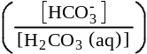 (2.5)

which is a simplification of the H-H equation, and which shows that if pH rises (less acid) then bicarbonate should rise because the two are directly proportional or, carbon dioxide should fall because they are inversely proportional.

The H-H equation indicates that if the ratio bicarbonate / CO₂ increases then the calculated pH will also increase (acidity decreases). If the ratio bicarbonate / CO₂ falls below 1 then the calculated pH will decrease. A change in the ratio bicarbonate / CO₂ can be caused by either a change in bicarbonate or a change in CO₂.

It is also possible to see the relationship between disturbances and compensating changes graphically by using a nomogram. This approach will be used later in investigating some sample problems.

There are some simple scenarios which could be described as primary disturbances followed by a main and perhaps a secondary compensating change. This is possible because the equilibrium can be at least temporarily moved out of balance and may take some time to return to normal. It may however be a challenge to work out what is a main and what is a secondary compensation.

An increase in pH for example, requires either an increase in bicarbonate or a decrease in CO₂ to compensate. An increase in CO₂ requires either an increase in bicarbonate or a decrease in pH to compensate. To complicate things, in the last example both pH and bicarbonate may change at the same time to compensate the initial change in CO₂. It may be difficult to determine which compensatory reaction is the primary compensation. The reverse finding from this relationship is that a compensation, for example, increase in CO₂ levels, could be a reaction to either lowered pH or increased bicarbonate or even both.

It has to be assumed that equilibria are ‘dynamic’, that is a system not only settles into a particular state which is often a balance between opposing forces but it may take some time to get there. In the meantime there may be an ‘out of balance’ phase. In other words concentrations of bicarbonate, hydrogen ions and carbonic acid in water may not be present in a ratio determined by the carbonic acid dissociation constant and the Henderson-Hasselbalch equation. This is especially true if one quantity changes but there is some other process limiting the rate at which a compensating change occurs.

pH equilibria in medical diagnosis
The theory of disturbances to pH equilibria has been used in the study of blood electrolytes and associated disorders. For example, problems with lung function can abnormally increase or decrease CO₂ in the blood pushing the bicarbonate buffer system out of balance. The kidneys have the job of excreting other acids and replenishing bicarbonate levels to keep the blood pH stable. There is often a time lag before the kidneys can compensate for changes caused by other factors in the blood. Or, if the kidneys are affected by disease then this part of the bicarbonate system can be disrupted.

Evidence from the study of blood gas and electrolyte disorders suggests that ‘acute’ and ‘chronic’ effects can be observed. ‘Acute’ effects are likely to be disturbances which have occurred and dissipated rapidly. ‘Chronic’ effects are active over a longer term. ‘Uncompensated’ means disruptions which haven’t been or are only slowly compensated by the buffering system. ‘Compensated’ means that the pH buffer system is somewhere near equilibrium although the initial disturbance is still evident.

A chronic uncompensated effect may see increased acidity due to increased CO₂ levels but the buffer system is still out of equilibrium.

The H-H equation is widely used in medicine in the field of diagnosis of blood electrolyte and acid-base disorders. Martin (1999) has provided an overview and analysis of much of the theory used to understand blood gas disorders and Patil (1981) has provided a diagnostic system based on understanding pH equilibria in blood. However the H-H equation is only sometimes mentioned in environmental chemistry texts and as far as is known, has not been used as an aid to understanding disturbances to chemical equilibria in natural waters.

However, the applicability of this approach to problem solving in natural waters hinges on whether it can be established if and how the buffer system can be pushed out of equilibrium, the time taken for compensating mechanisms to react and the way natural waters react to disturbances.

It is known that the bicarbonate buffer system in water does come under attack. For example, one factor which can send water ‘out of equilibrium’ is pollution by acid mining waste discharge (Evangelou 1998).

Factors affecting acidity in water
Carbon dioxide dissolves in water slowly and conversely diffuses from water slowly. For example, in organically polluted water CO₂ levels can build up if production from decomposition exceeds diffusion to the atmosphere.

There are two well known examples of natural changes in acidity in water due to CO₂ changes. In water where there are algal blooms, pH often rises in the daytime and returns at night. This is thought to be because photosynthesis by the algae in the daytime removes CO₂ quicker than it can be replaced. The assumption is that the pH buffer system compensates by reducing the H⁺ concentration. If H⁺ cannot be quickly replaced by outside sources then H⁺ remains low and consequently pH rises.

Many natural waters tend to have elevated dissolved CO₂ levels due to CO₂ production from breakdown of above normal levels of organic material (Jensen 2003). This is assumed to be capable of increasing aqueous CO₂ levels which in turn is compensated for by a rise in H⁺. The excess CO₂ thus pushes the bicarbonate equilibrium towards more acid conditions.

Waters with high organic loads can become very acidic especially if oxygen is depleted (for example in swamps). The problem is increased if excess H⁺ cannot be used up or dissipated. A number of other natural processes have the capacity to alter the pH of water. Langmuir (1997) has outlined some of these processes.

Some processes can potentially affect acidity directly by producing hydrogen ions or indirectly by changing chemical equilibria by mass action. An example of the first is respiration whilst an example of the second is input from acid mine drainage. Evangelou (1998) has provided a basis for understanding the results of acid mine drainage on exposed water sources.

Challenges in the domain
There are a variety of factors which add to the difficulty in understanding and interpreting the factors which regulate pH in water or soil solution. Here are some of the issues:
- Acid forming reactions (dissociation reactions) involve many variables and stages. For example carbonic acid dissociates to form hydrogen ions in two stages, each characterised by a dissociation constant.
- pH is initially established by opposing processes on the one hand dissolving CO₂ in water and by carbonates from the soil dissolving in the soil solution. It is possible that opposing disturbances may result in no major change to pH.
- Buffering processes regulate and control pH. These are likely to become more significant in soil solutions.
- pH is a measure of acidity based on a logarithmic scale therefore interpretation of significance of changes in pH is conceptually difficult.
- In the soil solution and in water it is more difficult to establish “normal” or baseline conditions. The pH of human blood is normally close to 7.4 but there is no easy starting point for establishing “expected” conditions in water. For example, pH of different surface waters commonly range from around 5 to 8, a 1000 fold change in [H⁺]. In general bicarbonate levels are much higher in blood than in most waters. For example 915 mg/l is a moderately low level in blood but would be considered very high in many surface waters. In addition bicarbonate levels vary greatly between different natural waters. The same applies for dissociated carbon dioxide. Values in the blood range from around 900 to 1200 mg/l, however these values would be considered extremely high for natural waters. Typical values from samples measured in this research project range from < 5 to around 160 mg/l.
- There is no established vocabulary for describing pH abnormalities in natural waters and little work done on establishing a schema for understanding pH abnormalities similar to the pH - aqueous CO₂ nomograms sometimes used in medicine. For example acid-base disturbances are described as causing an acidosis (an acidifying effect in body fluids) or conversely an alkalosis, as either an acute or a chronic effect and originating normally from respiratory or metabolic functions.

Measuring acidity in water
If an analysis of acid-base disturbances in water is to be based on measurements of acidity then those measurements and their interpretation must be valid and reliable. The Henderson-Hasselbalch equation requires 3 quantities; pH, bicarbonate and an estimate of carbonic acid.

Carbonic acid and alkalinity titrations are relatively simple to perform but very seldom reported in water test reports (Langmuir 1997). This is probably because up to now little attempt has been made to provide an interpretive framework which gives insights into the importance of these factors to system functions. Bicarbonate levels are often interpreted simply as ‘buffering capacity’. There is some validity in this perception. However the equilibrium constant of the bicarbonate system suggests that significant buffering capacity is only provided at pH levels around 6.3 - usually and often lower than that of most water samples. Therefore this interpretation may be an over simplification in many cases. Without a broader framework, the significance of buffering capacity in the sample water is hard to determine, hence the focus of this research project.

Summary
Some of the key factors and principles which characterise the research environment are:

- Task analysis usually precedes development of knowledge based applications but for applications that emphasise cognitive aspects this model has to incorporate a cognitive component that includes strategic and heuristic knowledge and mental models. However, particularly where the emphasis is on modelling the task environment, further knowledge types have to be defined and these primarily include diagnostic knowledge.
- Object oriented representations have many advantages for defining and organising domain concepts. However these methodologies are defined more in terms of strategies for creating representations that have reasonable coherence.
- Significant examples of approaches to problem solving under uncertainty can be found in the medical field. These emphasise ‘clinical’ knowledge and diagnostic methods.
- Perspectives from educational theory that attempt to provide insight into designing cognitive learning environments emphasise issues such as qualitative and causal reasoning, situation specific models and knowledge models.
- Current practise mostly treats pH and acidity as static quantities. There is a tendency to manage problems by directly manipulating a limited number of factors. For example typical management objectives include managing or preventing the effects of acidifying processes.
- There is a well established theory of the chemistry of acid-base reactions, buffers, effect of pH on chemical reactions and processes. In addition there is a well established research base which defines and describes many of the mechanisms which underpin biochemical processes, for example, key processes such as respiration. However much of the analysis to understand the chemistry of aquatic systems requires complex calculations and therefore presents practical challenges to students or practitioners.
- The task environment has a level of complexity comparable to that of body systems. In addition, recent research for example, Kay (2000) has suggested that ecological systems may ‘behave’ in ways that result from self organising, optimisation and feedback effects. However in dealing with this complexity there are limited theoretical perspectives in recognising or dealing with abnormal or disturbed situations for natural systems like water. This includes limited vocabulary or terminology to describe ‘clinical’ type conditions.
- As yet in the ecological field generally there are relatively few applications that integrate heuristic or causal knowledge into decision making which involves conventional ‘scientific’ knowledge. In addition a ‘task’ knowledge which includes selecting various strategies or paths for problem solving water quality problems is yet to be formally elicited or described.
- The theoretical perspective of this research project that deals with water processes aligns closely with the field of limnology and aquatic chemistry. However, typically the knowledge base of limnology and aquatic chemistry is not structured or organised principally for defining hypotheses useful for diagnosing the causes of water quality problems.
- A problem solving methodology that is suited to complex systems like the determination of pH in water most likely includes decision making which requires establishing, selecting and testing diagnoses. Experience from the medical domain suggests that practitioners may often be dealing with multiple or interacting causes for a problem. Interpretation of effects far removed from observations may be required. Because there may be multiple causal pathways a method is usually needed for comparing possible alternative explanations. Consequently, for example, in the medical field there are ongoing efforts to build robust, coherent, extensible and accessible knowledge resources specifically to support problem solving.

Chapter 3. Research Design / Methodology
This section outlines the research process that resulted in the design and development of a prototype EP/LSS in the field of water quality management called ACIDEX. Part of the process is to define a problem solving architecture that suitable for reasoning about causes of water quality problems. The architecture is meant to represent a model of cognition. Later, a computer application, ACIDEX is described. Its role is to implement the previously defined architecture. The research model for this project is one that supports design and testing of learning environments like ACIDEX.

How the research developed
The following introduction to the methodology is designed to convey something of the detail of the journey the researcher took into this research area. The motivation for the research was primarily the lack of methods for solving practical water and soil problems that build an understanding of the processes actually responsible for a problem. There could have been a number of approaches to this research including:

- Further scientific research to define soil and water processes better.
- A study of the beliefs, knowledge and problem solving strategies of practitioners, teachers even students.
- Investigating new ways to solve old problems by adopting a problem solving perspective.

The choice of strategy was primarily influenced by some key perspectives and observations with the following conclusions:

- There is a large and growing body of knowledge reflecting an educational, cognitive or psychological perspective on how people work with complicated tasks. This includes advances in designing new types of cognitively based learning environments.
- There is a large amount of ‘scientific’ information available to describe aquatic chemistry, soils and associated biology.
- Current ‘practice’ in water (and soil) management reflects both relatively poor understanding of complex issues and interactions (or inability to deal with such complexity) and poor methodology. The evidence for this is broadly the ‘engineering’ solutions often proposed and which are mentioned elsewhere in this research project. The implication is that educational practices may not be adequately serving the needs of environmental managers engaged in areas such as water supply, soil fertility management or in management for sustainability.

A choice was made to research the problem solving process itself. The initial focus of the research was on finding evidence of some of the ‘mental models’ practitioners like farmers hold to explain what happens in natural systems. The research framework was that of a ‘cognitive’ task analysis. The goal was to provide some understanding of strategies, actual practice and perceptions associated with activities like farming, particularly focussed on dealing with soil acidification.

The initial goal was the ‘design‘ of a performance support system to be based on an understanding of the types of heuristic methods people are assumed to use. But after some preliminary orientation interviews with practicing farmers and some review of strategies and approaches used by more alternative or organic farmers it became apparent that an adequate cognitive task analysis even for a limited problem area would be very difficult. This type of analysis had only been tried in relatively constrained domains, like training in technical subjects where procedures and goals could be fairly clearly established.

Some of the initial research effort was directed at building simple concept maps to help identify the issues relevant to understanding some particular aspects of nutrient cycling in water and soil. They were developed as part of a task analysis identifying key domain concepts. These were retained and later served as the basis for a more structured knowledge base to support reasoning about actual problems.

This initial approach was not sufficient and focussed enough to integrate educational and ecological theory and to provide practical outcomes. There were some obvious and urgent problems to be addressed. Soils and water are being degraded now in Australia (and around the world) so expedient solutions are required.

Some practical experience solving plant growth problems in a production nursery showed that there was a lack of suitable frameworks for dealing with uncertainty in situations where neat experiments can not be performed. The researcher also noted that many soils textbooks, even those with a comprehensive practical orientation, provide little direction or support for actual problem solving. An example is Brady and Weil (2002).

Further development and elaboration of the research strategy was required. The researcher looked for other subject areas where there may have been precedents for dealing with similar types of problems. The researcher found that in the medical field there is extensive experience using problem solving strategies using a principle of diagnosis that includes understanding the context of a problem, forming an hypothesis and testing treatments.

However solutions, strategies and practices from other subject areas cannot be applied loosely without validating the assumptions on which they are built, especially for a new field.

At the same time and at a more practical level the researcher noted inconsistencies and deficiencies in the way pH measurements in water and soil were interpreted. The common practice of assessing nutrients in soils by referring to simple pH versus nutrient concentration graphs is limited because it does not take into account the factors that determine pH and the interactions within the situation. These graphs are the Truog diagrams commonly seen in agricultural texts, for example, Donahue, Miller et al. (1983, p 257). There was already some evidence that processes which produce nutrients also alter, or can alter, the acidity in the soil or water. These same processes may be regulated by acidity, so the whole situation is necessarily cyclic.

The researcher started to look at the pH buffer system in water while researching what was known about the factors which determine acidity but was surprised to find that in most environmental chemistry texts the buffer system equations were mostly used to create and balance budgets for the different chemical components in water. For example Jensen (2003) demonstrates methods for calculating the concentrations of the individual inorganic components of the carbonic acid – bicarbonate buffer system in water, but these calculations assume a theoretical or steady state situation. There was also the question of why the pH settles at different values in different situations. During literature searches the researcher discovered that in the medical field, disturbances to the pH buffer system in blood are commonly used to help with diagnosing different diseases.

This changed the perspective of the research. In some ways this could be seen as simply an evolution in thinking or part of the research process. It also meant that considerable chemical and physical data from a variety of sources which was already available could be usefully integrated because there was now a suitable ‘causal’ framework. From around the mid point of the project the researcher started to measure the pH buffer system properties of samples from a number of natural waters.

The researcher considered that a useful way to develop and promote new ideas was to implement them as much as possible in a type of learning tool. Examples of some computer based performance tools were available from other disciplines. The researcher planned to incorporate pH buffer system theory into the design for a EP/LSS. There are potential benefits to prototyping a decision support tool. These were seen as a way to embody particular educational theory, a way to obtain feedback on actual use in practice and by demonstrating a way to explain the design features of such a tool.

This research project is an attempt to improve educational practice both in the field of environmental management and more broadly, in the field of designing learning environments for complex systems. Educators have long searched for ways to bring together theory and practice by carrying out research which will provide valid guidelines under given conditions or in a given setting which can then be extended more broadly. This can mean bringing together some practical steps or methods, or designs for learning, even to the point of designing learning tools which can act as both a medium for learning and as an educational research tool.

Providing an interpretive framework for findings
The usefulness of laboratory data and observations (findings) is often limited by a lack of an interpretative framework that facilitates a better understanding of higher level processes in the system being studied. Water test laboratories commonly test a range of physical and chemical factors including pH, REDOX potential, conductivity, turbidity, nutrients, salts, metals and sometime organic compounds. Less commonly, bicarbonate and acidity are determined. Other parameters may include dissolved oxygen, biochemical oxygen demand (index of organic load) and algal biomass (index of trophic condition). Often qualitative aspects like colour, smell and even taste are recorded.

Usually interpretation of these measurements in terms of their relevance to system function is limited by a lack of theoretical framework. For example pH is often described as a ‘master’ variable implying that the value is determined externally. Bicarbonate is often only interpreted as ‘buffering capacity’ but its role is more complex (see p 72). However evidence suggests that pH not only determines other properties but is itself altered by other processes in water.

Once the parameters pH, bicarbonate and acidity are seen as part of the pH buffering system in water then some more useful interpretations can be made. This new approach which underpins ACIDEX has the potential to make these simple to measure, but otherwise perplexing quantities, the cornerstone of a new type of investigative method.

Problem solving as modelling
Many examples are available of the use of problem solving protocols built on mainly heuristic, statistical or associational knowledge. This approach was typical of many of the medical problem solving models which underpinned early medical decision support systems. Whilst many of these attained a respectable level of ‘expertise’, their main drawback was inflexibility in dealing with new or involved situations. An example was MYCIN, Shortliffe (1976), a decision support system for identifying the causes of bacterial infections.

Associational models or case models that allow inferring based on having seen similar problems and outcomes before, are often built on the assumption that problem states are pre definable or that the system is adequately understood at a functional level. Often these systems incorporate rules or probabilistic relationships.

Problem solving is often approached by replicating or simulating part of a system. The system processes and interactions are often described mathematically with models that include the rates of change of many connected state parameters. For example, some weather forecasting and climate change models use this approach. This type of model assumes first that the main components and interactions can be adequately defined and secondly, that the system will 'behave' and conform to the rules of operation that have been set. The major shortcoming of these models is that they don't attempt to 'understand' the system. Leavesley (1994) has suggested ways to improve quantitative climate modelling approaches including the need for better ways to model uncertainty and establish scenarios. However most emphasis is still on extending quantitative methods including establishing recognisable patterns. More recently some progress has been made using qualitative simulation methods which attempt to capture system behaviour at a broader level by defining how one behaviour is likely to follow another, (Kuipers 1989).

The goals of this research project are based on the approach that problem solving is more a question of building a coherent understanding of each specific situation. This is to both explain, for example ‘what has gone wrong’ and then to be able to ask relevant questions of the model so the working knowledge of a system can be developed. Implicit in this approach is the idea that complex systems can never be understood completely and that often a start must be made by working on real problems, sometimes with only incomplete information.

All problem solving approaches have their advantages and disadvantages. Heuristic methods may provide expedient solutions but may lack a prediction capability. Simulation approaches take full advantage of technology but may not be able to account for unusual or changing situations. Modelling based approaches require a paradigm shift away from trying to describe a system to trying to understand a system. Qualitative simulation approaches for complex systems, for example Kuipers (1989), are an attempt to model the overall behaviour of a system by assuming key interdependencies. The ultimate goal of this type of approach is to simulate changes in the state of a system by predicting small steps, as and when required, using an understanding of behaviour.

The concept of modelling can be extended to understanding how systems work. In the context of this research project, ‘modelling’ emphasises the functional, behavioural and causal aspects of a situation.

By using a modelling approach it may be possible to allow a causal level to be added between the typical ‘observation - reaction’ approach often seen in dealing with environmental problems. For example, agricultural soils are often limed to reduce acidity, but liming is often an expedient solution, sometimes based on a relatively simple measurement (pH) and adopted with a limited understanding of the possible causes of the problem. Without good management tools there is a temptation to avoid or sidestep the problem. Again, acidity in soils is sometimes tackled by simply selecting more acid tolerant crops.

Problem solving by using a functional understanding could be supported by combining a purely empirical approach and an holistic approach. Using this strategy basic structural understanding could provide at least the mechanisms and hopefully the theories which can provide organisation and explanations of scientific laws, facts and relationships (Jørgensen and Müller 2000).

Perspectives from other domains
Some examples of problem solving methods from the field of medical diagnosis provide a focus in the current research project. There have been many approaches to developing medical diagnostic models to account for the challenges of diagnosis typically faced by doctors. Some of these have been outlined, see Deutsch, Carson et al. (1994). Recently a diagnostic and patient management strategy has been described called the ‘Family medicine’ approach. In this approach emphasis is placed on more in depth qualitative analysis of patients, including the ‘context’ which may be wider and includes family, background, history and circumstances Whinney (1989); Rakel (1993). A more holistic or systems based approach includes data collection or orientation which is broad and flexible and takes into account the problem or situation context. This increases the possibility that decisions ultimately made will take into account a fuller range of implications and outcomes.

Research design
The research methodology for this project supports the aim of designing and evaluating a new problem solving approach for complex systems, a ‘proof of application by example’ approach. When the goal is to test particular ideas on learning where there is no existing example of an application, to find out how a new idea works it is best to build an example and test it on some real problems to find out if it improves the ability to understand both the system under study and the design of the tool itself.

The research methodology hinges on the idea that in dealing with complex systems, for example biological systems, building a better understanding of how competence develops is an iterative process. This involves modelling the system and building the tools necessary to enable a type of competence model to be described. The combined model along with an investigative strategy can then be applied to specific situations. Finally the product and outcomes can be evaluated and validated. In a sense this research project is all about modelling: Modelling at the mechanical level using scientific theory, modelling natural system behaviour and modelling competence and understanding. This approach is validated internally by measuring the coherence of the models and externally against emerging systems level theory.

The goals implicit in this approach are to:

1. Develop a suitable knowledge base in a restricted domain to support problem solving. This knowledge base will include structural, functional, time dependent and causal components.

2. Provide meta-analysis to extend the knowledge base, for example, categorize and build relationships.

3. Investigate representational tools. Develop examples using appropriate representation tools. In this case the project will use a frame based tool - Protégé from the Stanford University Medical Informatics Group.

4. Build and test a model to solve selected constrained or representative problems using methods with flexibility to include probabilistic, rule based and other causal representations (again using appropriate methodologies).

Research questions
The key research question addressed and investigated by this methodology is the applicability of a causal model based diagnostic system to advancing educational practice in teaching for understanding aquatic systems and potential in the design and development of a EP/LSS.

Research goals and focus
A great deal of knowledge about water is available ranging from the chemistry and biology of water, descriptions of water processes and general principles for managing water. Models of system processes exist but are often quantitative (often derived from statistics) and descriptive (for example, describing materials flows). There are relatively few attempts at models of system behaviour or causal models of system function. Further, there are relatively few examples showing how this functional knowledge can be organised to help solve typical problems or provide useful explanations of how problems develop or how they can be treated.

The central thesis of this research project is that advances in understanding water acidification and related problems, including soil acidification, will come from working with existing information, new field data and an interpretative model for ‘clinical’ type disorders, provided that a new type of problem solving strategy along with a structured knowledge base is provided. Similar models, sometimes called knowledge level models for example Long (1992), have seen some application in medical physiology domains but similar examples in other domains, for example agriculture, are rare or minimally developed.

Research focus
This research project focuses initially on an analysis of the pH buffer system for a series of samples. The examples chosen here are mainly from a range of natural surface and subsurface waters. The aim is to identify and characterise types of buffer system disturbances at the level of the chemistry of the pH buffer system.

Later in this research project in Chapter 5 Applications, some examples of a type of differential diagnosis for chemical equilibria related problems, which are based on deeper causal (scientific) knowledge, in natural waters will be described. These approaches are then extended to building and testing an explanation system through an understanding of the factors and the processes at work within a specific situation. A term for this approach is ‘problem solving by modelling’ Clancey (1989), a method which emphasises the need to build a case model for a given situation. This model can then be put to work to predict how a situation will potentially evolve. These deeper first principles causal models are the keystone for more generalised qualitative or causal models.

This research project provides an application of such a problem solving strategy to some problems in water management and thus provides the preliminary design of a prototype system to test the feasibility, efficacy and outcomes of such a system.

In this research project the strategy is not to create more "scientific" knowledge about the subject but to organise existing knowledge to create a better understanding of how aspects of water processes and water health can be addressed. In view of recent thinking and newer system level approaches to understanding ecosystem structure and function (for example see Regier and Kay 1995) it may be possible (in this research project) to show how some current methods can be improved. In general this research project is seeking to advance methods which provide mechanisms for investigating alternative methods for problem solving and research.

This research project adopts a ‘problem solving by modelling’ approach to understanding complex systems. If a problem solving by modelling approach is used then practical goals have to be integrated, for example, as treatments, predictions and conditions. For example, a farmer has a farm dam which he needs to use for a domestic water supply. Most solutions focus on treating the existing conditions. Existing technologies of water treatment are not perfect and cannot be easily applied to cover all situations. However, in certain situations it is possible to prescribe a range of treatments which will bring most water to some adopted standard. This could be called an ‘engineering’ solution and is prevalent in the water treatment industry. This is also usually expensive and mostly ignores the causes of any quality problems.

Problem solving by modelling builds on what is already known about a system, mainly from the point of view of practitioners working on problems. A decision making process which makes a short link between observations and interventions (treatments) can work well in the majority of cases especially where there is a weight of evidence or prior experience and there is a need to act expediently. This situation occurs in the medical field where there may be an imperative to act quickly, based on the best available information at the time.

Problem solving by modelling goes further, acknowledging that interventions are only a part of overall understanding and that effective treatments depend in the long term on a better understanding of underlying causes. A problem solving by modelling strategy essentially requires a diagnostic perspective.

It means that goals are now couched in terms of how well 'treatments' fit within a given situation. In many ways this parallels the ‘soft systems’ approach articulated by Bawden and Macadam (1991), but there are complications, for example, how should normal be defined? How has a specific situation evolved from ‘normal’? How should overall goal conditions be specified?

Figure 3.4 illustrates the different questions to consider when moving from an ‘associational’ type strategy to a problem solving strategy based on a deeper level understanding. The domain is water quality management. The ‘engineered’ solution often used in environmental problems of this type is represented by the dashed line. The example shows how understanding of water quality could be related to choosing treatment options.
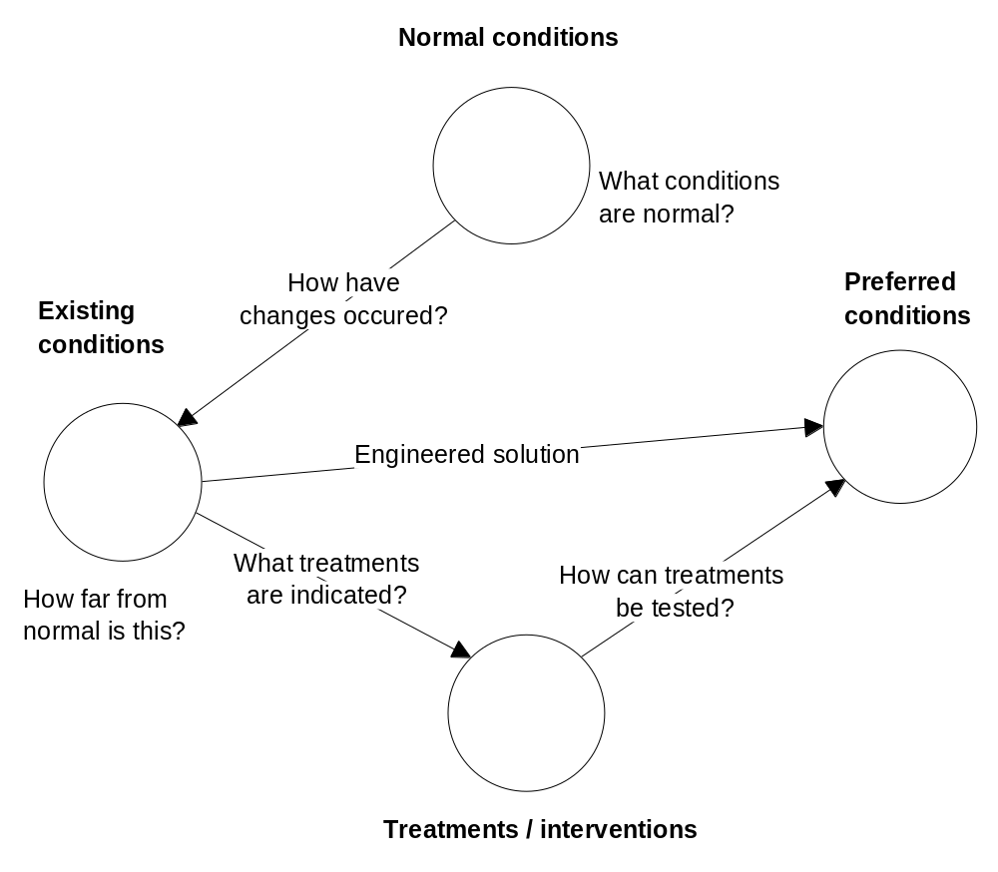
Figure 3.4 Orientation to problems in managing water quality.

Strategy for applying a model based approach
The key strategy in a model based approach is to investigate causes for an observed problem or to assess some measure of system function (in this case related to water health) by building and testing hypotheses about the cause of the problem or its health status.

It is easier to think of this type of problem solving as a form of diagnosis. Here diagnosis means more than just identifying, describing or choosing a likely set of causes for a problem. It also means testing initial ideas about the cause of a problem and being able to adequately explain how a problem has developed, decide on an effective treatment strategy and even select productive data collection strategies.

Much can be gained by including qualitative understanding. For example, if the water being studied has a smell, is devoid of fish, contains copious bacteria and fungal masses, this could suggest excessive organic matter loading and may mean low available oxygen in the water. So a preliminary diagnosis could be “fish are dying because of an anoxia due to excessive organic matter loading”. This is an hypothesis which does not by itself say what has caused the problem, how the particular situation has developed, what the prognosis is or how the water can be made suitable for a given purpose. Thus qualitative understanding can be the basis for putting forward some preliminary causal models.

It may be that commonly held views about causes, which may be couched as 'associations' may vary in validity. It does not prevent associational knowledge being used as a starting point in diagnosing a problem, because in a model based approach no prior assumptions about the validity of an idea need be made. Ultimately, when some situation that has developed needs to be explained, these initial ideas can be put to the test.

In the strategy proposed here, initial hypotheses are based on causal knowledge about chemical equilibria primarily relating to acid-base balance. This is because so many fundamental biochemical processes affect or are affected by acidity status. These preliminary hypotheses are based on focussed data collection on the status of components of the acid base buffering system in water.

Ultimately, to explain how a problem has occurred and is likely to develop in a particular situation, a type of situation specific model has to be developed. Applied here, it is similar to saying – given a few fragments of information and some theory about water chemistry and biology, what is going on in this situation? Put another way, how can measurements and observations be taken, then used to reach some conclusions about what has gone wrong and then to explain how that situation has developed?

One of the great advantages of a situation specific model (a localised explanation) is that it avoids the arduous and sometimes impossible task of developing generalised, all encompassing models to suit all situations. It also acknowledges the fact that no two situations are the same and that different factors may be operating to produce the observed effect. The model based approach also acknowledges that it may be impossible to anticipate all the ways factors may interact and importantly, the mechanism by which a malfunction or impairment may originate.

For example it may be impossible to anticipate all of the impairments to biochemical processes which may result in a surplus of acidity. Building a situation specific model requires that only those rules, relationships or values necessary to explain a given situation need to invoked, generated or instantiated. It also means that some type of functional understanding to build an explanation of particular system behaviour needs to be utilised. This is mainly because it cannot be assumed that all knowledge will be neatly available. Much will need to be inferred to provide a coherent view which can be put to the test or validated further.

In this research project a situation specific model is viewed as an overlay on a generalised concept map that links observations and measurements to ultimate causes through any intermediate conditions or states. Not all components need to be present or relationships instantiated, just enough to create a reasonable explanation. Ideally by looking at what can be observed or measured, the goal is to say what is going wrong or what processes are being disrupted and how are changes acting to cause an overall condition.

The main tool in generating an initial perspective is an understanding, in this case, about what keeps key chemical processes going and regulated in water and soil solutions. Ideally some ‘low level’ relationships are needed. These may potentially be based on equilibria models because these models give details about the dynamics of a system. Some theoretical relationships, for example the Henderson-Hasselbalch equation are available to describe acid-base equilibria in water and therefore this becomes a possible candidate.

Establishing the applicability of a pH equilibrium modelling approach is one of the goals of this research project. It is important because identifying the type of disturbance to an equilibrium can be the first step in establishing alternative causes, or put another way, a differential diagnosis. This approach is used widely in medical diagnosis. In this way chemical equilibria models have found success in a related domain, diagnosis of diseases, through understanding their impact on blood gas and electrolyte status.

With some assumptions and constraints this and other theoretical models can be applied to natural systems. The goal is to find a way of detecting, measuring and describing changes or abnormal conditions. It is easier to problem solve if it can be established if something is not normal. Abnormal conditions can be described in terms of changes to very fundamental chemical relationships, that is they are grounded in established physicochemical theory. Equilibria models have been used in water analysis in the past but they are mostly used to predict (theoretical) chemical composition.

By using equilibrium models to find when processes are not in equilibrium, initial hypotheses can be specified in terms of abnormal conditions, for example deviation from results expected, based on equilibrium calculations.

The great advantage of this starting point is that detailed causal understanding can be built progressively as new knowledge is applied. Models are then validated because they are always built on a strong foundation of scientific knowledge.

Problem solving architecture
The design of any method to implement this type of problem solving strategy must incorporate these main aspects and goals:

1. A knowledge base of structures, components and relationships which will underpin subsequent deeper level reasoning.

2. Description of a suitable diagnostic model which integrates causal relationships into an explanation system.

3. A way of inferring future states of a system or subsystem given starting conditions, for example a range of measurements, observations or assumed values will provide a way to establish and test any alternative diagnostic hypotheses.

Outline of an investigative process using causal models
These steps are proposed as a practical way to approach building causal models in the field of diagnosing water quality problems generally. The whole process is necessarily iterative and incremental because it is designed to start with some concrete findings and then slowly build an increasingly more complete understanding of how a particular problem has occurred.

1. Problem orientation – constraining the domain, identifying underlying causal relationships (principles) which may be helpful; collecting some baseline data for example, conventional tests; make observations (qualitative); set initial goals.

2. Identifying relevant components (structural) of the system being studied. This can be built up as time goes on. Development of structural relationships which build or extend a suitable domain ontology. This may include causal, time based and process knowledge. The models here could be hybrid, that is they could mix some rules, associations, states, processes involved and mix high (more abstract) and low level (more mechanistic) concepts. Their role is to establish and define the context, or put another way, to describe the relationships under study. This includes establishing major relevant concepts which may need to be considered.

3. Initial data collection. This is probably going to include a conventional set of physical and chemical parameters as well as some more general observations, sometimes called ‘findings’.

4. Developing working causal hypotheses using initial mechanical level causal models. For example, identify changes based on a chemical equilibrium model. If possible express the hypothesis in terms of ‘x observation is being caused by y acid-base disturbance’. Any number of suitable relationships can be employed as long as they provide insight into function or dynamics rather than just static or structural aspects. Use initial hypotheses to provide some type of directed or informed data collection.

5. Choose major goals and methods, for example, diagnostic, predictive and design methods. For example, if a body of water has a disagreeable smell it may be important to know why. At other times the design of a method of treating effluent from an industrial process may be a goal. It may be that the goals are less specific. For example, if water is to be used for drinking then it may be necessary to know if there are any issues that have to be dealt with.

6. Apply or integrate available phenomenological knowledge (observations, measurements). This includes taking a broader view and actively collecting information about the context of the situation. This is somewhat like approaches used in an integrated ‘patient centred’ diagnosis where possible significant factors are identified by asking a patient about their lifestyle. At this stage an initial ‘situation specific model’ is being developed.

7. Develop a multi level causal network which is capable of representing issues identified so far. This network can be supported by relationships identified in steps 2 to 6. The network could start as a network of relationships such as ‘a causes b’, ‘b causes c’ et cetera but ideally will evolve into a multi level causal representation of the problem situation where higher levels represent broad, even abstract concepts and lower levels represent raw data, such as observations. Such models connect observations and measurements through intermediate states to ultimate (postulated) causes or recognisable disorders. Use these representations to advance alternative generalised and simple scenarios (these could be seen as diagnoses).

8. Build a situation specific model by integrating, with previous generalised models, qualitative knowledge about the function and behaviour of the system being studied. This is the most important and most difficult step because it requires the developer to start building a model of how the system under study is working.

9. Choose methodologies to rank diagnoses or assess states or possibly scenarios according to their coherence, adequacy and ability to explain themselves. Generate explanations about how situations have developed.

10. Review: Complete the loop by feeding back to phenomenological knowledge, suggesting ways to improve starting points and actions. Suggest ways of improving these problem solving tools and processes.

Design-Based Research
Given the complexity of the research and the need to propose a new type of learning environment as a research tool, a replicable and valid research process was required which would demonstrate useful and clear outcomes.

Description
Recently a relatively new paradigm for educational research, Design-Based Research (DBR) has been described (Design-Based Research Collective 2003). Its aim is to provide reproducible, extensible and accountable research based evidence within a framework which integrates theory and practice. The method is applicable to technology or computer based learning environments and is especially suitable to designing and testing educational innovations in practice. DBR is a methodology based on an understanding that cognition and learning are interconnected with learner, context and task Barab and Squire (2004). Therefore instead of designing experiments where the researcher is the observer, controlling or accounting for as many variables as possible, the design-based researcher adopts a methodology that studies learning in context and from the learners point of view. The theoretical educational perspective is expressed as a model encapsulated in a constructed learning environment. The findings therefore are expressed in terms of the goals, design and outcomes of the research environment.

In summary Design-Based Research encompasses these key principles (adapted from (Design-Based Research Collective 2003):

1. Designing learning environments can lead to development of theories of learning.

2. The research process has to be essentially iterative, including steps for design, implementation, analysis and redesign.

3. The research must contribute to further development by others by expressing results within a coherent theoretical framework.

4. The research must be able to highlight the learning issues involved by providing a mechanism for studying user interactions with the learning system and the design process used by the developer.

5.The research should be able to show how the design of any learning environment relates to actual problems or learning situations.

Justification
A guiding principle in the methodology is that data collection and analysis should help provide a framework to bring together and compare theory, actual practice, resources and possibilities. As such this research is consistent with the aims of Design-Based Research (see p 99) in that it attempts to link empirical or practical knowledge of performance, practice and learning to both domain theory and theories of cognition and learning.

This research project supports the primary principles of Design-Based Research in the following ways:

1. Design of an EP/LSS in this research project is similar to the approach called ‘prototyping’ in computer science. Its design is based on an understanding of chemical and other processes specifically related to water management and is specifically designed to address practical problems using practical analytical methods.

2. The theoretical perspective of the design of an EP/LSS is set out and describes the assumptions underpinning chemical analysis, inferring methods, representations of successive situation models and representations within the knowledge base. This transparent process is available to other researchers.

3. The EP/LSS provides an organised platform for observations of user behaviour and problem solving outcomes because it provides an interface that encourages successive refinement of diagnoses of pH disturbances.

4. The prototype EP/LSS described below supports educational theory that examines the role and application of causal reasoning and the building of situation specific models. Importantly its design is transparent, flexible and open ended to allow the possibility of extending existing theories particularly where they relate to methods of diagnosis in complex domains. The design of the knowledge base is based on established principles of object modelling, a methodology that has been explored in the medical domain (Senyk, Patil et al. 1990). The architecture and interface of the prototype EP/LSS is informed by some examples of computer assisted learning environments from the medical field (see Section 2.6.1).

Application of the research model
The Design-Based Research methodology was adopted for this research project primarily because the research goals required a methodology to investigate learning in a designed environment. Design-Based Research does not specify a stringent methodology but is more a set of principles that define an interpretive framework for findings. Table 3.4 is a retrospective summary of how the current research project satisfied the principles of Design-Based Research.

Table 3.4 Application of a Design-Based Research framework to the research project.
Principle * | Justification in using DBR | How addressed | Outcomes | Suitability / fit | Lessons
1. Designing a LE ** can extend theory. | Few research models exist for studying learning where no previous examples exist. | Design a LE architecture that integrates causal diagnostic methods and independent domain concepts. | A LE was developed using an architecture that supports diagnosis by modelling. | Well suited because better understanding of reasoning and kb *** issues emerged during development and testing. | Design goals for LE’s for complex tasks are necessarily presumptive,  however open architectures are advantageous.
2. Research process is iterative. | Outcome is a competence model therefore open to review. | Create a prototype learning environment. | Buffer system interpretations and kb development proceeded in individual cycles. | Suited to the design of the prototype but less useful in studying emergent properties. | Prototype only tested on historical data.  Prototype important as a practical example for further refinement.
3. Results reported within a coherent framework. | Perspectives are from chemistry and learning theory. | Diagnosis uses established chemical and cognitive theory. | Results reported in frameworks of kb design, chemistry and problem solving strategies. | Theory on system behaviour, learning support systems and knowledge models is mainly theoretical. | Results ultimately have to be reported as competence models.
4. Mechanism provided for studying user and designer. | Both design and user interaction to be tested against coherence and efficacy. | Assumptions and kb components are accessible.  Diagnosis made explicit. | The prototype provides a structured platform for observing user interaction. | Limited support for developing and making explicit, a user situation model. | The main limitation is that mappings cannot be made explicit therefore observable.
5. Design relates to actual tasks and situations. | Research goals are stated in the context of environmental problems. | A prototype to support diagnosis of specific types of problems. | Design was supported by an analysis of diagnostic tasks. | Diagnosis in complex problems requires modelling in context. | Model based approach underpins decision making in complex domains.
* Adapted from the key principles of Design-Based Research p 100.
** Learning Environment
*** knowledge base

Data collection
Secondary sources
The main objective of this research project is to build causal models which operate at a more abstract or ‘clinical’ level. However these are underpinned by much of the ‘basic’ science of aquatic chemistry and this has come from a number of readily available texts on water chemistry and management. In particular Langmuir (1997); Stumm and Morgan (1996) and Evangelou (1998) have been valuable.

Case study data
Data was collected from land owners, from waters on public land and from property owned by the researcher. All of the water test data used in developing the case studies and examples in this research project was collected by the researcher. Data was of two types, the history, intended use and details of any noticeable problems obtained where possible from people whose water was being tested, and chemical analysis data of the water. Where locations were visited by the researcher, additional notes were made of qualitative aspects of the water quality and environment. In all cases but one, where samples were from private individuals, written consent was obtained for the use of analytical data from current or previous tests and for the application of further tests relating specifically to the pH buffer system. In the remaining case (Bore 4) where sample data was only used in construction of the buffer system nomogram (p 122), verbal consent was obtained.

Data that formed the basis of an investigation of buffer system equilibria were collected during the period 2003 to 2004. The samples represented a broad range of water types. Samples from three locations on the researcher’s own property were included and were found on analysis to be distinctly different (as explained in results) but were not specifically included to extend the range of samples. Some further data that formed the basis of case studies was collected up to early 2006.

To avoid having any people or properties identified through this research project, all sample locations were given a code name and a master list was retained by the researcher. A summary list of all samples and case studies used in this research project are as follows:

Table 3.5 Code names and samples for locations studied in this research project.
Code name | Location
Creek 1 | Creek in the eastern suburbs of Melbourne
Creek 2 | Creek in the upper reaches of the Yarra River. The samples taken from this location were from a large dam on the creek. The samples were taken from the overflow and from the lower outlet.
Creek 3 | Creek in East Gippsland entering the Gippsland Lakes
Dam 1 | Dam in West Gippsland
Dam 2 | Dam near Gembrook
Dam 3 | Dam near Gembrook
Bore 1 | Bore at Maroota NSW
Bore 2 | Bore on Banksia Peninsula, Gippsland Lakes
Bore 3 | Bore in the outer eastern suburbs of Melbourne
Bore 4 | Bore in Rowena NSW
Bore 5 | Bore in central Gippsland near Thorpdale
Spring 1 | Spring in Gembrook
Lake 1 | Lake in the outer eastern suburbs of Melbourne

Chemical and physical analysis
Key measurements for this research project are pH, ORP, bicarbonate or alkalinity and carbonic acid. pH is a measure of the H⁺ ion activity which at low concentrations can be considered the same as the concentration of H⁺ ion (an assumption commonly made in chemistry texts). pH is often measured chemically or electrometrically with an ion specific electrode. These types of measurements are accepted practice and are reliable, providing instruments are maintained, used within their limits and calibrated properly.

Acidity is different to pH and is defined as the amount of strong base, such as hydroxide ions, which the water can neutralise. Thus it can be estimated by quickly neutralising all the H⁺ ions by titrating the sample with a strong base. This measurement is assumed to be a measure of aqueous carbonic acid and hence dissociated CO₂ because the dissociation reaction of aqueous carbonic acid is relatively rapid. Therefore what is really being done by neutralising with a base is forcing all the dissociated carbon dioxide present to convert to H⁺ and bicarbonate ion.

Acidity in water was determined in this study by neutralisation to the phenolphthalein endpoint at pH 8.3. At this pH the majority of aqueous carbonic acid can be considered converted to H⁺ and bicarbonate ion. This method conforms to APHA method 4500-CO2 C American Public Health Association (1995, pp 4-17). To carry out buffer system calculations, results have to be reported as concentration in mol / l. The stoichiometry of the equation for neutralisation of carbonic acid by a base suggests that the number of moles of carbonic acid neutralised is the same as the moles of the base consumed. This can then be assumed to represent the number of moles of CO₂ dissociated.

Provided the starting pH is less than 8.3, alkalinity is represented by bicarbonate ion. Bicarbonate was measured for this research project by titration with an hydrochloric acid to the methyl orange endpoint – around pH 4.3 according to the methods described in Jensen (2003). Again by stoichiometry, the molar quantity of acid consumed is assumed to represent the amount of bicarbonate present.

For this research project pH was determined electrometrically using a calibrated pH meter. All other measurements reported were obtained using standard and reproducible methods.

Knowledge base components and design
Six main components for a knowledge base to support reasoning about water quality problems are proposed. In summary these are:

1. Underlying physical and chemical properties and behaviours. Physical components.

2. For acid-base disturbances, factors directly and indirectly affecting acidity. Description of causal factors.

3. Signs, indicators and findings. Rules and guidelines for assessment and monitoring.

4. Descriptions at the system level for example eutrophication.

5. Treatments and interventions.

6. Descriptions of behavioural ecophysiology, that is how systems behave and react at a large scale level.

Associational knowledge
The main role of associational knowledge within the knowledge base proposed in this research project is to help with establishing a preliminary diagnosis. Associations can be of any number of types.

In the medical field, for example, associational knowledge links signs and symptoms to clinical states. The strength of an indicator can be expressed in terms of conditions such as ‘implicated in’, ‘needed for’, ‘related to’ or ‘symptom of’. These can be further modified as sometimes, always, never or usually. For example, yellow staining around taps is ‘sometimes’ a ‘symptom of’ artificially high iron levels in water.

Indicators, tests and symptoms may vary in importance in forming a diagnosis. In the diagnosis of diabetes, high blood sugar is a strong indicator but conclusions can be strengthened if high potassium and blood ketones are also present.

Therefore causal knowledge can be used to form an initial diagnosis. Used this way the user assumes a cause, therefore establishing a link between observations and ultimate assumed cause. The challenge then is to prove or substantiate that link.

Causal knowledge
This section describes the possibilities for developing a ‘clinical’ level model to help diagnose disturbances in acid-base balance in water.

Describing causal relationships in natural water
In general, very few researchers attempt to represent causal relationships in natural systems. Thus examples showing causal representations are poorly developed for water and in particular, the water component of soils. Sometimes causal relationships are inferred from statistical relationships, for example, correlations such as 'waterlogged soils cause yellowing of leaves'. Sometimes causality is expressed in terms of the action of some process on a state variable or quantity, for example, 'oxidation causes a reduction in dissolved iron’. This latter view supports an object view of systems because causal relationships can be constructed in terms of two components; processes and parameter values.

Causal relationships are mostly defined as a way of explaining 'how' a situation has developed. They are usually somewhat undefined concepts, so causality is mostly impossible to prove. Causality can be seen as a ‘construct’, useful to allow some interpretation of mechanisms.

Further, causal relationships attempt to capture a consequence relationship, that is, one thing happens as a consequence of another. For example reduction in photosynthesis may be a consequence of increasing turbidity. Sometimes associations are expressed as causes, for example, 'high trans fat diets cause cardio-pulmonary problems'.
Causal relationships are a useful way to express some aspects of system function which are otherwise difficult to capture in conventional structural representations. Therefore they are a useful starting point for deriving system behaviour. If the conjectured causal relationship is set at a higher, more abstract level then the challenge is to build in the more 'mechanical' detail to support the relationship. The knowledge base in ACIDEX represents some broad causal relationships showing how some processes affect water quality.

In this research project some of the reasoning and theory, which is the basis for construction of an initial causal representation of acid-base behaviour in water has been outlined. This initial 'mechanism' draws on an interpretation of chemical equilibria theory and other relevant relationships. It represents a coherent and objective starting point but should not be regarded as necessarily complete. It is built on a number of simplifications and assumptions but is nevertheless an advance on previous methods.

Sometimes it may be necessary to assume some causal links in order to adequately state an hypothesis about the cause of some problem in natural waters. Causal links stated at a higher level are almost certainly subject to interpretation and validation. As a consequence, many conventional limnology texts do not advance many causal links. They are only useful as part of a diagnosis - explanation system in which causal knowledge is used to construct a ‘clinical model’ of a system.

Describing water health at the clinical level
In the medical field clinical conditions are often and commonly described in terms of failures of organ or physiological systems, for example diabetes, or as abnormally high / low or extreme conditions, for example hypertension. There are few useful descriptions for failures in natural systems. Although such terms often represent broad concepts, they are essential for focussed diagnosis and treatment. Even the terms ‘acidification’ and ‘acidified’ don’t actually specify an equivalent clinical condition.

In some ways concepts like oligotrophic, characterised as relatively infertile, less diverse situations and eutrophic, characterised as productive environments with stressed nutrient cycles, provide some building blocks for an ontology of clinical conditions. However these concepts are fairly general and may not directly support an understanding of disturbed ecophysiology.

In their influential work, Bayly and Williams (1973, p 217) talk about this very issue. They suggest that understanding causal factors leading to oligotrophy could assist water engineers to produce water suited to domestic purposes.

Diagnostic knowledge
This research project will show the application of a diagnostic method to some water quality problems. Diagnosis should always be seen more as a way to orient to a problem, rather than as an actual solution. Even within more established fields (see the previous discussion on diagnosis in a consultative context p. 51) diagnosis is all about bringing information together in a focussed way. By comparison to examples from the medical field, the study of water quality problems using a diagnostic approach is at an early stage of evolution. The case studies presented here are used to explore a new problem solving methodology. As such they are a way to provide focus, give direction and help explore possibilities. They are very open ended and are limited only by the underpinning causal theory of malfunctions or by the extent of the knowledge base.

It is important to remember that not all problems are caused by pH buffer system disturbances. Changes to pH for example may be a symptom as well as a cause of a problem.

Prototype learning environment
This section describes the design and development of the EP/LSS ACIDEX. Aspects include design considerations for the key components, how the prototype evolved and some perspectives on how well the prototype achieved the original goals.

Task analysis for the domain
The starting point for this research project is based on a partial structured cognitive task analysis based on an adaptation of the ICTA Model. The framework for this is shown in Table 2.1, p 36.

The role of a structured task analysis is needed to situate this research project or provide the ‘orientation’ to current practice. The aim is not to develop an extensive task analysis for a particular domain. Subsequent analysis of domain data and concepts is part of the process of building a problem solving methodology and practical performance support system. The domain, which is acid-base disturbances in water is a test domain for researching ways to help practitioners and students work with problems in agriculture.

This research project mainly concentrates on the 'orientation' stage of the ICTA Model as described on p 34.

The knowledge base that underpins ACIDEX is limited to the domain of acid-base disturbances of water including aspects such as causes, mechanisms and components. Its origin is an ontology, that is a definition of the relationships and structures necessary to work in a given domain. Its role is also to represent the knowledge necessary to address problems in a given domain. The knowledge includes heuristics, rules of thumb, causal knowledge and empirical knowledge gained through the experience of seeing and working on many problems.

Architecture and design of ACIDEX
An interim architecture is presented for a model based approach suitable for addressing certain water management problems. It encapsulates ACIDEX, an outcome of this research (a computer program which implements a methodology for understanding acid-base disturbances in water). ACIDEX is a prototype which encompasses the components of a model based approach.

The model based approach is designed to capture associational and causal relationships to build a situation specific model for a problem or situation. This approach is potentially suitable for diverse goals such as finding the cause and effect of water pollution, developing effective water treatment methods, managing nutritional problems in water and soils or for designing management approaches for drinking water supply.

There is an important distinction to be made between architecture and implementation. Although it has been said that people often think in terms of concept maps and even that these tools are considered important (Senyk, Patil et al. 1990), it is not the claim of this project that such representations resemble those of any cognitive structures. Rather, ACIDEX should be seen as an environment which supports the formation of conceptual knowledge, partly through the use of concept maps. This approach supports that of Clancey (1997) and recognises that expertise is not just about applying rules or inferring about causes using frame based representations. Put another way, ACIDEX is designed to create a ‘context’ in which expertise will hopefully develop. ACIDEX is not designed to ‘solve’ problems or to act as an ‘expert system’, but to advance thinking about problems. In this respect ACIDEX supports a ‘situated cognition’ approach to learning.

Components
Figure 3.5 shows the architecture of ACIDEX. The architecture specifies data flows and processing steps but does not specify how any of that processing should be carried out. The architecture emphasises the contribution of three main components, the user, diagnostic module and domain model. These components are considered independent in this design to allow maximum flexibility in developing interactions between components.

Some recent work, for example, Prem (1995), suggests that such open architectures are a reasonable representation of complex systems in which interactions between components are considered to be mediated by autonomous agents. Because these components are independent, the architecture does not precisely specify the interactions and processing steps. Therefore the links shown in Figure 3.5 are proposed to show only likely data flows and processes. Within the diagnostic module the architecture specifies two functions; a diagnosis using buffer system test results and associational data and an explanation system based on a situation specific model.
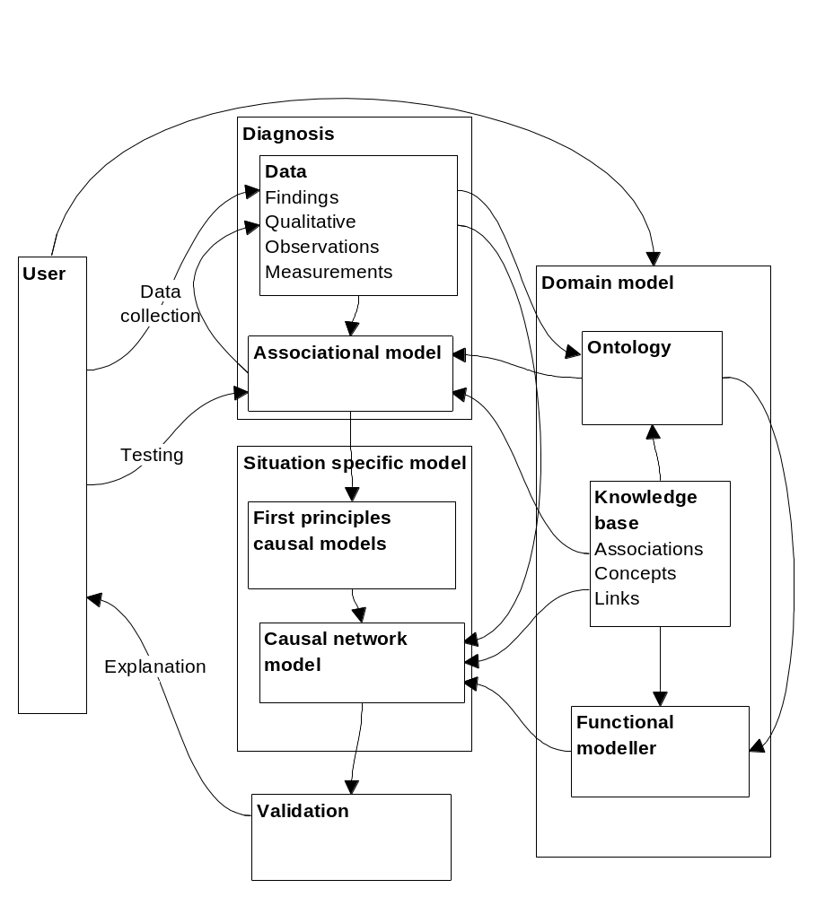
Figure 3.5 Components of ACIDEX showing data flows and processes.

Development
ACIDEX is implemented using an object oriented programming language, Java and a frame based knowledge representation tool, Protégé (Knublauch 2003). These tools support representation of concept maps which in this case are used to assist in the construction of some examples of associational and causal networks. The advantage of Java is that applications are platform (operating system) independent. A technology exists (Java Web Start) that allows Java applications to be launched from the internet. ACIDEX is able to communicate with Protégé through a programming interface, the Protégé API for the Protégé knowledge base editor. Technology exists to make Protégé knowledge bases available independently from the internet but implementing this feature is beyond the scope of this research. The Protégé knowledge base that supports ACIDEX is instead treated as a resource file by ACIDEX and downloaded as part of the application.

User interface
The user interface is passive, that is, it provides a set of tools. The user still has to take responsibility for assessing the value of information. The user’s role is to assemble relevant domain knowledge, collect data and evaluate outcomes. As such, the user has an ongoing responsibility in monitoring output from ACIDEX, assessing its usefulness, deciding what information to retain as part of an ongoing model, then asking the program to provide further information.

ACIDEX is designed to help the user assemble a situation specific model for a problem. At any point the user can review the progress of data collection, diagnosis or review because ACIDEX maintains the current status and shows this to the user. ACIDEX does not prescribe a sequence of steps but rather describes a group of interacting components with an overriding feedback or review property.

At the final implementation of ACIDEX described in this research project, case study data are coded directly into the program. This decision is discussed in the Conclusions, p 228.

Calculations
A calculation component performs buffer system calculations based on the Henderson-Hasselbalch equation to find if the pH buffer system is in or out of equilibrium. It can do this for single or paired data sets. A facility is provided for the user to input single sample buffer system data from additional samples for analysis by ACIDEX. This feature is included in ACIDEX to provide support for the user in carrying out the complex calculations necessary to determine how and to what extent the buffer system is being disturbed. This component also provides an initial differential diagnosis of the type of acid-base disturbance present. The main limitation of using the H-H equation is that other factors that may affect pH are not directly considered and in forming a diagnosis, other evidence to do with ionic composition are not considered.

The first version of ACIDEX was based on the findings from initial investigations that pH buffer system disequilibrium could be detected and measured. ACIDEX was able to carry out the calculations to obtain a theoretical pH value for a given data set. Similar programs in the medical field rely on the relatively stable and clear baseline conditions usually present in blood. However in natural waters there is a much wider variability in typical conditions. This was noted from some of the earlier measurements of buffer system parameters used to construct a pH buffer system nomogram. This necessitated a different strategy and the one adopted to extend ACIDEX was to allow comparison of the pH data from any two samples. The outcome of this approach is that any other conditions must be noted for each sample and that any inferences subsequently made are interpretable in that context only.

Diagnosis
The centre section of Figure 3.5 represents mainly the ‘constructed’ or situation specific component and specifies diagnosis and explanation functions. The diagnosis module has two components, first a low level diagnosis of buffer system disorders and secondly, a deeper diagnosis based on causal knowledge.

The low level diagnosis is based on an analysis of buffer system data. An initial hypothesis can then be integrated with associational data, linking findings to conditions to provide a more detailed hypothesis. Causal knowledge from the knowledge base is then integrated to create a situation specific model.

Validation
Validation is considered to be a function of the coherence of any explanation system. In the current implementation of ACIDEX no rigorous explicit methodology for validation has been specified. This is realistically an advanced function of the EP/LSS but one way to implement this feature would be to allow a trace along a causal chain from any chosen condition to any finding. At the final iteration of ACIDEX, validation is left up to the user, who must assess coherence in a qualitative way.

Knowledge base
In Figure 3.5 the right hand side represents the knowledge base of ACIDEX. The knowledge base is an independent sub component of ACIDEX. Its function is to retain key domain concepts and relationships collectively called domain knowledge. The structure of the knowledge base is described on p 199. The generalised knowledge in the knowledge base can include a wide range of data types including definitions, scientific data, descriptions, properties, associational and causal information. In ACIDEX the knowledge base is organised using a frame structure. Strictly speaking the knowledge base should not be described as a component of ACIDEX because the intent of this EP/LSS is ultimately to be able to access an independent collectively held structured knowledge base in the domain. For the purposes of this research project, because a separate knowledge base is not available, the knowledge base is, for simplicity considered a part of ACIDEX.

An ontology is usually considered to hold structural components and their relationships thereby creating a semantic network. In the context of this research project a knowledge base has a wider definition and can contain associational, heuristic and causal information. Most of this type of knowledge has to be assumed to be correct and representative of the real world. However, these relationships have to be made available for validation of some type, usually within a particular context.

The final implementation of the knowledge base contains mainly, some findings as measurements, symptoms and observations, some ‘clinical’ conditions including pH buffer disturbances and some associations linking them together. The knowledge base contains relatively little strategic or task knowledge, knowledge about treatments or interventions, or ecophysiological knowledge.

Summary of prototype development
Table 3.6 summarises and reviews the design criteria, stages and limitations for the key components of ACIDEX. Even though ACIDEX has had a small number of design iterations it has demonstrated some key capabilities, including developing initial hypotheses and accessing independently held domain information. As such it has a significant role as a research tool and constructed learning environment.

Table 3.6 Design of ACIDEX – summary of criteria and stages.
Component | Design criteria | Initial implementation | Final implementation | Review / limitations
Interface | Provide a set of tools. | For H-H calculations and initial diagnosis only. | Extended to show findings and conclusions to date. Allows exploration of the knowledge base. | Relatively unstructured. Does not provide any feedback on strategies.
Calculations | Provide an initial differential diagnosis. | Based on single sample. | Based on sample comparison. | Limited to H-H calculations and relative changes only.
Data collection and orientation | Allow guided fact finding by connecting conditions to findings. | Exploration of conditions and findings in the knowledge base, including definitions and other resources. | Users can choose as a starting point any conditions or findings then have the knowledge base display any linked concepts. | Limited by extent of development of the knowledge base. Limited to closely linked concepts.
Diagnosis | Establish a differential diagnosis based on buffer system disturbance. | Used H-H analysis only. | User can be guided towards candidate conditions causing disturbance. | Limited by buffer system and knowledge model adopted. Passive.
Explanation | Test any selected hypothesis by tracing a causal path from cause to findings. | Not implemented in first version. | Flexible trace from any component of the knowledge base, but only for a single step at a time. | Limited by ability of the knowledge base to represent causal chain as a temporal model. No explicit method to assess competing hypotheses.
Knowledge base | Provide a knowledge base of clinical, structural and heuristics to support reasoning. | Initially limited to conditions and findings considered relevant. Mostly ‘clinical’ knowledge. | Extended to some related concepts and structural knowledge. | No mapping or strategy knowledge. causal and associational knowledge mostly presumptive.

At its latest implementation ACIDEX is mainly limited as a research tool by having an interface that does not explicitly support tracking, monitoring and reporting user interactions. In addition, because the knowledge base at its final implementation is mainly limited to a small number of presumed associations and causal relationships, this limits the extent of the exploration and the conclusions that can be reached by the user.

Overview of research methods
In this research project the researcher originally planned to investigate the design of a performance support system to assist practitioners and learners address some common types of soil and water problems particularly those that related to plant growth and nutrition. The motivation was essentially a lack of suitable frameworks that were able to organise information and provide a higher level view of system level processes and behaviours. Whilst some system level thinking can be captured in heuristics or ‘rules of thumb’, this was considered to be an inefficient approach because of the difficulty of bringing together relatively unfocussed information. Literature searches showed that in the medical field the concept of ‘diagnosis’ is an important strategy in problem solving and that analysis of the blood pH buffer system was often used as the basis of reasoning about impairments or diseases. Therefore, although the basic goals of this research project stayed the same, the research strategy changed to become more focused towards grounding the proposed performance support system using low level causal knowledge about the chemistry of the processes that ultimately affect nutrients and nutrition.

This research project was also guided by some principles that were emerging in the educational literature, see Literature review p 63, that highlighted the importance of causal models and reasoning, knowledge models, competence modelling and situated cognition. In addition there was seen to be an imperative in this research to focus on practical problems and achieve practical outcomes.

In practical terms the goals of this research project were to build a prototype performance support system that also supported learning, an EP/LSS. A research methodology that supported design, development, trialling and review of such prototypes was required and this was found to be that of Design-Based Research. This methodology is really a set of principles guiding the study of learning in context, often using constructed learning environments.

Some initial measurements of pH buffer system data from a number of natural waters showed that buffer system abnormalities could be detected and measured. The initial design of the prototype ACIDEX specified a set of assumptions about interpreting pH buffer system data and established some necessary terminology. An architecture for ACIDEX also had to be designed and this was specified as a flexible arrangement of independent components that essentially supported a form of diagnosis. Importantly the architecture recognises three independent models, a user model, a situation specific model and a generalised knowledge model but does not specifically define the interactions between them.

ACIDEX was developed as an internet application to satisfy some implicit design goals. These were that the EP/LSS had to be widely available, ideally to people working on actual problems; the knowledge base component of the EP/LSS had to be potentially modifiable by users and become a property of the research community and that the prototype had to be kept up to date as new versions became available.

ACIDEX was also developed because there were few precedents of applications in the environmental field that support reasoning about causes. The design of ACIDEX requires that questions about the suitability and coherence of the knowledge base, user interface, reasoning strategy, diagnostic support and validation of findings be addressed. Therefore it is useful as a research tool, to study the process of developing a diagnostic system. Its limitations as a research tool relate mainly to aspects that are in their preliminary stages of development, such as, including help on strategies or tasks, extending the knowledge base to allow better representation of causal relationships, including better reasoning tools and including an interface that is able to report user interaction.

Chapter 4. Results
This section has two parts. The aim of the first part is to investigate the potential for using a pH buffer system analysis to detect disturbances in natural waters. To do this sample data are presented for different types of natural waters with an analysis to determine if the pH buffer system is in equilibrium. This is followed by a discussion of the assumptions needed to define and describe buffer system disturbances in water. The second part identifies and describes some of the key processes in water that potentially impact the pH buffer system.

Problem solving for water management
A review (see Literature Review) of approaches to understanding and managing soil and water pH and its implications reveals that water and soil management systems are often viewed as comprising simple associational knowledge. Consequently efforts in controlling water and soil pH often try to directly manipulate single factors. There is little evidence in natural systems management that the dynamic nature of systems, including feedback and internal regulation such as the regulation of pH, is taken into account.

In summary, the evidence for these approaches includes:

- pH is often seen as a static variable with a direct relationship between pH and nutrient availability.
- Treatments to adjust pH in water and soils often reflect a simple association and /or an empirical model of pH as a factor.
- Simulation based models that are sometimes used to predict changes in pH and acidity over time often do not incorporate knowledge about causes and mechanisms.

Progress towards a model based approach to problem solving hinges on development of explanations rather than descriptions and there is little evidence of this approach in natural resource management. The inherent complexity of environmental systems has been a constant impediment to developing system level models.

Sample data
The samples included a wide range of water types and situations including: Creeks, dams and springs to the east and south east of Melbourne, bores in Gippsland and NSW and bores and small lakes in suburban Melbourne.

These samples were used first to establish the principles of a coherent diagnostic framework and secondly, a subset were analysed in more detail .

Raw sample data included pH, dissociated CO₂, and bicarbonate. These data were collected using the methods for analysis described under Chemical analysis p. 104. Data are summarised in Table 4.7.

Table 4.7 pH buffer system data for samples from a series of natural waters.
Point No. | Sample No. * | Sample name | Actual pH | Calculated pH | CO₂ (ppm) | Bicarbonate (mol/l)
1 | 195 | Bore 4 | 7.03 | 7.67 | 11.7 | 0.0056
2 | 61 | Lake 1 | 7.4 | 8.0 | 3.7 | 0.0037
2a | 193 | Lake 1 after 1 month | 7.15 | 8.0 | 4.4 | 0.0045
3 | 169 | Dam 1 medium level | 7.01 | 7.23 | 7.9 | 0.00136
3a | 183 | Dam 1 full | 6.9 | 7.64 | 2.6 | 0.00116
4 | 301 | Creek 1 high flow | 6.84 | 7.49 | 4.7 | 0.00137
4a | 302 | Creek 1 low flow | 7.15 | 7.65 | 4.4 | 0.002
5 | 210 | Bore 1 fresh | 6.12 | 6.98 | 4.1 | 0.0004
5a | 212 | Bore 1 standing 24 hr | 6.65 | 6.78 | 5.85 | 0.00036
6 | 211 | Dam 2 | 6.55 | 6.29 | 16.2 | 0.00032
6a | 207 | Dam 2 after rain | 6.48 | 6.23 | 13.8 | 0.00024
6b | 213 | Dam 2 standing 24 hr | 6.8 | 6.92 | 3.8 | 0.00032
7 | 159 | Creek 2 | 6.68 | 6.65 | 7.0 | 0.00032
7a | 158 | Creek 2 at 5 m deep | 6.67 | 6.43 | 11.7 | 0.00032
7b | 208 | Creek 2 after rain | 6.54 | 6.67 | 5.9 | 0.00028
8 | 155 | Bore 5 | 7.2 | 7.51 | 10.25 | 0.0034
9 | 210 | Spring 1 | 6.62 | 6.13 | 20.55 | 0.00028

* The sample number is a unique identifier for a sample. It is held in a database of sites, samples and measurements that is maintained by the researcher.

Table 4.7 summarises the pH buffer system data for a number of natural waters. For each sample, the calculated pH is obtained using the Henderson-Hasselbalch equation. Figure 4.6 is a pH buffer system nomogram for the series of surface waters outlined in Table 4.7. Bicarbonate was graphed against dissociated CO₂ for the samples. Note that it would have been just as valid to plot pH on one axis then report the third factor as measured versus expected. But because the H-H equation is arranged to easily calculate expected pH it is easier and more intuitive to display data this way. For clarity only one calculated pH line (pH 7) is provided on the nomogram.
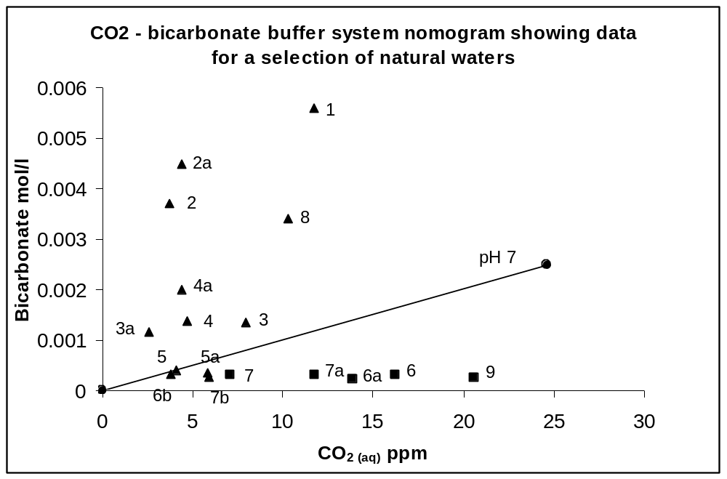
Figure 4.6 Bicarbonate buffer system nomogram for a selection of natural waters.

To assist interpretations – the H-H equation suggests that:
If calculated pH < actual pH this means the ratio (fraction) bicarbonate / CO₂ is lower than expected. Samples where this applies are mostly to the right and lower right of the nomogram. These data points are indicated with a square symbol .

For example point 5 - Bore 1 water from Maroota NSW. The point lies almost on the pH 7 line. In fact if the pH is calculated for this bore sample from bicarbonate and CO₂ measurements it is found to be 6.98. But the actual, measured pH was 6.12. This is a simple indication that the 3 buffer system variables are not balanced according to the theoretical buffer equation. A measure of the discrepancy is the distance or difference between pH 6.98 and pH 6.12.

If calculated pH > actual pH this means the ratio bicarbonate / CO₂ is higher than expected. Samples where this occurs are mostly to the left and upper left of the nomogram. These data points are indicated with a triangle symbol .

Of course the H-H equation can be used to calculate expected bicarbonate and CO₂ levels by holding the other two variables in each case, constant. Although it is unnecessary to actually do this, the following relationship and its reverse applies: If actual pH > calculated pH then actual CO₂ > calculated CO₂ and actual bicarbonate < calculated bicarbonate.

There are a number of preliminary findings from these data. Because these data come from a limited number of samples, interpretation is based on understanding how the pH characteristics of different samples can be potentially attributed to conditions that differ between samples.

- A number of the samples were out of pH equilibrium.
- Samples with higher CO₂ (lower right on the graph) seemed to be more likely to have a low bicarbonate / CO₂ ratio. This is the group where measured pH was generally higher than calculated pH and includes points 6, 6a, 7a and 9 . High CO₂ seems to be implicated in low ratios.
- This higher CO₂ group included water from distinctly different sources: From low within a deep dam, from an underground spring and from dam water taken at the edge of the dam. The suggestion is that the low bicarbonate / CO₂ ratio is being caused by different factors which are acting to raise the CO₂ levels.
- Samples with relatively little difference between expected and observed pH came from very different sources namely a bore, a farm dam and a creek. These were points 5a, 6b, 7 and 7b. This suggests that status of the bicarbonate equilibrium does not necessarily depend on the source, type or location of the water. The other explanation is that there may be opposing influences at work.
- Samples where calculated pH was larger than measured pH fell into two distinct groups: Those with low bicarbonate – including 3 flooding or diluted flowing waters points 3, 3a, 4 and 4a and those with higher bicarbonate, waters from bores and a lake, points 1, 2, 2a and 8. This strongly suggests that there are different factors at work disrupting the bicarbonate equilibrium.

Based on these preliminary data, disturbed equilibria exist and can be detected in natural waters and there is a strong prima facie case for pursuing the study of disturbances to the bicarbonate pH buffering system by using the approach offered by the Henderson-Hasselbalch relationship.

However as pointed out previously, it may be a much more challenging problem to understand buffer system disturbances in natural waters (and in the soil solution if the same theory is applied) compared to similar disturbances in the blood, mainly because of the much wider variation in factors such as pH. Amongst other issues are that ecophysiological systems are likely to be less coherent, composed of fairly independent processes and under less strict feedback control.

Types of acid – base disturbances
From a theoretical perspective, two major pH buffer disturbances can be identified:

1. Calculated pH is larger than measured pH (mostly upper left of the bicarbonate buffer system nomogram p 122). These samples are more acidic than expected because the equilibrium equation for the dissociation of aqueous CO₂ (p 124) is biased towards the right.

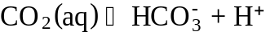 (4.6)

2. Calculated pH is smaller than measured pH (lower right of nomogram). These samples are less acidic than expected because the equilibrium equation is biased towards the left.

An introduction to types of disturbances and how they can be described using the Henderson-Hasselbalch equation was given in Section 2.13.1 starting from page 74.

The next stage of obtaining results is to revisit each of the main types of disturbances to identify possible and theoretical primary and compensating effects.

Disturbances in which the water is more acidic than expected
In some situations the calculated pH is larger than the actual pH. These samples tend to fit on the left hand side of the bicarbonate buffer system nomogram. Samples are more acidic than expected.

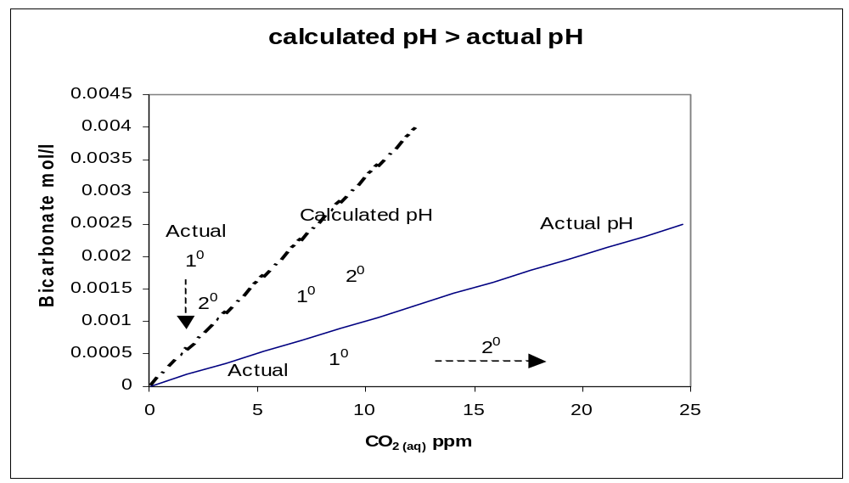
Figure 4.7 Buffer system nomogram for calculated pH > actual pH.

Figure 4.7 shows a simplified pH buffer system nomogram for waters in which the calculated pH is larger than the actual pH. Primary and secondary changes that may account for the difference between calculated and actual pH are indicated.

Presentation of a nomogram in this way is not often seen in the literature (and not at all in literature with an environmental theme) so this discussion presents information in a relatively new way. This allows the clarification of issues in the mind of any reader and any subsequent researchers for 2 reasons: 1. it is very difficult to understand and interpret chemical equilibria and especially situations where the equilibrium has been disturbed; 2 placing the discussion here should make it easier for the reader to see the project and its foundation concepts as a whole.

The following example shows how to interpret data on a pH buffer system nomogram. First assume that in a water sample measurements were taken of the actual pH, bicarbonate and dissociated or aqueous CO₂. The figures for bicarbonate and CO₂ have been plotted and intersect on the upper pH line. The pH value this represents can be calculated using the H-H equation and is hence the calculated pH. But the actual pH measured was lower; it sits on the lower isometric pH line on the nomogram. The actual pH is different to the calculated pH. A change has occurred to put the buffer system out of balance.

Further interpretation can be based on assuming different scenarios. First assume that bicarbonate has not changed recently in the sample. Where the actual (measured) bicarbonate value intersects the lower pH line draw a line down to the CO₂ axis. This is where the CO₂ value should be. Perhaps the CO₂ level has dropped from a previously higher value. Alternatively it might be bicarbonate that has changed. Draw a line up from the actual CO₂ value to the lower pH line then across to the bicarbonate axis. This could be the value for bicarbonate before it has risen due to some factor. Of course it may be that both bicarbonate and CO₂ were originally different and that both have recently changed.

There are three possible basic scenarios to account for the bias in the CO₂ – bicarbonate buffer equation towards the right: The simple model of acid-base disturbances assumes that at least one primary change can be identified and that it is expected that this initial change is compensated by at least one other secondary change.

1. Lower than expected pH. A way to interpret this is to say that some factor has increased the amount of H⁺ ions present, or there has been a primary rise in H⁺. According to the simplified H-H relationship above, this primary change should be compensated by either a fall in bicarbonate or a rise in CO₂, or both.

2. Higher than expected bicarbonate. A primary increase in bicarbonate is assumed. Compensations are therefore either an increase in pH (lower H⁺) or an increase in CO₂.

3. Lower than expected CO₂. Compensations are a decrease in bicarbonate or a decrease in H⁺ (increase in pH).

These scenarios are summarised in the following table:

Table 4.8 Theoretical primary and compensating changes for waters more acidic than expected.
Primary change | Compensating change | Compensating change
H⁺  | Bicarbonate  | CO₂ 
Bicarbonate  | H⁺  | CO₂ 
CO₂  | Bicarbonate  | H⁺ 

Disturbances in which the water is less acidic than expected
In some situations the calculated or expected pH is smaller than the actual or measured pH. These waters are in the lower right in the bicarbonate buffer system nomogram and are less acidic than expected. The diagram shows the 3 main primary disturbances possible using the equilibrium model and possible secondary responses.

Figure 4.8 shows a simplified pH buffer system nomogram for waters where the calculated pH is smaller than the actual pH. Three possible scenarios can be constructed to account for the shift in the bicarbonate buffer system to the left.

1. A primary drop in H⁺ or at least H⁺ lower than expected. Compensations in this case are a rise in bicarbonate or a fall in CO₂.

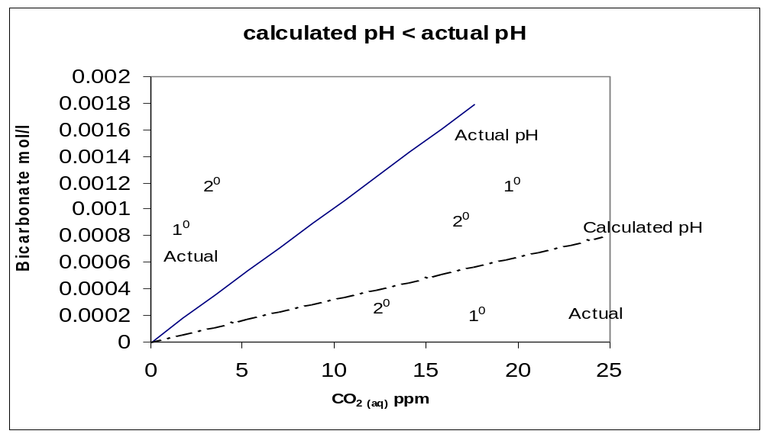
Figure 4.8 Buffer system nomogram for calculated pH < actual pH.

2. A primary drop in bicarbonate compensated by a rise in H⁺ (drop in pH) or a drop in CO₂.

3. Primary rise in CO₂ compensated by either a rise in bicarbonate or an increase in H⁺.

These scenarios are summarised in the following table:

Table 4.9 Theoretical primary and compensating changes for waters less acidic than expected.
Primary change | Compensating change | Compensating change
H⁺  | Bicarbonate  | CO₂ 
Bicarbonate  | H⁺  | CO₂ 
CO₂  | Bicarbonate  | H⁺ 

A number of examples representing different pH disturbances or pH buffer status have been tentatively identified for further study. These are discussed under Chapter 5 Applications p 147.

Terminology and relationships to other studies
There are some similarities between the results of this research project and some findings for blood gas related disorders. In the body, effects resulting from changes in CO₂ concentration are called ‘respiratory’ because gas exchanges take place in the lungs. Effects arising from changes to either H⁺ or bicarbonate concentrations are caused by ‘metabolic’ processes, for example, secretion or retention of ions by the kidneys.

For example, an unusual or abnormal rise in CO₂ followed by a partial compensating rise in H⁺ will lead to a form of acidosis in the blood. Acidosis means an acidifying effect or tendency. In this case it is called a ‘respiratory’ acidosis. In the absence of a better description for natural waters this is a convenient term to adopt for this research project. An acidosis may be caused by processes directly adding to or raising H⁺ concentrations. In the body this is called a ‘metabolic’ acidosis.

Also noted in blood pH disorders is an alkalosis or tendency to create alkaline conditions. This is often caused indirectly by an increase in bicarbonate secreted from the kidneys. The assumed mechanism is a compensatory fall in H⁺ resulting in a rise in pH (more alkaline conditions). In the body an alkalosis may be caused by processes in the lungs which expel more CO₂, for example, an increased breathing rate.

Because there is not a suitable terminology to describe parallel effects in water, some medical terminology will have to be borrowed. The terms acidosis and alkalosis have been traditionally used to describe pH disturbances in blood and body fluids although there may be no reason why they can not be used generically.

Summary
Acidity in water can change from direct and indirect (compensating) effects. The main anticipated effects are summarised in Table 4.10.

Table 4.10 Summary of main and compensating effects that change acidity in water.
Water with.. | Acidity will rise if .. | Acidity will fall if ..
pH calculated > pH actual  - more acidic than expected | Primary H⁺ rise | 1. H⁺ fall as compensation for CO₂ fall.  2. H⁺ fall as compensation for bicarbonate rise.
pH calculated < pH actual  - less acidic than expected | 1. H⁺ rise as compensation for CO₂ rise.  2. H⁺ rise as compensation for bicarbonate fall. | Primary H⁺ fall

Under normal conditions it is more likely that bicarbonate will be consumed or produced as a consequence of the two way dissolution reaction of calcium carbonate. This is more likely to show up or contribute as a longer term chronic effect on pH. Therefore bicarbonate is not likely to be a primary factor that alters pH unless, for example some bicarbonate as a solution is directly added. It is probably more meaningful to talk about a sustained capacity or a limited capacity to produce or consume bicarbonate rather than any short term rise or fall.

A significant outcome of this model for other studies in aquatic ecology is that it provides a framework for recognising and understanding the process of buffering in natural waters, relating it firmly within the theory of buffer system function and disturbances.

Whilst the Henderson-Hasselbalch equation can help explain how these relationships between primary and compensating effects can develop (see the simplified H-H relationship p .74) it does not yet provide a set of rules for ACIDEX to implement, but rather classify the important theoretical changes to the pH buffer system.

Major disturbances
Data from the case studies has provided evidence of buffer system disorders in water similar to those seen in blood. A preliminary and more coherent model of disorders can now be presented for further analysis.

Two main types can be identified: those causing an increase in acidity and those causing a lowering of acidity. Both types can be disturbances on the gas exchange (CO₂) side or on the mineral ion side (including, for example, direct alteration of the H⁺ level).

Acidosis
Acidosis is caused by increasing or elevated CO₂ levels (called CO₂ acidosis). In this case H⁺ ion rises (as a compensation in the CO₂ – bicarbonate buffer system) in response to cause an increase in acidity. CO₂ acidosis is detected by comparing the calculated pH using the H-H relationship to the actual pH. A CO₂ acidosis can result in actual pH > calculated pH (other factors can cause the same discrepancy).

An acidosis may also be caused by a direct increase in H⁺ levels, for example, by addition of H⁺ from an external source. This can be termed an H⁺ acidosis. It is one of the factors which can cause the water to be more acidic than expected, that is, actual pH < calculated pH.

Alkalosis
A primary drop in CO₂ levels will cause a rise in pH if H⁺ falls as a compensation. This can be termed a CO₂ alkalosis (borrowing medical terminology). It is indicated as a possible cause if measured pH is lower than that expected by calculation.

Theoretically an alkalosis can be produced if H⁺ ion is directly removed or neutralised. This process requires the H⁺ to be removed by direct neutralisation by a strong alkali. In this case measured pH will be larger than calculated pH.

Table 4.11 summarises the main pH buffer system disturbances and mechanisms where water is found to be more acidic than expected by calculation.

Table 4.11 pH buffer system disturbances and mechanisms for waters more acidic than expected.
Disturbance | Main mechanism
H⁺ acidosis | Acidification – direct input of H⁺ ion.
HCO₃⁻ surplus | Neutralisation through CaCO₃ dissolution.
CO₂ alkalosis | Compensatory decrease in H⁺ due to loss of CO₂.

Table 4.12 shows the main disturbances and mechanisms where water is found to be less acidic than expected.

Table 4.12 pH buffer system disturbances and mechanisms for waters less acidic than expected.
Disturbance | Main mechanism
H⁺ alkalosis | Neutralisation – direct input of a strong base, for example OH⁻.
HCO₃⁻ restriction | Low availability of CaCO₃ for dissolution.
CO₂ acidosis | Compensatory increase in H⁺ due to rise in CO₂.

Mechanisms
This section describes the mechanics of how the types of disturbances can occur and provides some preliminary tools for measuring the degree of change.

Compensation versus buffering
Compensation by the buffer system can occur at two levels. For example, according to the H-H equation, a rise in CO₂ will trigger a rise in H⁺ but the increased H⁺ will then be partly removed by carbonate dissolution. In low buffer capacity waters, (those with low bicarbonates), the initial compensation may be more pronounced. In the case of rising CO₂ this will noticeably increase acidity. But in highly buffered waters the 'true' buffer system will resist acidity changes.

Data from two case studies demonstrate this effect. Water from Bore 2 (Gippsland Lakes) is poorly buffered compared to water from Bore 3 (eastern suburbs of Melbourne). When Bore 2 water is aerated the pH rises considerably but when Bore 3 water is aerated the pH rises only very slightly.

The main reactions in the pH buffer system have been described on page 67.

Acidifying disturbances
A CO₂ acidosis theoretically occurs due to a compensating rise in H⁺ when dissociated CO₂ rises. If CO₂ is produced in water too quickly for natural diffusion to remove it or if the water is isolated from the air then it is presumed that a larger proportion dissociates. Both bicarbonate and H⁺ rise to compensate in order to maintain equilibrium. The intensity and duration of the acidosis depends on how fast H⁺ rises and to what extent it is itself compensated.

For example, again borrowing medical terminology, an acute acidosis occurs when H⁺ rises relatively quickly and there is not time for the carbonate dissolution system to compensate by removing the H⁺. Recall that calcium carbonate dissolves only very slowly. A chronic acidosis could be defined as a low pH condition which has developed because of a persistent elevated CO₂ level. In this case it is assumed that the carbonate dissolution system is working too slowly or has reached its capacity to remove H⁺.

If the rise in H⁺ is completely compensated or buffered by dissolving carbonates then it is expected that for every two H⁺ ions produced, two bicarbonate ions are produced: one from conversion of CO₂ and one from dissolving of carbonates.

In an H⁺ acidosis, increase in H⁺ is a primary change caused by a direct addition of H⁺ over prior levels. This change can be compensated by two mechanisms. First, to balance the aqueous CO₂ – bicarbonate system, CO₂ rises and bicarbonate falls. Secondly, the external carbonate dissolution system attempts to remove H⁺ by dissolving carbonate and replacing H⁺ with bicarbonate. Again the intensity of the acidosis is likely to be affected by how much capacity there is on the gaseous side to accommodate a rise in CO₂ and on the carbonate side to remove H⁺ ions.

Acid lowering disturbances
A CO₂ alkalosis results when a drop in CO₂ is compensated by a drop in H⁺ as the buffer system tries to adjust. The severity of this type of alkalosis is reduced if bicarbonate is available and is converted to H⁺ to replace lost H⁺ ion.

Acidity can be lowered by addition of an alkali or acid neutralising agent. Examples are the addition of lime to swimming pools or drinking water and the addition of lime to agricultural soils. In these reactions H⁺ ions are neutralised directly. The type of lime required is the type which dissociates to produce a strong neutralising ion like OH⁻.

Measuring the amount of compensation
Just how much of the drop in H⁺ is buffered by bicarbonate loss? In theory, for each H⁺ ion lost back to aqueous CO₂, two bicarbonate ions are used up (one goes to CO₂ and the other replaces the lost H⁺). If all lost H⁺ is replaced then the amount replaced can be calculated as ½ bicarbonate loss. Bicarbonate loss also accounts for the drop in H⁺, measured as pH.

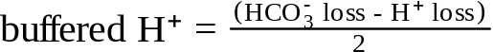 (4.7)

This equation gives us a simple way to use the measured drop in bicarbonate together with the drop in H⁺ to estimate how much compensation or resistance there has been to the loss of H⁺. The same relationship can be used to quantify the amount of buffering when acidity rises.

Implications
It has been seen how increasing and decreasing CO₂ levels in water can potentially alter the water’s pH. The effect is modified by both the speed of change and the amount of buffering by the carbonate system. Interestingly it is not so much the pH which is significant in controlling dependent processes, but the degree to which the buffer system is not able to cope to restore equilibrium. This effect is better appreciated by using the proposed equilibrium model of pH change.

A useful way to think of pH and acidity is by comparing them to temperature and heat. Heat is like acidity in that it represents a quantity to be compensated or overcome. This is important because a considerable amount of emphasis is placed on measuring and reporting pH in fields like agriculture and aquaculture. There is a difference between acidity measured as pH and acidity as an amount which has to be compensated or overcome to change pH – for example by liming.

Although the notion of quantity of acidity is not a new idea, a model based approach using equilibria to this problem in agriculture is new. Agronomists have long been challenged by the notion of calculating the amount of lime to apply to change the pH in a given soil. Usually this is done, either by trial and error, or empirically by mixing the soil with a buffered solution and measuring how the pH changes. The limitation of this approach is that it does not consider what is causing the acidity to be what it is or the rate at which it is possibly changing.

Processes that add or subtract H⁺ ions have the potential to change the relative proportions of ions in solution and therefore can affect other processes which change the ionic balance. An acute acidosis resulting from a small night time rise in CO₂ levels may not have such a dramatic effect on processes involving nutrient cycles as a chronic, partly uncompensated acidosis due to long term build up of CO₂.

Identifying and describing buffer system disturbances

Strategies
The Henderson-Hasselbalch equation provides a potentially powerful tool for understanding buffer system disturbances in natural waters. But the first step is to set out a strategy for working with the equation so the results can be effectively integrated into any subsequent diagnostic system.

A suggested strategy is as follows. For any single water sample:

1. Determine if the bicarbonate buffer system is in balance by calculating pH using the H-H equation. Compare this to the actual (measured) pH.

2. Look up the possible primary disturbances based on calculated pH being either greater or less than measured pH. Three main disturbances are associated with each condition. They can help to either diagnose or explain a given situation. But each possibility needs to be tested (see Diagnosis p 208).

3. Look for any unusually high or low values, particularly pH or CO₂, or note any values expected, assumed normal or anticipated. For example, unexpected high or low values may suggest one disturbance over another. One difficulty with this approach is that it may not be possible to know what is ‘normal’ under particular conditions. For example, the pH buffer system may be balanced with high CO₂. At least two bore water samples outlined in the case studies were like this.

Using the H-H equation like this provides only a snapshot of the situation and does not show how any of the variables have changed or will possibly change. If data can be obtained from the same water body at different times or conditions then changes in the parameters of the H-H equation can be noted and any original hypotheses can be retested. The goal is to understand how any two ‘states’ are related. In the absence of a second data set the original data could be compared to an average or ‘normal’ condition.

For any two samples from the same water body but under different conditions such as time or space:

4. Use qualitative data on changes between any of the 3 main parameters (pH, bicarbonate and carbon dioxide) to assess the amount of compensation present and the severity of any changes. Look at any historical data to determine if changes are short term or persistent. With this method it may be possible to designate primary and secondary compensating changes as predicted by the buffer system equilibrium model.

Choosing a model
Either a right hand side RHS or left hand side LHS analysis can be applied to data. This is a convenient but arbitrary scheme based on the tendency of water samples to be distributed to the left or right of the buffer system nomogram. The question is, what criteria should be used to choose between LHS or RHS models? It is probably not adequate to consider the relationship between calculated pH and actual pH in deciding.

However, ACIDEX has to use the calculated pH versus actual pH criteria when choosing a model for a single sample. Note that these choices of models are based on assumptions and can only be regarded as suggestions.

If two samples are available then they can be compared. One has to be the ‘focus’, that is the water sample whose conditions the investigation is trying to explain while the other acts a reference. The second sample is chosen to represent a change in time for example, day / night or space such as water taken from the top layers and bottom layers of a dam.

A LHS model means that any primary changes will result in the buffer system reaction as described in the buffer system equation

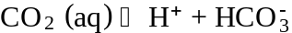 (4.8)

becoming biased towards the right. It is relatively easy to see changes to CO₂ (a fall) and bicarbonate (a rise) on the nomogram because they are plotted directly. But the same calculations will also suggest a LHS model if the H⁺ concentration rises between samples. This is not so obvious to see on the nomogram because it is difficult to clearly depict all the relationships in a simple diagram. For a RHS model the reverse reasoning applies.

Multiple primary disturbances
Where application of either a RHS or LHS model shows two or more primary disturbances are present then the investigation is forced to delve deeper to interpret these changes because they include net changes. Consider the possibility where application of a LHS model reveals a drop in CO₂ and a rise in H⁺ (both primary changes). According to the equilibrium model each is a possible compensation of the other. The measured CO₂ and H⁺ levels are therefore assumed to be net changes. Further interpretation has to be based on analysis of the relative changes in molar concentrations. However in this case both primary changes contribute to change in the calculated pH in the same direction.

Composite disturbances
It is theoretically possible to have a primary H⁺ acidosis coupled with a CO₂ acidosis. These two primary changes are additive in their effect but the equilibrium model may not reveal an equilibrium imbalance. Again a possible solution is to draw on knowledge of molar concentrations of components.

Distinguishing between causes
The model underlying ACIDEX is able to distinguish between changes to acidity caused by CO₂ changes or direct change to H⁺ concentration. As yet the model does not distinguish between sources of acidity, whether mineral or organic in origin. This can potentially shed light on the nature and the cause of the buffer system disturbance. In the blood, under some circumstances organic acids can contribute to acidity. A technique has been developed in the diagnosis of particular medical diseases which examines the amount of acidity in the blood in relation to the balance between other positive and negative ions. The accepted measurement is called the ‘anion gap’ (see Martin 1999) and is used to assess whether a greater than normal amount of acidity is being contributed by organic acids. Organic acids are a common component of some natural waters but there is no precedent for using an 'anion gap' approach in determining their contribution. It may be possible to use this method to account for organic acids in water which are not part of the normal bicarbonate buffering system.

Knowledge base
ACIDEX derives its inferring capability from two key components. These are an understanding of the chemistry of the pH buffer system, and a knowledge base of relevant domain concepts. This section identifies some of the key concepts that can make up a knowledge base.

Domain concepts
The focus here is on the development of a structural representation in the domain which is problems related to disturbances and consequences in the acid / base / charge balance in water and soils. The representations should support inferring about likely causes of disturbances or imbalances in the main examples and case studies. Structural knowledge encapsulates the semantics of the domain, especially the relationships, properties and connections between components. Useful structures may include some description of chemistry, mechanisms, players, abnormal / disturbed conditions and may also include causal representations. The components of a suitable knowledge base have been outlined on p 105.

Development of the knowledge base includes use of suitable hierarchical and network representations. Arrangements of concepts are really models which include components, states and causal relations. The concepts outlined here are not exhaustive and in addition may be defined at different levels of resolution. Normal and abnormal ecophysiological conditions can be represented linking a variety of other information into a suitable ‘concept’.

Key processes in natural waters
A large number of processes occur in water. Which of these processes are key processes or represent unifying concepts? Some of these aspects include:

- REDOX / pH relationships
- Gas exchange
- Solubility of metals
- Photosynthesis
- Respiration

pH – REDOX relationship
An important relationship in natural water is the pH – REDOX relationship. pH and REDOX are key parameters of aquatic systems because of the central importance of acid-base and REDOX chemistry. Because REDOX reactions often include transfers of H⁺ ions they can influence the pH buffer system. The tendency of REDOX reactions to proceed is often estimated from measurements of electrical potential in millivolts.

Figure 4.9 is a pH – REDOX (ORP) phase diagram for natural waters. It shows the theoretical limits of pH and REDOX as well as the range of each parameter expected in various environment types. This type of diagram is sometimes called a stability diagram. pH and REDOX potential are interrelated in a way that can be described by various chemical equilibria theories. Evangelou (1998) has provided an in depth treatment. The relevant point of stability diagrams is that a wide range of pH – REDOX combinations can be expected in natural waters. Certain combinations indicate more extreme conditions such as highly reducing conditions, found in sediments. If pH and REDOX figures are available at least these diagrams provide some indication of normality or possible problems for a given situation.

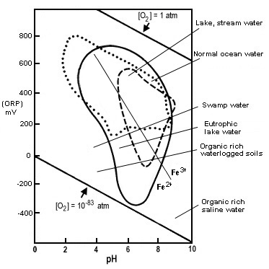
Figure 4.9 pH - REDOX phase diagram for natural waters. Adapted from Langmuir (1997).
Interpreting REDOX measurements in water and soil is less precise than for pH. It is thought that the overall REDOX measurement is made up of potentials from a large number of REDOX reactions. This means, for example, that it may be difficult to predict what is happening in the Fe²⁺ - Fe³⁺ system based on the overall potential. Not only that but REDOX reactions proceed according to equilibrium rules somewhat similar to those for acid-base, pH forming reactions. Therefore a REDOX system like the Fe²⁺ - Fe³⁺ system could itself be out of equilibrium. It is thought that these unbalanced states are what provides opportunities for some micro-organisms to extract energy and facilitate chemical reactions. For a more detailed analysis of these aspects see Evangelou (1998). Any future development of this research project would benefit from better models which take into account the influence of REDOX potential.

The above model of REDOX – pH relationships is a generalised model and in addition, there can be difficulties with measurement and interpretation of data. If data from a sample are entered on the graph there is no way of saying that the situation is normal or abnormal for that sample. There is also no way of deciding what any future movements might be. This is an argument in support of situation specific models.

Factors affecting acidity
Many processes either produce or consume acidity and these include many natural processes. Langmuir (1997) has provided a summary of some of these.

Under normal conditions there is a balance between release and uptake of acidity. It is only when a process is stressed or overloaded, or when some compensating mechanism is unable to counteract changes that a net increase or decrease in acidity can occur. This can also occur if some factor prevents a pH balancing process from occurring for example because of nitrate leaching see p 59.

Table 4.13 shows some examples of natural processes occurring in water that change or have the potential to change pH. Some of the mechanisms for these processes are shown. Many of these processes involve REDOX reactions. This partly explains the close connection between REDOX and pH.

Table 4.13 Some natural processes and mechanisms that potentially change pH.
Process | Effect on pH | Reason
Photosynthesis | pH up | REDOX - removes CO₂
Respiration including aerobic decomposition | pH down | REDOX - increases CO₂
Methanogenesis and anaerobic decomposition | pH down | Increases CO₂
Nitrate uptake | pH up | Consumes H⁺
Denitrification | pH up | A REDOX reaction consuming H⁺
Sulphate reduction | pH up | Consumes H⁺ sometimes in sediments
Calcite dissolution | pH up | Consumes H⁺
Calcite precipitation | pH down | Produces H⁺ sometimes in response to high photosynthesis rate
Nitrification | pH down | A REDOX reaction producing H⁺

Actual changes in acidity are still net results and there may be different levels of compensation. A simple example of this is seen in the method for determining CO₂ in water (an important part of this project). A moderately strong base is added to neutralise H⁺ in solution and it is assumed that fully dissociated CO₂ is readily converted to supply H⁺. If the solution is left for a short time, dissolved CO₂ already present in the water then takes the place of the dissociated CO₂ bringing conditions slowly back to normal.

Some disturbances of natural water
There are a number of processes which can be defined as causal factors for disturbances. Some are well known and well described, for example, acid mine drainage. The overall effects of others may only be assumed. The situation is complicated by interactions between factors or long causal chains. Some of these factors are described in Table 4.14.

Table 4.14 Environmental processes affecting pH in water.
Disturbance or condition | Anticipated effect on pH | Mechanism
Acid rain | Decrease (more acidic) | Direct increase in H⁺
Fertiliser runoff | Decrease or increase | Increase if algae stimulated
Manure and organic matter runoff | Decrease | Organic acids, increase in respiration (CO₂ decrease)
Organic matter breakdown in soils and water | Decrease | Organic acids, decomposition and respiration
Eutrophication | Increase  Decrease | High photosynthesis rate  decomposition
Organic pollution of water | Decrease | Organic acids, decomposition and respiration
Rising CO₂ levels in air | Decrease | Higher proportion of dissociated CO₂ in water
Turbidity | Decrease | Favours respiration
Other pollutants | may vary
Application of lime | Increase | Neutralisation
Acid mine drainage | Decrease | Direct increase in H⁺
Reduced CO₂ levels in water | Increase | As compensatory decrease in H⁺
Increased CO₂ levels in water | Decrease | As compensatory increase in H⁺

Structural components
The function of a knowledge base is to supply the concepts, data and links to construct intermediate views between observations and ‘clinical’ states which will ultimately help us to understand both normal and abnormal ‘physiology’.

For example, for a problem to do with the diagnosis of iron deficiency, the knowledge base should be able to supply:

- Concepts covering normal physiology of iron. Normal reactions and conditions resulting in a balanced supply of iron.
- Concepts covering abnormal physiology of iron. For example circumstances under which iron may become excessive or become deficient or otherwise create undesirable conditions.

Summary
Measurements taken in a variety of natural waters and analysed using the Henderson-Hasselbalch equation have been presented using a buffer system nomogram. Significantly, calculations of expected pH show that many of the samples are not in pH equilibrium. The analysis provides prima facie evidence of the types of acid-base disturbances seen in blood as a result of respiratory or metabolic disorders. The results indicated that different types of buffer system disturbances can be detected in natural waters and make the water either more acidic or less acidic than expected. In addition the results indicate that similar factors may be responsible for disturbances in different situations.

To use the disturbance model first requires defining the terminology for disturbances and to do this some medical terminology has been borrowed. The disturbance model outlined defines primary effects and expected compensations and describes how these can be interpreted as changes to pH. Based on evidence from field data and the interpretive framework described, it is therefore possible to apply the relatively simple model of buffer system function to predict and characterise some possible types of disturbances in natural waters.

Because there are no precedents for using a scheme such as the one outlined for natural waters and because baseline or normal conditions are difficult to specify, it is necessary to outline an investigative strategy. This strategy, when applied to understanding differences between samples, has to take into account the theoretical interpretation of the H-H results, qualitative data on unusually high or low values and relative changes in the three key H-H parameters pH, bicarbonate and carbon dioxide.

A number of natural processes have the potential to change acidity. The main mechanisms are through changing CO₂ levels or direct changes to H⁺ ions. In the first case pH changes through compensations of the pH buffer system. In the second case the pH changes can be caused by processes that directly add or neutralise acidity or in a situation where production and consumption of H⁺ is not balanced because of disruption to a process. While many of these processes can be understood at the level of the chemical reactions involved, the overall effects of others may be less clear because they involve many steps.

Chapter 5. Applications
The applications and case studies described in this section are designed to show how the proposed method for model based diagnosis can be applied. In the context of this research they are essentially an exploration of the methodology proposed earlier to explain the causes of buffer system disturbances. Therefore this section has two functions. These are:

1. To provide further evidence to show how a buffer system analysis can provide the basis for a better understanding of factors affecting pH in a variety of different situations and under different environmental conditions.

2. To look for evidence to test the assumptions that underpin pH buffer system analysis. These have been outlined in Chapter 4 Results.

The case studies provide examples of the types of buffer system disturbances likely to be found in natural waters. The cases are completely open ended and the examples below show some of the interpretations that can be made from studying and comparing different samples. This section provides background data and other test results for the case studies described in Table 3.5. The data is also available for analysis in the ACIDEX application accompanying this research project.

Some of the cases were subjected to a more detailed analysis and these findings are described in Section 5.2. The underlying relationships of interest involve factors that change acidity and for the extended case studies, the effect those acidity changes have on particular aspects of system function including metals and or nutrient cycling and availability. The examples implement the problem solving methodology proposed in section 3.4.3.

Given that diagnosis is primarily a modelling process, the outcomes or models described below for particular cases should only be considered tentative or partial explanations. These applications bring together assumptions concerning pH buffer system equilibria and some mostly tentative associations and causal relationships. The results are some tentative diagnostic models constructed to create plausible explanations of how particular situations have developed. In addition the process of working through applications is part of this research process as well as part of the results. Thus a key outcome of these analyses are lessons that will contribute to a better design for a learning environment for tackling related types of water quality problems. This idea is encapsulated in the methodology adopted for this research project, Design-Based Research specifically as it relates to the objectives of prototyping learning environments.

The method of diagnosing acid-base disturbances described previously in section 4.2 is based either on data from single samples or from comparisons between two samples. There is no rule about when and where any two samples should be taken only that it is assumed there will be some noticeable or predicted differences between the two conditions which will allow some inference about causes to be made. In the longest studied case, Case 9 Dam 1 – described on p 178, samples were analysed over a three year span (some with and some without pH buffer data) but only a few are used in the workup of data. So the overall view of water quality in this dam is built up out of a number of fragments each designed to explain changes within distinct periods or due to identifiable or significant changes.

Case studies
The cases represent a number of situations including a suburban creek, a large lake, smaller spring fed dams, a creek draining agricultural land, a deep dam on that creek and bores. A series of buffer equilibrium analyses are provided that include initial hypotheses but these analyses are not exhaustive.

Case 1 – Creek 1
Creek 1 is a small suburban creek in the eastern suburbs of Melbourne. It is subject to runoff from large residential areas and experiences great fluctuations in flow rate. Data was collected from Creek 1 on two occasions. The first was when the creek was in flood after heavy rain in August and the second was when the water level was low after a period of dry weather in November of the same year. pH buffer data collected under the two conditions are presented in Table 5.15.

Table 5.15 pH buffer system data from Creek 1 for low and high flow conditions.
 | Sample 302 Low flow | Sample 301 High flow
pH measured | 7.15 | 6.84
pH calculated | 7.65 | 7.49
Bicarbonate | 0.002mol/l | 0.00137 mol/l
CO₂ (aq) | 0.0001 mol/l  4.4 ppm CO₂ | 0.000107 mol/l  4.7 ppm CO₂

Sample 301 was taken first and the initial question was what happens to the creek water when the creek floods? The pH calculation suggests that there should not have been as much acidity as was actually measured with a pH meter (calculated pH was higher than actual pH).

Possible buffer system disturbances are:
H+ rise → H+ acidosis
Bicarbonate rise → increased buffering
CO2 fall → CO2 alkalosis

One possibility is that something else is contributing to acidity other than the carbonate system, or that either there is an excess of bicarbonate coming from somewhere (this would raise the ratio bicarbonate / CO₂) or something is suppressing the carbon dioxide (to again raise the ratio). Analysis at this stage suggests these 3 possible reasons for disturbance of the acidity regulation of this water however it is not possible to conclude why this has happened or what has caused it.

Subsequently, data for low flow conditions became available. Both samples lay to the LHS of the buffer system nomogram with pH calculated > pH actual. The focus was still on explaining the flooded condition. Different conclusions can be reached depending on whether a RHS or a LHS buffer system model is applied.

By applying the left bias (LHS) model the only primary change noted (when working from low to high flow) was a rise in H⁺ under flood conditions. The two other changes, a fall in bicarbonate and a rise in CO₂ can be seen as compensating factors for the primary rise. These changes are summarized in Table 5.16.

Table 5.16 Primary and compensatory pH buffer system changes noted for Creek 1 under flooding conditions.
Primary change | Present | Compensating change | Present | Compensating change | Present
H⁺  |  | Bicarbonate  |  | CO₂  | 
Bicarbonate  |  | H⁺  |  | CO₂ 
CO₂  |  | Bicarbonate  |  | H⁺ 

Hypothesis 1: These observations can be tentatively explained as an H⁺ acidosis (results in a drop in pH) caused by an increase in H⁺ ion. This happens quickly and may be related to rainfall. Compensations are due to re-organisation of the CO₂ - bicarbonate buffer system and don’t involve the carbonate dissolution system. So the primary effect is only partly compensated. Bicarbonate ion is assumed to be converted directly to the aqueous CO₂ phase along with a similar amount of H⁺ ion thus preventing the influx of H⁺ from excessively lowering the pH. The fall in bicarbonate is around 100 times the rise in CO₂ and therefore this change remains unexplained.

However if the right bias (RHS) model is applied a different result is noted. This is the ‘intuitive’ model to use because there appears to be a movement towards a left bias in the bicarbonate buffer system. This approach at least partly accounts for observations in terms of two primary changes. These changes are summarized in Table 5.17.

Hypothesis 2: An acidosis occurs because of the combined effects of an increase in CO₂ and a decrease in bicarbonate. The changes in these latter two components are assumed to be net changes.

Table 5.17 Primary and compensatory pH buffer system changes noted using an alternative model for Creek 1 under flooding conditions.
Primary change | Present | Compensating change | Present | Compensating change | Present
H⁺  |  | Bicarbonate  |  | CO₂ 
Bicarbonate  |  | H⁺  |  | CO₂ 
CO₂  |  | Bicarbonate  |  | H⁺  | 

This hypothesis is less appealing because the greatest change was in H⁺.

Case 2 – Lake 1
This example is water from a lake in a large privately owned facility in eastern suburban Melbourne. The water is used for irrigating extensive areas of grass, lawns and gardens. Water is pumped from 2 bores into the main lake and this is supplemented with water collected from buildings and runoff areas. To conserve water some is pumped to a higher holding lake and this is returned to the main lake according to demand. Some of the water runs off from irrigated areas and some finds its way back to the lakes through seepage. Therefore the water is partly recycled.

The main concern the users had with this water was the relatively high dissolved inorganic phosphate levels. Phosphate may be an unwanted growth stimulant both in recreational turf areas and in water where it is implicated in the development of algal blooms and eutrophication.

Data for the pH buffer system collected at the main pump shed in September and October 2004 are shown in Table 5.18.

Table 5.18 pH buffer system data from Lake 1.
 | Sample 61 September 2004 | Sample 193 October 2004
pH measured | 7.4 | 7.15
pH calculated | 8.0 | 8.0
Bicarbonate | 0.0037 mol/l | 0.0045
CO₂ (aq) | 0.000083 mol/l  3.7 ppm CO₂ | 0.0001mol/l  4.4 ppm CO₂

On the bicarbonate buffer nomogram on page 122 these samples are at top left. Calculated pH is larger than actual pH meaning that this water is more acid than expected. pH fell between September and October but bicarbonate (greatest increase) and CO₂ increased (second largest increase). If sample 193 is examined it is apparent the buffer system is out of equilibrium.

There are two ways to interpret the changes observed between the first and second sample:

1. The primary change is a rise in CO₂ followed by compensatory rises in bicarbonate and H⁺. This model assumes a move towards the left of the equilibrium equation.

2. Two primary changes have occurred. They are a rise in bicarbonate and a rise in H⁺. Both are compensated by a rise in CO₂.

Both scenarios are possible and remain to be tested. The interesting finding is that they both represent a type of acidosis or more acidifying conditions. Scenario 1 represents a CO₂ acidosis and scenario 2 more an exogenous or external influence of the amount of H⁺ present.

Case 3 – Dam 2
This case study was of a farm dam at Gembrook, Victoria. Figure 5.10 shows the extensive areas of floating and emergent vegetation in Dam 2. The dam is approximately 15 m x 15 m and has been dug out in a gully. It has extensive weedy shallow areas and some limited areas to 2 m deep. It is mainly supplied by an adjacent underground spring. There is an extensive attached community of algae and fungus and there is a very significant amount of decaying vegetable matter on the bottom of the dam.

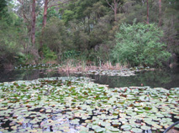
Figure 5.10 Dam 2 showing extensive floating vegetation.
The spring which feeds this dam was sampled in October 2004 and the following results were obtained: dissociated CO₂ 4.4 ppm, pH 6.74. This spring supplies enough water to refill the dam in around 30 days.

Investigation 1
Two sample sets are provided for their intrinsic interest because they represent normal and flooded (high rainfall period) conditions. These are shown in Table 5.19.

Table 5.19 pH buffer system data for Dam 2 for normal height and after heavy rain.
 | Sample 211 Normal dam height | Sample 207 After heavy rain
pH measured | 6.55 | 6.48
pH calculated | 6.29 | 6.23
Bicarbonate | 0.00032 mol/l | 0.00024 mol/l
CO₂ (aq) | 0.00037 mol/l  16.2 ppm CO₂ | 0.00031 mol/l  13.8 ppm CO₂

Most notable about these samples are the relatively high CO₂ levels.

Both these samples lie to the RHS of the buffer nomogram. The goal of this analysis is to determine how rainfall and dam filling change the pH buffer system.

Changes between the normal height sample (211) and the full after rain sample (207) can be interpreted using two different models which gives rise to conflicting scenarios. If the left bias model is used then the only primary factor is a fall in bicarbonate. The other changes, a slight fall in CO₂ and a rise in H⁺ can be seen as secondary, compensating factors.

If the right bias (in the equilibrium equation, LHS model in ACIDEX) model is used then two primary factors are a rise in H⁺ and a fall in CO₂. fall in bicarbonate is a compensating factor in each primary factor.

Conclusions are the same as for another case study – Dam 3 (p 154), an H⁺ acidosis combined with a CO₂ alkalosis.

Investigation 2
In a second test a sample was taken from Dam 2 and allowed to stand open for 24 hrs. Note the “Normal” data are the same as for the dam at normal height.

Data obtained are shown in Table 5.20.

Table 5.20 pH buffer system data from Dam 2 showing changes on standing for 24 hr.
 | Sample 211 Normal | Sample 213 Standing 24 hrs
pH measured | 6.55 | 6.8
pH calculated | 6.29 | 6.92
Bicarbonate | 0.00032 mol/l | 0.00032 mol/l
CO₂ (aq) | 0.00037 mol/l  16.2 ppm CO₂ | 0.000087 mol/l  3.8 ppm CO₂

There was a large drop in CO₂ levels when the water was allowed to equilibrate. An interesting finding was that the water went from being less acidic than expected to being more acidic than expected, based on calculations. The changes on standing can be interpreted using the model for calculated pH > actual pH as a primary drop in CO₂ partly compensated by a fall in H⁺.

Conclusions / hypothesis: an acute uncompensated CO₂ alkalosis.

If the Focus sample is changed to 211 and the Reference sample to 213, ACIDEX will suggest a CO₂ acidosis. An interpretation is that CO₂ levels in the water are being held at an artificially high level.

Case 4 – Dam 3
Data were collected from a small farm dam at Gembrook Victoria. This dam is approximately 10 m x 7 m and is fed by a small spring. During summer the water level in this dam tends to fall. During heavy rain it sometimes receives runoff from nearby roadside drains. Depth is about 2 m and the dam supports an extensive ‘attached’ community of algae, fungi and bacteria on submerged vegetation. This water is often discoloured, usually pale to distinct yellow / brown. It is more coloured and has higher conductivity in the dry summer months (see sample data in ACIDEX, turbidity 37 FTU and conductivity 105 μS/cm). One sample taken during winter after steady rain had turbidity of 6 FTU and conductivity 84 μS/cm. Figure 5.11 shows the extensive submerged vegetation in Dam 3 that is covered with a brownish coloured attached community of algae and fungus. The water itself has a pale yellow / brown colour that can be seen in the photo.

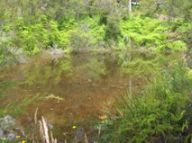
Figure 5.11 Dam 3 showing submerged community and yellow / brown colour in water.
Investigation 1
Data were collected at 21:00 hrs (at nightfall) and at 06:00 hrs the next morning (sunrise). At the time of the year when data was collected the water level in the dam was below maximum and had been slowly falling for several weeks. These data were collected to characterise diurnal changes to the pH buffer system equilibrium. They are presented in Table 5.21.

Table 5.21 pH buffer system data from Dam 3 representing day and night conditions.
 | Sample 221  2 Jan 2005 21:00 hrs | Sample 222  3 Jan 2005 06:00 hrs
pH measured | 7.10 | 6.69
pH calculated | 6.47 | 6.27
Bicarbonate | 0.00046 mol/l | 0.00046 mol/l
CO₂ (aq) | 0.000348 mol/l  15.3 ppm CO₂ | 0.000556 mol/l  24.5 ppm CO₂

Overnight, carbon dioxide levels in the water have risen. By calculation, H⁺ molar concentration has also risen but by only 1/1000th that of CO₂ levels. The rise in carbon dioxide is seen as the primary change with H⁺ as the compensating change.

Sample 222 shows a bias towards the LHS of the equilibrium equation (calculated pH < actual pH). Using sample 221 as a starting point, changes resulting in sample 222 data can be summarised in Table 5.22.

Table 5.22 Primary and compensatory pH buffer system changes noted for Dam 3 during the night period.
Primary change | Present | Compensating change | Present | Compensating change | Present
H⁺  |  | Bicarbonate  |  | CO₂ 
Bicarbonate  |  | H⁺  |  | CO₂ 
CO₂  |  | Bicarbonate  |  | H⁺  | 

Hypothesis: ACIDEX uses these data to suggest a CO₂ acidosis during the night. The reverse process which occurs during the day is a CO₂ alkalosis which is assumed to restore the pH level. Both are uncompensated and are short term or acute.

Investigation 2
Additional samples were taken from Dam 3 on three other occasions and pH buffer system parameters were measured. The results are summarized in Table 5.23. The first sample was taken in Autumn, the second and third in Spring, the latter after heavy rain. Samples were collected during the day.

Table 5.23 pH buffer system data from Dam 3 taken reflecting seasonal and rainfall conditions.
 | Sample 147  19 April 2004, medium level | Sample 198  18 Oct 2004, medium level | Sample 205  12 Nov 2004 after heavy rain
PH measured | 6.6 | 6.88 | 6.8
PH calculated | 6.28 | 6.59 | 6.57
Bicarbonate | 0.00028 mol/l | 0.00032 mol/l | 0.00028 mol/l
CO₂ (aq) | 0.000333 mol/l  14.7 ppm CO₂ | 0.000183 mol/l  8.1 ppm CO₂ | 0.000167 mol/l  7.35 ppm CO₂

What happens to the dam water after heavy rain? Sample 205 shows a bias towards the LHS of the equilibrium equation (not as acidic as expected). What factor accounts for this? ACIDEX can be run with Sample 205 as the Focus and Sample 198 as the Reference. The key changes are that H⁺ increases but both CO₂ and bicarbonate fall.

A RHS model provides the interpretation shown in Table 5.24.

Table 5.24 Primary and compensatory pH buffer system changes noted for Dam 3 after heavy rain.
Primary change | Present | Compensating change | Present | Compensating change | Present
H⁺  |  | Bicarbonate  |  | CO₂ 
Bicarbonate  |  | H⁺  |  | CO₂  | 
CO₂  |  | Bicarbonate  |  | H⁺ 

Hypothesis 1: The observed bias in the bicarbonate buffer system equilibrium is accounted for by a fall in bicarbonate concentration with both expected compensations, a rise in H⁺ and a fall in CO₂ .

If a LHS model is applied the result shown in Table 5.25 is obtained.

Table 5.25 Primary and compensatory pH buffer system changes noted for Dam 3 after heavy rain using an alternative model.
Primary change | Present | Compensating change | Present | Compensating change | Present
H⁺  |  | Bicarbonate  |  | CO₂  | assumed
Bicarbonate  |  | H⁺  |  | CO₂ 
CO₂  |  | Bicarbonate  |  | H⁺  | assumed

Hypothesis 2: Two effects are present. An H⁺ acidosis and a CO₂ alkalosis. The measured CO₂ is assumed to be a net change. Likewise the measured H⁺ is assumed to be a composite of a primary increase and a compensatory decrease.

Therefore two hypotheses are available to account for these observations. However a limitation to understanding this example is that changes are relatively small.

This case study provides an interesting perspective in applying the equilibrium model. Normally if a sample is less acidic than expected by calculation, ACIDEX’s RHS model would be applied, that is, to explain the situation for samples in the lower RHS of the acid-base nomogram. However in this case H⁺ increases but both CO₂ and bicarbonate fall. This suggest that applying a LHS model could be useful.

Case 5 – Creek 2
Creek 2 is a small creek which starts in farming and forested country high in the Yarra Valley catchment in Victoria. It ultimately becomes part of the Yarra River. The soils in this area are basaltic in origin and are very acidic (round 6.3 in a 5 : 1 water : soil mix). The creek is often discoloured by sediments and colloids originating from eroded material and humic acids. Figure 5.12 shows the creek at a point where it overflows from a large dam situated on the creek.

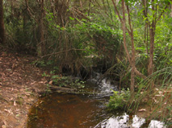
Figure 5.12 Overflow from a dam on Creek 2.
There were two separate studies conducted on this creek water. Both focussed on a large dam situated on Creek 2. Three samples were available, two during normal flow – one from the overflow of a dam and the other from the outlet taking water from deep within the dam, while the third sample was taken during high flow conditions.

Investigation 1
Samples were collected on one occasion (during average flow conditions) from the overflow of the dam and at the same time from an outlet through the bottom of the dam wall. The lower outlet takes water from about 5 metres below the surface. These data are presented in Table 5.26.

Table 5.26 pH buffer system data from Creek 2 samples taken from a dam on the creek at the surface and at 5m depth.
 | Sample 159  23 June 2004  Overflow (surface) | Sample 158  23 June 2004 Outlet (5 m depth)
pH measured | 6.68 | 6.67
pH calculated | 6.65 | 6.43
Bicarbonate | 0.00032 mol/l | 0.00032 mol/l
CO₂ (aq) | 0.00016 mol/l  7.0 ppm CO₂ | 0.00027 mol/l  11.7 ppm CO₂

The overflow water is close to buffer equilibrium but the outlet water is biased towards the left of the equilibrium equation (RHS of the nomogram).

To try to understand what has happened to the pH buffer system in the water deeper in the dam, the strategy adopted here is to consider the overflow water (sample 159) to be nearer normal and the outlet water (sample 158) to represent an altered condition.

Three possible primary disturbances are suggested by the equilibrium model:
H+ fall → H+ alkalosis
Bicarbonate restriction → lowered buffering
CO2 rise → CO2 acidosis

ACIDEX calculates that the H⁺ concentration changes very little and the bicarbonate not at all. Therefore only an increased dissociated CO₂ level seems confirmed. This primary change appears to be uncompensated, that is, there is almost no difference in either bicarbonate or H⁺ between the samples. Therefore an expected acidosis is not present. Carbon dioxide build up deep in lakes has been commonly observed. One reason is the slowed exchange with the atmosphere in deeper water. This is a possible cause for the equilibrium imbalance observed in this example.

Investigation 2
In October 2004 heavy rainfall over 2 days resulted in a significant (estimated at approximately twofold) increase in the flow in Creek 2 compared to June when the previous measurements were made. A water sample was taken during this high flow period at the dam overflow and the data are presented in Table 5.27.

Table 5.27 pH buffer system data from Creek 2 for low and high flow conditions.
 | Sample 159 Overflow – normal flow | Sample 208 Overflow - high flow
pH measured | 6.68 | 6.54
pH calculated | 6.65 | 6.67
Bicarbonate | 0.00032 mol/l | 0.00028 mol/l
CO₂ (aq) | 0.00016 mol/l  7.0 ppm CO₂ | 0.000133 mol/l  5.9 ppm CO₂

The main aim of this investigation is to explain buffer system changes between low and high flow conditions. Significantly, because calculated pH is now larger than actual pH (meaning the water is now more acidic than expected) this sample is situated to the LHS of the buffer nomogram (see p 122).

Two primary disturbances which fit the equilibrium model can be identified. A fall in CO₂ (although only slight) and a rise in acidity (H⁺). According to the model, a drop in bicarbonate is anticipated as a secondary response for both primary disturbances and this has dropped slightly.

Hypothesis: H⁺ acidosis plus CO₂ alkalosis due to increased flow / input.

Case 6 – Bore 1
A sample of water was obtained from a 60 m deep bore at Maroota NSW (west of Sydney). The water was very clear (low turbidity) but had slightly raised levels of copper. The first test results were obtained immediately after opening the collection bottle. A second set of measurements was taken after the sample had stood exposed to the air in an open container for 24 hrs. Buffer system data are summarised in Table 5.28.

The water is relatively acidic (low pH) and has low bicarbonate and CO₂. The calculated pH is substantially higher, meaning that the water is more acidic than expected. The sample data point therefore lies in the lower LHS of the buffer nomogram, indicating that in the original sample the bicarbonate equilibrium is biased to the right.
Table 5.28 pH buffer system data for Bore 1 for a fresh sample and a duplicate exposed for 24 hr.
 | Sample 210  On receipt at Lab. | Sample 212  After 24 hrs standing
pH measured | 6.12 | 6.65
pH calculated | 6.98 | 6.78
Bicarbonate | 0.0004 mol/l | 0.00036 mol/l
CO₂ (aq) | 0.000093 mol/l  4.1 ppm CO₂ | 0.000133 mol/l  5.85 ppm CO₂

The water was left out in an open container for 24 hrs to find out if there was any buffer system shift on equilibration. Some significant changes were noted. These were: a rise in CO₂ levels and a rise in pH (fall in H⁺). There was also a slight fall in bicarbonate.

How can these changes be interpreted using the equilibrium model? If two data points are plotted on the nomogram and the change of interest is generally from the left hand point to the right hand point, then the rules to apply are those for the RHS of the nomogram that is where actual pH is higher than calculated pH. Each of the three main predicted primary changes has taken place, that is, H⁺ and bicarbonate have dropped (the latter slightly) and CO₂ has risen. Normally the equilibrium model suggests an either/or situation that is one or at most two primary changes. Here three primary changes or disturbances have been detected.

This sample is particularly interesting as the equilibration step showed that the water was originally held out of equilibrium by factors which were additive in their effect. Further study is required to explain this effect.

Bore water is sometimes known to corrode copper pipes where they are used inside a house. This is often attributed to the high levels of CO₂ found in bore water. However the results here suggest a preliminary hypothesis that it is low pH that is at least partly responsible.

Case 7 – Bore 2
Data were collected from a bore on land adjacent to Lake Victoria, Gippsland Lakes in Summer 2004/5. The water was tested on collection and again after standing in an open container for 29 hrs. The bore water had the highest acidity and by far the highest carbon dioxide levels of all samples tested for this research project.

Some previous test data, but not buffer system data were available for this bore. ACIDEX shows data from this test as background to sample 216. The most significant results were high iron levels and an ORP value suggesting very low oxidising conditions. (See treatment of data from the Bore 3 sample for an interpretation of ORP values and iron transformations p 168.) Because of these findings it was decided to revisit the bore for another sample so that the buffer system could be investigated. Data for this sample are summarised in Table 5.29.

Table 5.29 pH buffer system data for Bore 2 for a fresh sample and a duplicate allowed to stand for 29 hr.
 | Sample 216. From bore. | Sample 217. After standing 29 hr.
pH measured | 5.92 | 6.78
pH calculated | 5.86 | 7.29
Bicarbonate | 0.00137 mol/l | 0.00128 mol/l
CO₂ (aq) | 0.0043 mol/l  187 ppm CO₂ | 0.000148 mol/l  6.5 ppm CO₂

There are two perspectives of interest. How did the bore water come to have the chemical characteristics measured and what will happen once the bore water is exposed to the air? There is some practical interest here to find out about what treatments the bore water needs to improve its chemical and physical properties. So in the interpretation of this data the original bore water can be set as the Reference sample and the sample left to stand, the Focus sample.

Main changes and compensations are summarised in Table 5.30. If the water is allowed to stand exposed to the air carbon dioxide levels fall quickly and dramatically. This change is compensated by falls in both bicarbonate and H⁺. An interesting issue about pH is worth noting here. The rise in pH from a low to a medium value is significant as it represents a much larger change in H⁺ concentration than in many other samples in this research project. This can be understood because of the logarithmic nature of the pH scale. As a rough indication, the H⁺ change is around 100 times that of the change in most other samples. This could be one of the aspects that makes pH a difficult concept to work with and explain.

Table 5.30 Primary and compensatory pH buffer system changes noted for Bore 2 after allowing a sample to stand for 29 hr.
Primary change | Present | Compensating change | Present | Compensating change | Present
H⁺  |  | Bicarbonate  |  | CO₂ 
Bicarbonate  |  | H⁺  |  | CO₂ 
CO₂  |  | Bicarbonate  |  | H⁺  | 

Hypothesis: CO₂ alkalosis. Rising pH is partly offset by loss of bicarbonate ion which recombines with calcium and produces replacement H⁺ ions. Note that this water had relatively high calcium levels.

Summary of results from case studies
Analysis of the pH buffer system of a number of samples using the H-H model advanced has shown that disturbances can be demonstrated as a result of:

- Environmental factors for example rainfall. This was noted in three cases, a dam and two creeks.
- Changes that occur over time in the same sample. This was noted in two bore water samples and a sample from a dam (Dam 2) when samples were allowed to equilibrate with the air. In another case Dam 3, an acidosis was noted during the night when CO₂ levels increased.
- Sampling at different points within the water body. This was noted in Creek 2 where water taken from deep within an in-stream dam were found to be more acidic. Based on buffer system analysis this was diagnosed as a CO₂ acidosis.

In addition the H-H model predicts the following possibilities:

- More than 1 compensating factor may act to counteract changes to acidity.
When water from Bore 2 was allowed to equilibrate with the air, changes to pH were compensated by changes to the other two buffer system factors.

- More than 1 primary factor may be acting to change acidity and these can be additive or counteracting.
High rainfall and flooding causes an increase in acidity at three locations Creek 1, Dam 2 and Creek 2. However in Creek 1 the only primary effect was a H⁺ acidosis whilst at the other locations this was accompanied by a counteracting CO₂ alkalosis.

- Changes may be compensated to different degrees depending on the capability of the system to respond. In addition changes may be short term or acute.
For example the water from Bore 1 partly resists change to pH on standing because of its ability to release more H⁺ ions. By contrast, if water from Dam 2 is allowed to stand there is no resistance to the change in pH caused by changing CO₂ levels. In both these cases changes are relatively short term or acute in effect.

In summary, most of the key effects of buffer system disturbance proposed by the model have been noted and accounted for in the samples studied.

However findings in some of the cases have highlighted the need to extend the interpretation of results by identifying values likely to be outside expected ranges and by comparing relative changes between the buffer system parameters. This situation occurred during analysis of data from Lake 1 and Creek 1 when initial hypotheses based solely on H-H calculations did not give a clear indication of what type of disturbance was occurring.

Applications
In this section the remaining case studies listed in Table 3.5 are examined. In the first application, Case 8, a bore in the eastern suburbs of Melbourne, the focus is on diagnosing a problem with iron in water. The next two applications, Case 9 and Case 10, assume a broader context of water quality in stressed or degraded situations and use the principles of buffer system analysis to better understand the factors determining water quality. These are a farm dam in West Gippsland, Dam 1 and a creek in East Gippsland, Creek 3. Based on the criteria for establishing eutrophication in Table 2.3 both of these waters can be considered to have at one time or another, eutrophic conditions. Therefore the concept of eutrophication becomes important in understanding how to describe and explain these situations.

The analysis of these cases is primarily designed to test the problem solving method outlined previously, using field data, a diagnostic method and some knowledge about water chemistry and biology. Some of this domain knowledge is considered a priori to be true, with some considered to be tentative.
The approach taken in this section is to assume the suitability of assumptions about the pH buffer system, the completeness of domain knowledge and the applicability of a diagnostic framework using causal reasoning, then to build as far as possible, explanations to help understand or solve given problems. During this process any shortcomings in any of the tools, methods or resources will be noted. If there are situations where additional knowledge or inferring steps are needed to form coherent models, these will be noted. In these case studies concept maps are constructed to show various stages in the development of diagnostic models. This process helps to further define key relationships, mappings between concepts, and assumptions necessary to form coherent explanations. Some of these concept maps utilise relationships already tentatively defined within the knowledge base.

Case 8 - Bore 3 Iron in bore water
Data were collected on water from a bore in Melbourne's outer east. The first sample (268) was fresh from the bore and the second sample (270) was a duplicate which was allowed to stand exposed to the air for 20 h. Table 5.31 summarises the data collected from the two samples.

Table 5.31 Diagnostic data from Bore 3.
 | Sample 268. From bore. | Sample 270. After standing 20 hrs.
pH measured | 6.61 | 6.67
pH calculated | 6.6 | 7.11
Bicarbonate | 0.00442 mol/l | 0.00437 mol/l
CO₂ (aq) | 0.00248 mol/l  109 ppm CO₂ | 0.000759 mol/l  33.4 ppm CO₂
EC | 1585 μS/cm
ORP | –2 mV
Turbidity | 32 FTU
Colour | slightly milky
Chloride | 500 mg/l
Hardness | 430 mg/l as Ca CO₃
Sodium | 270 mg/l
Iron | 6 mg/l
Manganese | 0.3 mg/l

The accompanying application ACIDEX provides the data for this case study and can be used to build an understanding of problems with this water. ACIDEX will carry out all the calculations and initial diagnosis of the buffer system. After that, the knowledge base can be accessed to look for indicators and causes of any condition identified and to help explain the diagnosis.

The water was pumped from a bore then stored in an enclosed plastic tank. The property owner had horses on agistment and wanted to know if the horses could safely drink the water. He also wanted to use the water to water the garden and an orchard. The original sample was taken from a tap in the orchard. There was a very noticeable brown staining around the polythene riser pipe and around the tap.

Diagnostic strategy
The diagnostic strategy is to:

- Look for abnormal or unexpected values in any of the commonly measured parameters,
- Look for any obvious signs not covered in the chemical analysis,
- Conduct an analysis of the buffer system equilibrium, and
- Collect information on the source of the water or conditions possibly contributing to its status, then
- Form a preliminary hypothesis about what is wrong with the water in terms of buffer system equilibrium. This means establishing the existence of an abnormal or ‘clinical’ condition. The goal of this diagnosis is to suggest possible causes leading to an ultimate cause. This could also be done by assuming a condition then looking for supporting evidence.
- Construct an explanation to account for any observations or findings. This means finding or proposing an ultimate cause for the problem.

The initial diagnosis consists of two parts; analysis of the buffer system equilibrium and search for indicators of a clinical high iron state.

Initial diagnosis

Indicators.
Laboratory measurements have established that there is 6 mg/l of soluble iron in the bore water. The criteria for ‘High iron’ condition is somewhat arbitrary but if it is set at > 5 mg/l then the condition “High dissolved iron’ can be established. However it has not been established that there is anything unusual about this level of iron. An artificially high iron level in water could be designated a clinical or abnormal state such as ‘Abnormal elevated iron’.

At this point a piece of associational information has to be brought into the problem solving process. It has to be assumed that experience shows that red brown staining is sometimes an indicator (symptom) of high dissolved iron in water.

The goal of the diagnosis was therefore to establish or explain if iron was a problem in the water, what were the factors contributing to that situation and if iron levels were too high what treatments were indicated.

Buffer system analysis
In the fresh sample from the bore the buffer system was nearly balanced because the calculated pH was almost the same as the actual pH.

The water is only slightly less acidic than expected. It was possible that this was an example of an almost fully compensated change. If an initial diagnosis is pursued, the possible buffer system disturbances are:

H⁺ alkalosis
HCO₃⁻ restriction (low buffering)
CO₂ acidosis

These are the main possible disturbances based on the summary on page 132.

The value for dissociated CO₂ was very high. This suggested that the CO₂ may have been artificially high. Normal CO₂ values are around 3 – 10 ppm. Therefore the finding “High dissociated CO₂” can be established.

Iron related concepts
Because iron levels are implicated in this problem it is useful to gather some information about the characteristics of iron in water.

Iron is a common component of water. It is important because of its role in agriculture, plant nutrition, aesthetics and drinking water quality. But it can also be a problem in water supplies. Also the supply of soluble iron for plant growth is a finely balanced process. There are some paradoxes with iron. For example, iron can be limiting for plant growth under some conditions, including in soils where the major constituents are iron compounds! This is because iron sometimes forms complexes which make it less available to plants, or exists in a highly oxidized state that limits its solubility and availability.

Some key issues for dealing with problems relating to iron are broadly; the different chemical forms of iron, its ability to form complexes especially with organic compounds, its role as an alternative energy source for microorganisms and its pH / REDOX behaviour.

In this example a model based diagnosis will be used to gain an understanding of the causes and management of iron levels in a sample of water from a bore. This is a common type of problem in Australia so the outcome could be of some interest.

The behaviour of iron must be understood in the broader context of factors such as pH, REDOX and probably many other factors. This will include a way to understand causal factors maintaining normal or leading to abnormal conditions. There are some assumptions and simplifications needed on the way to a better causal understanding. For example the REDOX behaviour of iron in natural waters is well described and is derived mainly from controlled laboratory studies. But this can only be a guide when a variety of complex forms of iron are present under normal field conditions.

By looking at the chemistry for individual REDOX reactions it is possible to theoretically say over what range of ORP values that reaction will proceed. So establishing oxidising or reducing conditions depends on what reaction is being considered. Dodds (2001, p 211) has provided a very useful summary of the main REDOX reactions and their ORP ranges.

So whilst a pH – Eh stability diagram for iron represents a theoretical relationship there is no guarantee that iron will behave according to this rule under normal conditions.

In natural waters between about pH 4 and pH 8.5 the important iron species are soluble ferrous ion and insoluble ferric hydroxides. The relationship between pH, REDOX potential and the prevalence of either part of a given REDOX pair can be expressed in a stability diagram. A stability diagram for the REDOX pair Fe²⁺ - Fe(OH)₃ (solid phase) is given in Figure 5.13.

The concentration of forms of iron do not just flip from one to the other on each side of the phase boundary in Figure 5.13. The concentrations are described in equilibrium equations in much the same way as an equilibrium equation describes pH. This diagram could be used to predict whether there is likely to be more or less of the oxidised form (iron oxides and hydroxides) or the reduced form (soluble ferrous ion) if either or both pH or REDOX change. This applies to water and water in the soil solution.

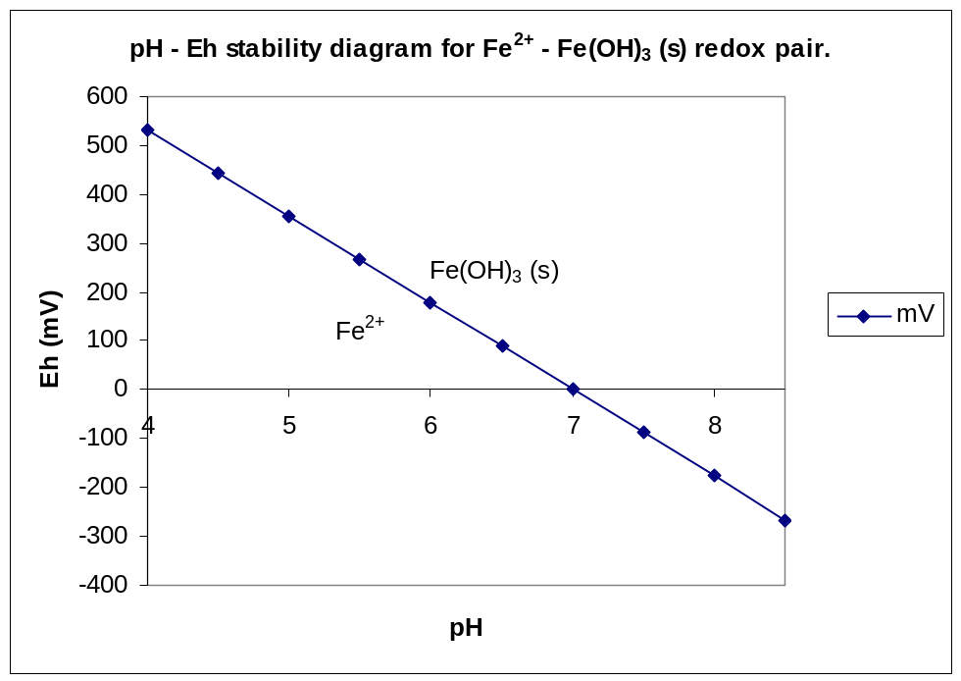
Figure 5.13 pH – Eh stability diagram for iron in natural waters. Adapted and based on calculations from Evangelou (1998).

Initial hypothesis
At this stage in the diagnosis the assertion about the source of staining is based purely on an assumption about the consequences of high iron in water. It is typical of the type of association held as ‘common’ knowledge. The assertion may not be proven and perhaps may not even have an identifiable source. It acts purely as a starting point for a diagnosis. There are many such assertions made in all disciplines at this rather general level. Therefore the diagnostic process itself in this research project acts as a type of self checking process. The goal is to eventually show how high iron in water could lead to brown staining on fixtures. The relationship ‘Staining symptom-of High iron’ is coded in the knowledge base used by ACIDEX with the modifiers ‘sometimes’.

However red brown staining may be caused by other factors such as high suspended sediments or colloids in the water.

At this point it might even be stated that ‘High CO₂ is causing a CO₂ acidosis’. But a causal link should indicate a “process causing a condition”. It is assumed that there is a process that results in an overall net increase in CO₂ , ultimately producing the acidosis. In addition, an assumption of this causal link is that the increase in CO₂ is not fully compensated, based on the H-H model outlined above. A slightly better way to view this relationship is to break it into two parts. First, processes causing a net increase in CO₂ ‘cause’ an increase in CO₂ in the water, and secondly, the (subsequent) process of CO₂ dissolution when uncompensated ‘causes’ a CO₂ acidosis.

Figure 5.14 represents the initial assessment. The dotted line relationship represents a tentative part of the diagnostic hypothesis. That is, CO₂ acidosis is causing an elevated iron condition. In the figure circles represent Processes, rectangles Findings and rounded rectangles Conditions or states.

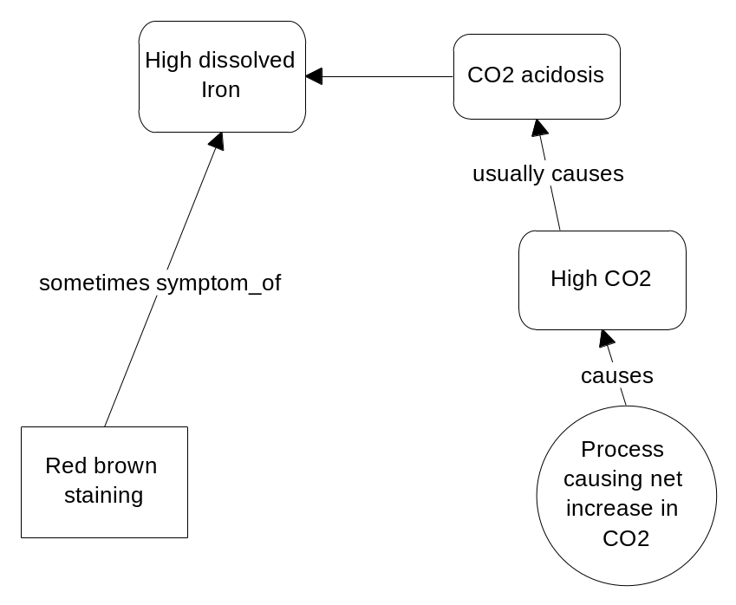
Figure 5.14 Initial diagnosis for brown staining on tap for a water sample.

The stage reached in this diagnosis is that an initial hypothesis has been formed. It is that abnormally high iron concentration in the water is being caused by CO₂ acidosis.

Alternative hypotheses are still available and they are based on the preliminary analysis of the buffer system: These are that abnormally high iron is being caused by a neutralisation of H⁺ or a tendency of the buffer system to reduce the supply of bicarbonate. This data is from only one sample and there is no other evidence to support either of these two alternative hypotheses.

However a second sample was available for comparison. This was a duplicate sample (sample 270) of the bore water but this time it was left to stand open to the air for 20 hrs. CO₂ dropped sharply and pH rose slightly in the exposed sample. A buffer system diagnosis established the following: note changes are from aerated sample to fresh sample from the bore, see the explanation below. These calculations can be carried out easily in ACIDEX and the report will be as follows:

Possible primary changes are:
H+ fall
Bicarbonate fall
CO2 rise
H+ difference is 3.17E-8 moles
Bicarbonate difference is 5E-5 moles
CO2 difference is 1.72E-3 moles
Primary change: CO2 rises
Compensations
Bicarbonate rises as compensation
H+ rises as compensation

This evidence supports the primary hypothesis that because CO₂ has risen beyond normal values in the water, this has created a CO₂ acidosis. Note that the calculations were performed by setting the exposed sample as the reference sample, assuming it approximated more closely, normal conditions. The water taken directly from the bore is set as the sample with altered or changed conditions. Another way to justify this is that an assumption has been made that the water started out with values closer to the exposed sample and some combination of factors has caused changes such as raised CO₂.

Other findings
The turbidity measurement is available and was 32 FTU. Water at this turbidity level looks faintly discoloured – certainly not ‘dirty’. The colour was also noted at the time to be slightly milky. Therefore there was no evidence that brown staining was being caused by high colloids or even suspended organic or mineral material.

The ORP (REDOX) value was –2 mV. Interpreting the implications of ORP values is difficult because of issues previously discussed, but as a guide, normal ORP values for well aerated surface waters are around 250 – 350 mV. One assumption is that for pH less than 7, an ORP of –2 mV represents reducing conditions and results in production of soluble iron. To make the model coherent, a condition, ‘Reducing conditions’ has to be assumed. This is a qualitative assessment and has to be made by the user based on the assessment of REDOX behaviour of iron species.

A stability diagram (for example see p 141) shows that both pH and ORP contribute to produce either reducing or oxidising conditions. In this example could a change in pH alone produce reducing conditions? It is possible that the sample left exposed to the air has not fully equilibrated with the air. Evidence for this is that the CO₂ levels are still unusually high at around 33 ppm. One way to interpret the calculated pH is to say it is the figure towards which the pH is approaching. So in this sample it is possible that with pH changes alone, the water could become oxidising for iron at around pH 7.1. No ORP reading was available for the equilibrated sample.

Although there is no further evidence about what has caused a low ORP value, it is likely that this value is abnormally low and therefore it is probable that both pH and ORP are contributing to reducing conditions.

The primary hypothesis now has to be amended to include the possibility that both low ORP and, low pH caused by CO₂ acidosis, are causing reducing conditions which are in turn causing high soluble iron in the water. Figure 5.15 shows the extended diagnosis.

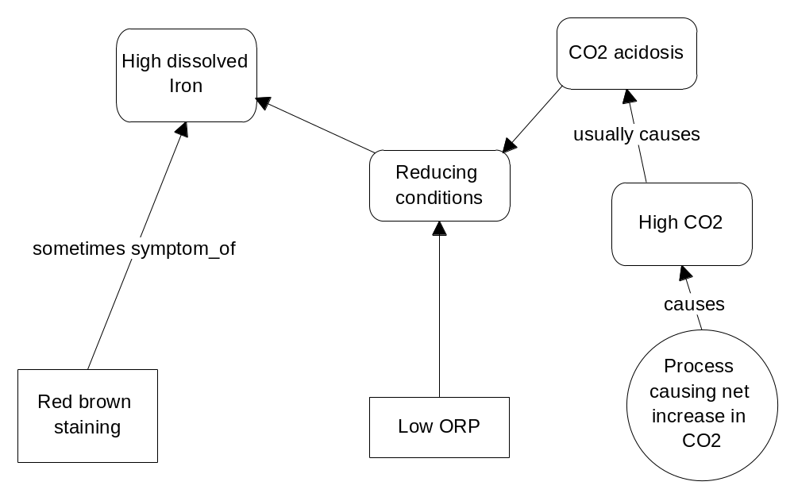
Figure 5.15 Extended diagnosis for brown staining on tap for a water sample.

Hypothesis testing
To test the main hypothesis, a mechanism for the cause of the acidosis and hence the high iron concentration has to be established. In doing so an explanation is provided as to why the red brown staining appears at the tap. No further reasons or causes for the low ORP are immediately available from field data.

Two common factors can contribute to increased CO₂. These are a surplus of respiration over photosynthesis or impaired gas exchange. The latter may also have an underlying cause. Impaired gas exchange can occur where water is cut off from the air. Such conditions can occur in deeper water where stratification can prevent lower layers from mixing with upper layers. Other situations are in underground water. There is no real evidence of anaerobic decomposition occurring in the present case so the underlying origin of the CO₂ is not apparent.

Further information is that the water comes from a bore. Therefore ‘Bore water’ as the source type becomes a possibly useful finding to establish. Underground conditions sometimes cause impaired gas exchange. Because the water is from a situation where gas exchange is inhibited, a process ‘Impaired gas exchange’ can be assumed. Figure 5.16 shows a preliminary situation specific model that has emerged by instantiating the generalised relationships between findings for the sample.
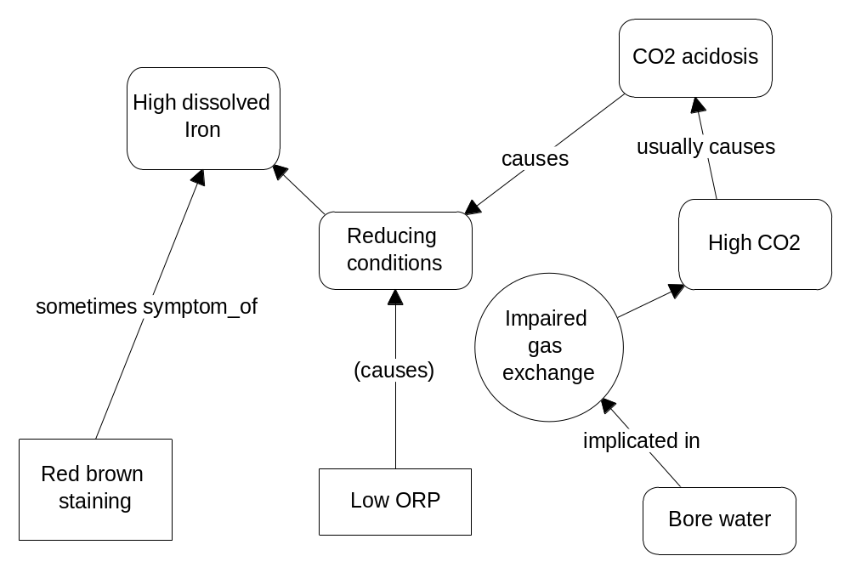
Figure 5.16 Preliminary situation specific model for a water sample from a bore.

The link between bore water and ‘Impaired gas exchange’ is a simplification and is established in the explanation because it is assumed that bore water is an example of an underground water supply and hence is a situation where gas exchange is usually inhibited.

The link ‘Low ORP causes reducing conditions’ is a simplification. It is meant to indicate that some processes that result in a low ORP value are assumed to cause reducing conditions.

Having established a cause for the development of abnormally raised soluble iron
levels in the sample, the model can now offer an explanation of how brown staining occurs.

The change in the buffer system from fresh to aerated (standing exposed) sample is diagnosed as a CO₂ alkalosis with pH increasing as compensation. Aeration is also known to increase oxygen levels, which in turn increases ORP. In the aerated (standing) sample oxidising conditions return due to rising pH and probably rising oxygen levels. If soluble iron is present, some (the exact amount may depend on a number of factors) will be converted to insoluble red brown ferrous compounds.

Unfortunately no data are available for ORP in the aerated sample. In addition there is no specific observation of a sediment appearing in the aerated sample. One possible reason is that the because the amount of iron in the water is relatively low for bore water (figures of 15 – 30 mg/l are common in bore water) only a small amount of sediment formed. Therefore the explanation for staining is built partly on direct evidence of acidity change and indirect evidence about the effects of aeration.

Figure 5.17 shows the possible underlying mechanism to account for staining in the case study sample. Aeration in this case is a process that has two components, a decrease in pH and an increase in ORP. These combine to create oxidizing conditions that precipitate some of the dissolved iron.

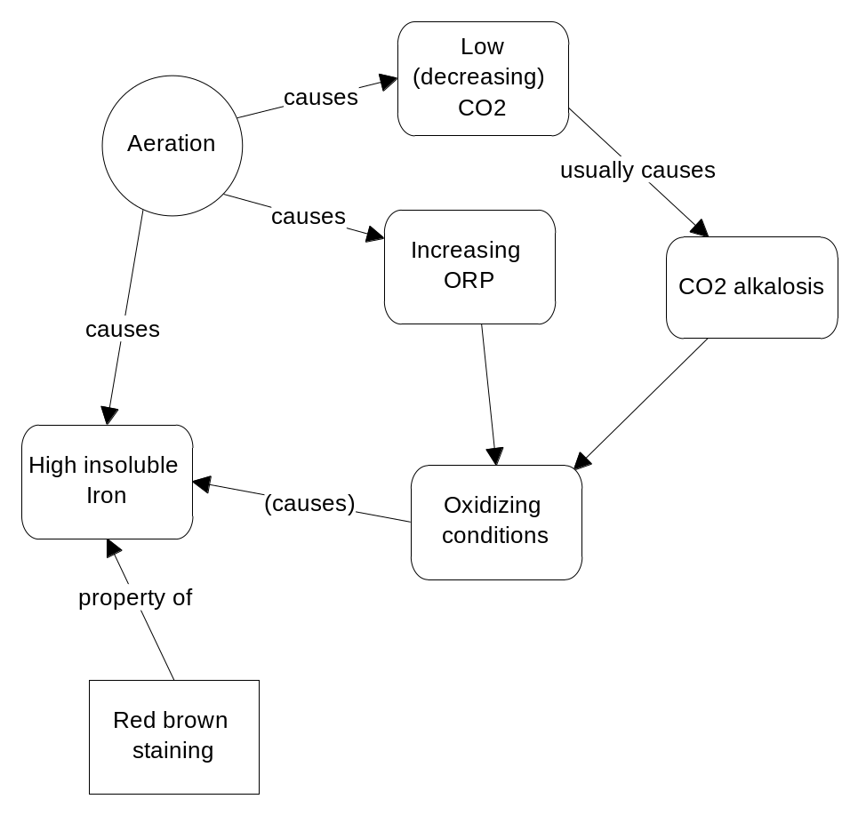
Figure 5.17 Mechanism for explaining staining in a bore water sample containing iron.

Additional fact finding.
A goal of the analysis was to assess the suitability of the water for drinking water for horses. The safe level of iron in drinking water for horses is 0.3 mg/l Kohnke, Kelleher et al. (1999). Acceptable levels for iron in irrigation water are somewhat less precise but over 3 mg/l is considered undesirable.

The proposed mechanism for producing red brown staining offers a possible treatment solution for the water to bring the iron level to within an acceptable level for horses. As such, if the sample was aerated and iron levels fell this would provide at least partial confirmation of the overall diagnosis.

Case 9 - Dam 1 Eutrophication
Data was collected from a small farm dam in West Gippsland. It is formed at the head of a small creek which locally drains grazing land in a relatively flat area. The dam is subject to wide fluctuations in water level and was formed historically by sand mining along a small depression. The dam is long and narrow, approx 100 m x 15 m. The surrounding paddocks are drained by a series of shallow drainage channels which connect into the dam. Cattle graze in the paddocks surrounding the dam and to drink from the dam the cattle walk down the banks along the edges of the water and into the water, leading to disturbance in the shallows (see Figure 5.18).

The dam is used as the backup water supply for a large production wholesale plant nursery. The water passes through an extensive treatment process which includes chlorination to control disease. Water from runoff within the plant nursery is allowed to return to the dam through a long (c. 300 m) open drain. Some early test data from this dam were known before pH buffer system data were collected during the main part of the research project.

The analysis of data from this site is designed to provide guidelines for managing the water quality to maintain its suitability for irrigation. The main criteria used by the owner were to lower turbidity particularly with respect to algae, control and maintain pH and, maintain the disinfecting capability of the water treatment plant.

When the first pH buffer measurements were taken the dam was at normal, intermediate capacity. Subsequent measurements were made when the dam was filled to overflowing after heavy rain and at other times, including when the dam was at a very low level.

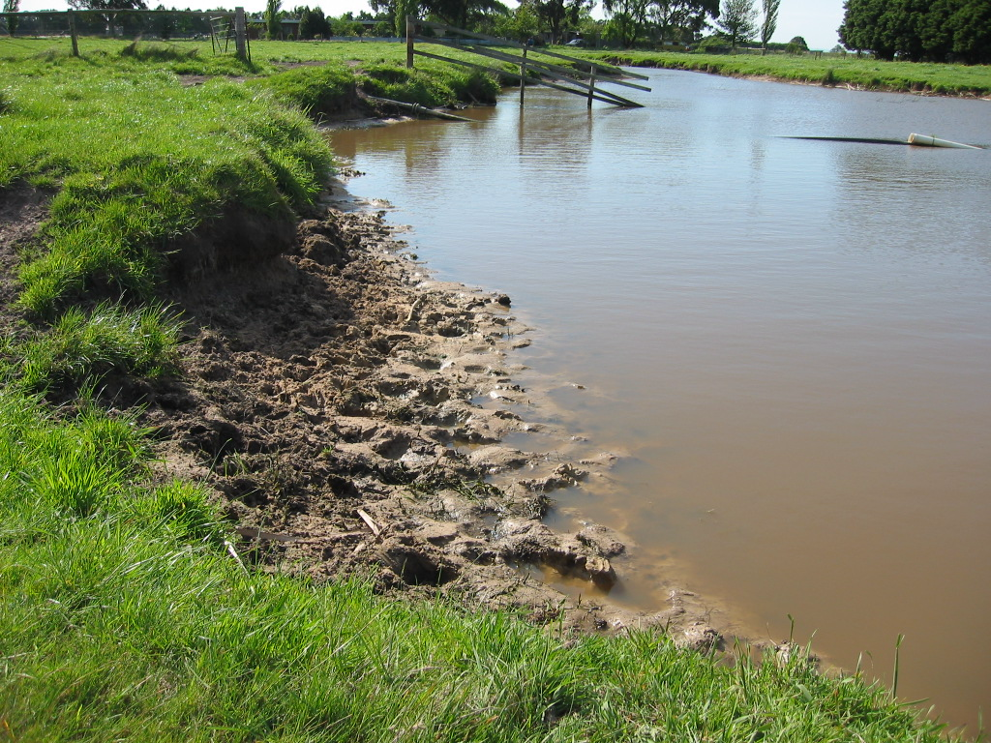
Figure 5.18 Dam 1 with water at intermediate level.
In this study different sets of buffer system data are compared and analysed to better understand the processes that are at work affecting water quality.

Background data.
Turbidity and conductivity measurements taken over a 30 month period (see Figure 5.19). These illustrate seasonal fluctuations and are expressed as a percentage of the highest recorded values of turbidity and conductivity during the study period.

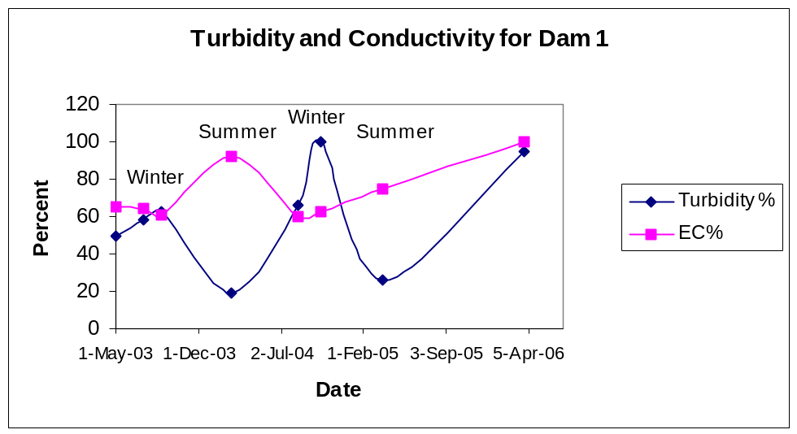
Figure 5.19 Graph of Turbidity & Conductivity for Dam 1 over approximately 3 years.
Generally, low turbidity (cloudiness in the water) corresponds to high conductivity (more concentrated salts). Records also show that the water has low turbidity when the water level is low. Generally, turbidity is lower in summer and higher in winter. However the exception to this pattern was observed during Autumn 2006 when the water had very high turbidity due to an algal bloom.

Data collected show that the water is more acidic in the winter months or when the dam level is high, and turbidity is up. Conversely, in general, when conductivity goes up so does pH and this tends to happen in Summer. pH is generally higher when the water level is low but there is no uniform relationship between turbidity and other factors. These relationships are summarized in Table 5.32.

Table 5.32 Summary of the main changes in Dam 1 between seasons.
 | Water level | Turbidity | Conductivity | pH
Summer | Low | Low (except when caused by an algal bloom) | High | High (less acidic)
Winter | High | High | Low | Low (more acidic)

Two algal blooms were noted during the period of the research project. The one at the end of 2003 was Ceratium, a Dinoflagellate which made the water slightly green. The other was noted in late summer of 2005-06 and was caused by a different algae, a species of Chlamydomonas or similar species. This gave the water a very intense vivid green colour. The sample taken at this time was sample 286.

Sample data.
pH buffer data are available for a number of samples from this dam taken over an extended period of approximately two years. Table 5.33 shows the dates that samples were taken from Dam 1 and the conditions prevailing at the time. Any two sets can be compared to investigate possible causes of changes in the buffer system equilibrium. ACIDEX can perform buffer system calculations and perform a low level diagnosis based on any single sample or any two samples in any order. The main situations investigated in this study are; high rainfall and subsequent flooding, an algal bloom over a short period, normal drop in turbidity over a 6 month period and decreasing water levels over an extended period.
Table 5.33 Summary of samples taken from Dam 1.
Sample number | Date | Conditions
183 | August 04 | full after heavy rain
169 | October 04 | around medium water level
235 | March 05 | around medium water level
286 | March 06 | very low water level, significant algal bloom
290 | March 06 | duplicate of sample 286 left exposed overnight

Investigation 1
This first investigation attempts to understand how the pH buffer system is disturbed when the dam floods, therefore the focus is on sample 183. Note that in this example, data from a subsequent condition are used to infer causes of changes in a previous condition. The reasoning is that this type of diagnosis just depends on examining any two states, noting the differences between them.

During August 2004 the dam was in full flood and very discoloured. By October 2004 the dam was back to normal intermediate level. pH buffer system data were collected during these periods and are presented below in Table 5.34. (Note sample numbers do not necessarily go in time sequence).

Table 5.34 pH buffer system data from Dam 1 under flooded and normal conditions.
 | Sample 169 Early Spring, non flooding | Sample 183 Winter after heavy rain
pH measured | 7.01 | 6.9
pH calculated | 7.23 | 7.64
Bicarbonate | 0.00136 mol/l | 0.00116 mol/l
CO₂ (aq) | 0.00018 mol/l  7.9 ppm CO₂ | 0.00006 mol/l  2.6 ppm CO₂

First consider sample 183. In this sample taken when the dam was full, calculated pH is larger then actual pH and the sample lies to the LHS of the bicarbonate buffer system nomogram for waters. The buffer system is out of equilibrium by a small amount. Three simple scenarios (or a combination) can be proposed to account for this observation: primary disturbances may be H⁺ acidosis, increased bicarbonate or CO₂ alkalosis. Any one of these factors acting alone could be responsible for the equilibrium imbalance. Hence a simple diagnostic situation can be developed with three alternative causes. This sample was taken after a period of very heavy rain which had filled the drainage channels in the surrounding paddocks and had subsequently filled the dam.

Without any comparative data it is difficult to rank the different possibilities but it is useful to look for possible reasons. Some possibilities are: a fall in CO₂ due to equilibration or escape to the atmosphere from a previously high value; input of an acidic material, possibly fertilizers, or an increase in acids from the breakdown of organic matter. Another source of acidic input could be acidic rain. With only one sample it is difficult to propose a source for bicarbonate.

However another sample was taken when the dam was at intermediate levels. This data is shown in Table 5.34, sample 169.

The two sets of data do not necessarily represent normal or abnormal conditions, just different conditions. In some ways they correspond to states, so the goal is to find processes which are acting to change those conditions or states, the main differences being a few weeks interval and significant rainfall. Which situation is nearer normal? Intuitively the sample which was closest to equilibrium may be chosen but this situation may itself be disturbed in a slightly different way for different reasons. Even a sample close to pH balance could be that way because there are opposing forces acting on the equilibrium from different directions. Taking two distinct states allows assessment and interpretation of the relative change, keeping in mind that the objective is to unravel the process or processes that have caused this change. So the aim is to interpret the changes which have occurred between non flooding and flooded conditions.

Interpretation of the buffer system analysis.
A fall in CO₂ is accepted as a primary change for samples on the left of the nomogram, where in general waters are more acidic than expected, and this is true for both samples. The observed fall in bicarbonate is predicted as a secondary change. However there appears to be another primary change – an elevated H⁺ concentration. Normally a fall in CO₂ is compensated by a fall in H⁺ which results in lower acidity. The rise in H⁺ is unexpected and appears to compound the effect of lowered CO₂ thus widening the calculated versus measured pH gap. It is important to note that no single primary change predicted by the model could be wholly responsible for the observed changes.

The main primary changes and predicted compensations are summarized in Table 5.35.

Table 5.35 Primary and compensatory pH buffer system changes noted for Dam 1 due to flooding using a RHS model.
Primary change | Present | Compensating change | Present | Compensating change | Present
H⁺  |  | Bicarbonate  |  | CO₂ 
Bicarbonate  |  | H⁺  |  | CO₂ 
CO₂  |  | Bicarbonate  |  | H⁺ 

The important point about these findings is that two main factors have been identified setting the acidity of the water. The challenge now is to work out what they are and to show as far as possible how the pH buffer system is actually being disrupted. In this case it appears that the two influences at least partly cancel each other. This is a significant advance on just measuring and trying to interpret the pH in isolation.

Hypothesis 1: H⁺ acidosis combined with a CO₂ alkalosis.

Interpretation has to take into account that because each factor partly compensates the other, both the measured CO₂ drop and the measured H⁺ rise are net changes. However the absolute change in bicarbonate concentration was larger than those of CO₂ and H⁺ so this works against the first hypothesis.

If a LHS buffer system disturbance model is used for interpretation, the main primary changes and predicted compensations for Dam 1 under flooded conditions are summarized in Table 5.36.

Table 5.36 Primary and compensatory pH buffer system changes noted for Dam 1 due to flooding using a LHS model.
Primary change | Present | Compensating change | Present | Compensating change | Present
H⁺  |  | Bicarbonate  |  | CO₂ 
Bicarbonate  |  | H⁺  |  | CO₂  | 
CO₂  |  | Bicarbonate  |  | H⁺ 

Hypothesis 2: Bicarbonate drops as a primary change creating an alkalosis.
At first this hypothesis seems less likely because it is suggested by a buffer system disturbance model where water is less acidic than expected, a LHS model and the sample from the flooded dam is more acidic than expected. However the model neatly accounts for observed changes in buffer system parameters. The hypothesis requires a cause for reduced bicarbonate. A tentative (yet to be tested) explanation could be that heavy rain has diluted the water in the dam. This could account for the lowered CO₂ levels as well as lowered bicarbonate levels. As of the final stage of this analysis no reliable information is available for CO₂ and bicarbonate levels in rainwater however the researcher measured the pH and conductivity of rainwater at Boronia about 20 kms from Dam 1 later in the same year. The pH was 6.9 and conductivity 13 μS/cm. The conductivity figure suggests a figure for bicarbonate much lower than that measured for Dam 1. However this scenario leaves open the question of how water runoff from the paddocks is likely to affect the pH of the water in the dam.

In conclusion, pH drops between normal and flooded conditions in the dam but whether this is occurs as a compensation to a primary drop in bicarbonate, as a primary increase in H⁺ ions, as a compensation for a drop in CO₂ levels or as a combination of these factors remains to be determined.

Investigation 2
Background: During the Summer of 2005-6 the dam level dropped significantly to the lowest observed in three years and the water developed an intense green colour at the beginning of Autumn. The owner had been monitoring the pH of the water at the nursery and had noticed it was very high.

Change in pH is one of the issues of concern at this plant nursery because of the relationship between pH and chlorination efficiency. Chlorination effectiveness decreases significantly in water over pH 7.3 and where water contains significant amounts of organic matter. A more detailed explanation of the reason for this is given in Appendix A p 246.

The immediate purpose of this investigation was to find out why the pH had risen well above normal levels but in a broader context the goal was to better understand the process that had created those conditions in the water.

Measurements were taken from a fresh sample and a duplicate sample left standing open overnight in the lab. These data are presented in Table 5.37. This second sample’s conditions were assumed to approximate overnight conditions and therefore the test measurements were interpreted as reflecting changes normally occurring overnight in the dam.

Table 5.37 pH buffer system data for samples taken from Dam 1 when an algal bloom was present.
 | Sample 286 early Autumn, late afternoon, low water level, algal bloom | Sample 290 duplicate of 286 left standing overnight
pH measured | 8.5 | 7.24
pH calculated | 10.71 | 7.69
Bicarbonate | 0.00227 mol/l | 0.0015 mol/l
CO₂ (aq) | none measurable | 0.000069 mol/l  3 ppm CO₂

Findings: During the day in the dam, dissociated CO₂ decreases to a very low value and pH rises. The implication is that CO₂ is being used up faster than it can be produced or replaced. If the daytime sample is considered on its own then ACIDEX suggests possible disturbances for conditions more acidic than expected as:

H+ rise → H+ acidosis
Bicarbonate rise → increased buffering
CO2 fall → CO2 alkalosis

However if the overnight sample is used to represent reference conditions then, for changes which result in the daytime situation, ACIDEX suggests a LHS model. The largest absolute change was in bicarbonate which rises. Primary and compensating changes are summarised in Table 5.38.

Table 5.38 Primary and compensatory pH buffer system changes noted for Dam 1 during daytime with algal bloom present.
Primary change | Present | Compensating change | Present | Compensating change | Present
H⁺  |  | Bicarbonate  |  | CO₂ 
Bicarbonate  |  | H⁺  |  | CO₂ 
CO₂  |  | Bicarbonate  |  | H⁺  | 

Two primary disturbances can be identified:
A primary rise in bicarbonate with lowered H⁺ as compensation.
A primary CO₂ fall with a compensating fall in H⁺ resulting in an alkalosis.

Because there is a significant algal bloom present and because algae use CO₂ for photosynthesis during the day, the initial and primary hypothesis is that pH rises during the day due to a CO₂ alkalosis caused by algal photosynthesis. The rise in bicarbonate is unexplained by the data or observations.

Other findings
The water is highly turbid and this appears to be mainly because of the density of algae. A sample of water was analysed for phosphate and this was relatively high at 6 ppm. But in a sample taken at the inflow, that is from water flowing back into the dam from the nursery, no Phosphate was detected.

The preliminary conclusion is that algae are consuming all the phosphate. Another implication is that the supply of phosphate may be limiting the growth of algae. Phosphate is considered to be one of the main contributors to algal growth which is a symptom of eutrophication. As such, this suggestion provides a working hypothesis to explain why the pH has risen. If the water returning to the dam was treated to reduce phosphate and this resulted in reduced algal growth then the hypothesis would be supported, but not proven.

Investigation 3
Two samples taken one year apart at the end of Summer are available for comparison. In the first, sample 235, water level in the dam was around medium but in the last, sample 286, water level had dropped to the lowest observed during the study period. Sample data are presented in Table 5.39. The main differences between the two samples were 12 months, decreased water levels and a significant algal bloom.

Table 5.39 pH buffer system data for samples taken from Dam 1 taken 12 months apart in early Autumn.
 | Sample 235  early Autumn 2006 | Sample 286 early Autumn 2005, algal bloom present
pH measured | 7.25 | 8.5
pH calculated | 7.4 | 10.71
Bicarbonate | 0.00155 mol/l | 0.00227 mol/l
CO₂ (aq) | 0.000138 mol/l  6.1 ppm CO₂ | none measurable

The main and compensating buffer system changes are summarised in Table 5.40.

Table 5.40 Primary and compensatory pH buffer system changes noted for Dam 1 12 months apart in early Autumn.
Primary change | Present | Compensating change | Present | Compensating change | Present
H⁺  |  | Bicarbonate  |  | CO₂ 
Bicarbonate  |  | H⁺  |  | CO₂ 
CO₂  |  | Bicarbonate  |  | H⁺  | 

An alkalosis has occurred due to possibly two factors; a decrease in a CO₂ and an increase in bicarbonate. However the analysis presented here provides only an indication of the effects that have occurred between the two samples. Specifically it provides a mechanism to describe the overall process that has changed conditions between samples. The data and analysis show that a decrease in acidity between the late Summer / Autumn of one year and the same time in the next year has been probably caused by another factor, increase in bicarbonate as well as the decrease in CO₂ usually associated with algal bloom conditions.

Investigation 4
Another comparison of interest is that between sample 169 taken in October 2005 and sample 235 taken in March 2006. Both samples were taken when the dam water level was at intermediate height. In October the turbidity was very high due mainly to colloids in the water but by March the turbidity value had returned to more normal low Summer levels. If ACIDEX is used to diagnose sample 235, using sample 169 as a reference then the diagnosis is an alkalosis due to both bicarbonate increase and CO₂ decrease. This result is similar to that in Investigation 4 but demonstrates an alkalosis during the warmer months.

Domain concepts
Eutrophication is a term commonly applied to an overall process that results in reduced water quality and it is considered to be largely a consequence of nutrient enrichment. A summary of the key characteristics of eutrophic waters and the effects of eutrophication have been provided (see Table 2.2 and Table 2.3). However, eutrophication is a relatively poorly defined concept because it is usually described in terms of indicators and other relatively generalised criteria. However the concept is useful as a starting point as it defines an altered or impaired condition. Amongst the indicators of eutrophication or contributing factors that are generally present in Dam 1 are high turbidity, algal growth including algal blooms, high phosphate inputs, raised pH and increased water treatment difficulties.

Dam 1 summary
Buffer system analysis can provide an understanding of some of the mechanisms underlying pH changes that can be observed through the seasons. They do not however provide a generalised view, rather they are a way to build a situation specific understanding not only because each situation is different but because conditions may vary from year to year. For example an explanation of how an algal bloom has developed might focus on understanding the transformations of phosphate in the dam over a preceding period. Phosphate availability is thought to be related to pH and oxidising conditions. The conventional view Dodds (2001) is that phosphates often form complexes with metals under oxidising conditions (generally high ORP and high pH) therefore becoming less available to plants. Conversely when pH drops, phosphate is likely to become more soluble. This process can occur in water and soils.
Figure 4.9 page 141, a generalised pH - REDOX phase diagram for waters shows the combination of pH and ORP values likely to be found in eutrophic conditions. This occurs when either ORP or pH, or both are low, conditions favourable to increased phosphate solubility. However by itself this relationship does not provide any indication of the mechanisms involved. This view of phosphate solubility and its relationship to eutrophication is not adequate to explain how an algal bloom has developed in Dam 1 because buffer system data generally indicate an increasing alkalosis before and during the warmer months. In addition there is likely to be a significant feedback effect because the algae are amplifying the alkaline conditions in the dam which may further reduce available phosphate. This example illustrates the importance of developing an explanatory model for each situation. Although such models are difficult to develop, a buffer system analysis can provide the building blocks for a causal model.

Case 10 - Creek 3 Eutrophication
Creek 3 is a small semi-permanent creek near Bairnsdale, Victoria (Figure 5.20). It drains mainly farming land in a low rainfall area, ultimately entering the Gippsland Lakes. In 2004, outbreaks of blue – green algae were detected where the creek enters the Lakes.

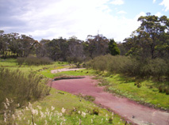
Figure 5.20 Creek 3 showing covering of Azolla.
Three samples were available from this location, two taken approximately 12 hrs apart in mid Summer 2004 and another taken in late afternoon in Autumn 2006. Data for these samples is summarised in Table 5.41.

Investigation 1
Two samples were taken on one day in Summer 2004. At this time the creek was not flowing and was a series of large disconnected pools. The water had conductivity of 1020 μS/cm and was slightly discoloured with turbidity 69 FTU. The floating algae / fern combination Azolla was abundant and qualitative microscopic examination revealed an abundance of single celled algae and protozoa. Data collected probably did not reflect the maximum daily CO₂ swing because samples were taken more towards the middle of the cycle. Sample 219 is assumed to capture conditions at the end of the night period. Sample 220 represents conditions approximating those after daylight hours. Data for the pH buffer system for the two samples taken approximately 12 hr apart are presented in Table 5.41.

Table 5.41 pH buffer data from Creek 3.
 | Sample 219 Summer 2004 Sampled at 11:00 hrs | Sample 220  Summer 2004 Sampled at 22:45 hrs | Sample 291  Autumn 2006  Sampled late afternoon
pH measured | 6.67 | 6.84 | 6.7
pH calculated | 6.84 | 6.98
Bicarbonate | 0.00189 mol/l | 0.00193 mol/l | 0.0036
CO₂ (aq) | 0.00074 mol/l  32.6 ppm CO₂ | 0.00056 mol/l  24.5 ppm CO₂ | 0.00276 mol/l  121.5 ppm CO₂

ACIDEX can be used to look for changes which have occurred during the day by setting the Focus sample to Sample 220. During daylight hours the carbon dioxide level and the H⁺ ion level fall. The greatest mol/l change is in carbon dioxide level. For comparison, change in bicarbonate is approximately half as much, with H⁺ about 1/1000th lower. Primary and compensating changes are summarised in Table 5.42.

Two primary changes occur during daylight hours in this creek. These are a rise in bicarbonate and a fall in CO₂. Both are partly compensated by a fall in H⁺.
Table 5.42 Primary and compensatory pH buffer system changes noted for Creek 3 over daylight hours.
Primary change | Present | Compensating change | Present | Compensating change | Present
H⁺  |  | Bicarbonate  |  | CO₂ 
Bicarbonate  |  | H⁺  |  | CO₂ 
CO₂  |  | Bicarbonate  |  | H⁺  | 

Primary hypothesis: CO₂ alkalosis probably uncompensated by change in bicarbonate. The rise in pH during the day is probably caused by algal photosynthesis. The rise in bicarbonate is unexplained by data.

Investigation 2
About 16 months after the first samples were taken, a sample, Sample 291 was taken from Creek 3 in the late afternoon during a time when the creek had stopped flowing and was just isolated pools. The pool where the sample was taken was covered with Duckweed (Lemna spp.) and this was excluding light from the water. The water itself was observed to be distinctly yellow in colour and had a strong earthy smell. Later a microscopic examination revealed very few algae and protozoans. Buffer system data for this sample are summarised in Table 5.41. An important feature of this water was that it contained a large amount of semi suspended detritus.

Changes from Sample 220 and Sample 291 can be analysed using a RHS model in ACIDEX. The primary change was a rise in CO₂ from 24.5 ppm in sample 220 to 121.5 ppm in sample 291. There was a relatively large compensatory increases in bicarbonate and a smaller compensatory rise in H⁺ which made the water slightly more acidic. Because the rise in bicarbonate was large with only a relatively small rise in acidity this buffer system change could be considered mostly compensated.

The main hypothesis to explain these changes is that increased CO₂ has caused an acidosis which has been largely compensated. The main conditions that changed between the two samples was drying out of the pools, growth of a surface cover of Duckweed and decrease in the amount of microscopic algae. Conductivity roughly doubled between samples however the ORP value was much higher in sample 291. This means that at least, conditions in the water were oxidising and that increase in CO₂ was probably mainly due to aerobic decomposition of detritus.

Creek 3 summary
Based on the small number of samples taken at this site it is possible to partly and tentatively explain how environmental conditions affect pH. Although no direct measurements of nutrients were made at this site it is likely that nutrients are either accumulating or being released as the creek dries up. Duckweed takes over from Azolla under these conditions. Azolla is a nitrogen fixer and is often harvested in different parts of the world as a soil amendment and fertilizer. Duckweed is known to thrive under nutrient rich conditions and because of this it is often grown in ponds as a way to remove nutrients, again the plant is later harvested. Under ‘Azolla’ conditions pH fluctuated slightly during each 24 hour period due to algal photosynthesis. However under ‘Duckweed’ conditions photosynthesis was suppressed leading to large production of CO₂ and to a mostly compensated CO₂ acidosis.

Summary of results from applications
This section has described some extended analyses of a problem involving iron in water and in another two cases involving broader aspects of water quality. In the first case where the problem goals and focus were more constrained, analysis extended through all stages of the problem solving schema previously outlined in Chapter 3 Research Design / Methodology, but in the other cases which involved more complicated situations that had developed over a period of time, analysis focused on using buffer system analysis to help build up an understanding of how the quality of the water was being changed by individual observable events.
The case studies have provided an opportunity to investigate the design and applicability of the problem solving schema, architecture and diagnostic strategy outlined previously. The problem solving model outlined has some advantages and some limitations when applied to investigating problems in water involving pH disturbances. These examples support the development of new educational theory by using a diagnostic methodology to show the reasoning and knowledge requirements for understanding aspects of system function in water.
One of the key advantages of the methodology is that it forces or at least encourages construction of coherent models, thus requiring the developer to identify additional sources, concepts, logical gaps in the chain of reasoning and limitations of the knowledge base components. Because any explanations that are developed are self checking, that is the models have to have internal coherence, the model itself provides evidence of the suitability of the method. In addition the model has to be validated against its ability to account for additional external conditions or findings.

Outcomes
The examples illustrate an important aspect of causal modeling. An explanation can be built from fragments each describing how a process causes a state. An example of such a fragment from the case studies (see Figure 5.16) is that ‘Impaired gas exchange’ is causing ‘High CO₂ levels’. Another, tentatively defined is that ‘an undefined process’ is causing a low ORP value which results in ‘reducing conditions’. Each of these fragments establishes a state or condition. A coherent model links these states in a sequence to establish a scenario. Where a concept map or explanation links nodes through causal links it is implied that there is an implicated process that is actually affecting the change. In some respects an explanation is built by first identifying the states of a system then establishing how that state developed or how it was caused.
The open problem solving architecture that underpins these examples recognizes the importance of the user in making ongoing assessments of the progress of a diagnosis. It also establishes the independence of domain theory whilst recognizing that this may be incomplete or not structured properly to support a given task. For example in the case study involving iron, there were some limitations in defining ‘High CO₂’ as a cause of an acidosis. In this example the developer was also required to tentatively construct a causal link between acidosis and ‘abnormal high iron’. The latter condition is a new concept constructed to account for conditions that are later observed as findings.
In particular, the case studies for Dam 1 and Creek 3 have illustrated the applicability of a causal or diagnostic approach. The data for conductivity and turbidity for Dam 1 shown in Figure 5.19 show the high variability of that situation from year to year. To complicate matters, turbidity can be caused by different factors. For example unexpected high turbidity in summer can be caused by an algal bloom. Implicit in the findings is that it is almost impossible to predict beforehand what information is going to be most useful trying to understand what is causing quality problems in the water. There is a balance between data collection and diagnosis. Essentially an early diagnosis acts as a focus for subsequent data collection. In addition the role of a diagnosis is to superimpose a causal understanding over existing facts or measurements. The examples have shown similarities with problems in medical diagnosis. For example human physiology is relatively well defined and understood but the health status of an individual is defined by conditions that include age, lifestyle, pre or co-existing health issues and diet. Similarly existing conditions in a waterway such a dam are the result of a large number of usually unknown factors which have acted to create those conditions. Like the medical practitioner, the water quality practitioner has the goal of understanding not the principles or generalities of a problem but of understanding each individual situation.

Through working with the case studies, this methodology has encouraged and supported the goal of building incremental models each one supporting a stage in the diagnosis. For example in the initial diagnosis phase in the Bore 3 case study there is an assumption that at least one process is causing a rise in CO₂ that ultimately is causing an acidosis and this relationship is tentatively established. Similarly having established a ‘clinical’ condition of abnormally high iron in bore water the goal of diagnosis then focused on finding likely causes.
A low level causal analysis using buffer system calculations has been shown to be a useful mechanism for linking the initial hypothesis formation stage with an explanation stage.
The methodology has other advantages in that it allows other information to be integrated as the need arises. An example is the use of ORP data to help confirm the presence of reducing conditions in bore water.

Chapter 6. How ACIDEX Works
This section describes the inner workings of ACIDEX and shows how the program allows the user to diagnose water quality problems. It will describe the interface through which the user interacts with the program and explain how this interface can help the user search for possible causes, build a diagnosis or just explore some water quality issues. This section will also explain the knowledge base structure, how ACIDEX is programmed and accessed, the functions that ACIDEX performs and points at which the user is expected to play a role in decision making.

ACIDEX is based on the problem solving architecture shown in Figure 3.5 p112. The user interacts with ACIDEX in a flexible way through a series of tabs in the interface to the program that represent modules for carrying out particular problem solving tasks. The user can access case study data, ask the program to carry out calculations and request information from an accompanying knowledge base.

Deployment
ACIDEX is deployed as an internet application. This way the application is widely available, can be kept current and can integrate with information resources on the internet. Importantly, the application is a small example which supports emerging strategies for providing a fully integrated ‘semantic’ internet or Web.

ACIDEX is written in the Java programming language to take advantage of the internet ready features of Java and to allow the application to be accessible through the internet. One of the main advantages of Java is that any application like ACIDEX can be run on a number of different platforms without modification. ACIDEX is launched from a nominated server via Java Web Start (Sun Microsystems). Java Web Start is an Java application launcher which must first be installed on the user's computer. It is available free for download at //java.sun.com/products/javawebstart/download.jsp. The user must have a version of the Java Runtime Environment JRE installed. For convenience Java Web Start can be downloaded as part of the JRE.

The developer places the application and a file which describes the application and provides all necessary initialisation parameters on the server. This is in XML format and is called a .jnlp file. To run the application the user requests the nominated .jnlp file through an internet browser. Because Java Web Start and the runtime environment are already installed, the application described in the .jnlp file is downloaded and installed. The great advantage of this method is that after the second use the application can be run from the ‘desktop’ of the user’s computer using an Application Manager. That is, it just looks like it is an application installed on the user's computer. Each time it is run, Java Web Start looks on the web for any updated versions of the application.

In the case of ACIDEX the accompanying knowledge base (ontology plus knowledge base) is placed on the same server as the application, as a Protégé source file. ACIDEX automatically downloads the Protégé knowledge base as required. Any updated knowledge base source files can be easily and immediately made available to users because the knowledge base is independent and any new version is simply uploaded and replaces the old version. The original knowledge base cannot be modified by the user although it would be possible for a user to download a copy and modify it for their own use.

With this distribution method the entire application is readily available to anyone with access to the internet and does not need to be distributed via other means such as on a compact disc. Instructions for accessing ACIDEX are found at www.appslabs.com.au/acidex.htm.

User interface
ACIDEX is an application which integrates pH buffer system analysis with access to a knowledge base to facilitate situation descriptions. Each component of the architecture previously described is completely independent. The advantage of this flexible approach is that the user may use ACIDEX in completely different ways. For example, the user may choose to start with a buffer system analysis and proceed to a low level diagnosis. Alternatively, the user may choose a type of ‘what if’ analysis. Here certain states or ‘clinical’ conditions may be assumed (invoked from the knowledge base using ACIDEX) and the user can let ACIDEX try to find some consequences of those states or conditions. Another way is to use ACIDEX as a tool to investigate general aspects of a problem by directly accessing the knowledge base starting with some concept of interest and then looking for linked concepts.

The user interface for ACIDEX is shown in Figure 6.21, p 200. Each of the six main components opens from a separate tab. These are:

Knowledge base. This tab allows the user to open the linked knowledge base then explore some of the concepts in the knowledge base.

Case studies. This tab allows the user to access the data from a number of case studies. The user can use these case studies to experiment with the program and practice diagnosing real problems. From this tab the user can perform buffer system calculations for any Focus sample chosen.

Findings. This tab allows the user to access the knowledge base and invoke findings that are present.

Diagnose. This tab performs two functions. It will carry out calculations for any pair of samples chosen from the case studies and it will access the knowledge base to start making connections to findings and conditions.

Explain. This tab provides routines that allow the user to look for causal links to previously invoked conditions or to look more flexibly for causal links to any selected condition in the knowledge base.

Table 6.43 summarises the links between diagnostic functions and interface components in ACIDEX.

Table 6.43 Summary of interface functions in ACIDEX.
Function | Component (Tab) | Actions
Orientation | Knowledgebase | • Open the knowledge base.  • List and give details for Findings and Conditions in the knowledge base.
Orientation | Findings | • List and invoke Findings and Conditions in the knowledge base.
Diagnosis | Case studies | • Choose samples for comparison from the built in case studies.  • Show all other collected data and descriptions for samples and cases.  • Apply a buffer equilibrium analysis to a single sample.
Diagnosis | New case | • Enter data for a new case study.  • Apply a buffer equilibrium analysis to a single sample.
Diagnosis | Diagnose | • Apply a buffer equilibrium analysis for a pair of samples from the case studies.  • Look in the knowledge base for any links to previously invoked Findings or Conditions.  • Select any Condition in the knowledge base then list any Findings linked to that Condition.
Explanation | Explain | • Look for causal links between selected conditions and processes in the knowledge base.

Knowledge base
ACIDEX is able to access an independent knowledge base through a Java language based interface. To access the knowledge base the user first has to go to the Knowledgebase tab and click the Open knowledge base button. Figure 6.21 shows the interface for the knowledge base used by ACIDEX.

In use, a copy of the knowledge base is downloaded to the user’s computer. Nodes are used to represent concepts and are called ‘instances’. Each instance has ‘slots’ which contain parameter values. For example the concept of ‘Elevated iron’ contains a slot which holds the value defining ‘high’. In this way ‘Elevated iron’ can be defined (in simple terms) as iron in excess of 5 mg/l. For each instance, there is a slot called ‘Invoked’. ACIDEX has a routine for placing a code in the ‘Invoked’ slot for any chosen instance. In this way ACIDEX can invoke or initialise various instances as the main application runs. These entries are temporary and only persist while the user has the knowledge base open. The user can then list instances which have been invoked. This is a simple way to produce a situation specific model (from all the generalised concepts and relationships in the knowledge base) to show all the present concepts (and links) for a particular problem.

The knowledge base technically uses a ‘frame’ based representation. This allows full implementation of object models along with inheritance in object hierarchies. One of the well known drawbacks of frame based methods is that they emphasise the structure of the data rather than the dynamic aspects useful for simulation. Specifically there is no direct facility for building methods or procedures into the definitions of knowledge base components.

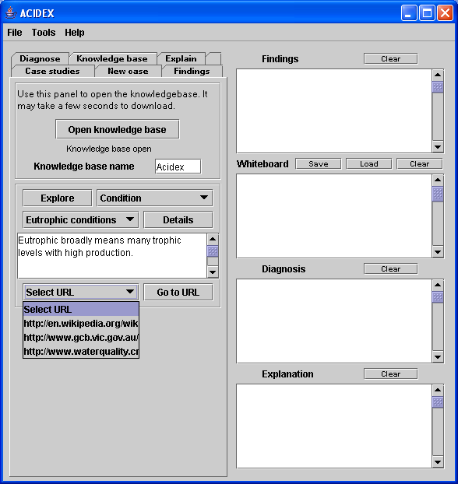
Figure 6.21 The knowledge base module in ACIDEX allows flexible searching.
Protégé has another important feature, links between objects or concepts. These can be expressed as simple links or reified links. In a simple link is a slot value is filled with the name of another object. A reified link is a link between concepts which is an object in itself. This way the link can be given properties such as a weighting or importance. A reified link is more flexible and intuitive but requires more programming overheads.

Reified links are used in ACIDEX by preference, mainly because they are suited to situations where there are multiple links and there is a need to modify a link by assigning a condition or modifier. The ACIDEX knowledge base contains less than 50 reified links.

In ACIDEX there are two types of reified links. Associational links connect Findings to a state or process or condition. A typical modifier is “Indicator of”. Causal links link processes to states with the modifier “Causes”. For reasoning it is possible to distinguish between the two types of links.

By using reified links more than one cause for ‘Elevated CO₂’ (the concept) can be defined. These could include ‘High decomposition’ or ‘Restricted diffusion’. The modifier ‘usually’ might be used in both cases. For example, ‘High decomposition’ usually causes ‘Elevated CO₂’.

The knowledge base contains approximately 100 nodes or concepts. ACIDEX provides some tools so the user can explore the knowledge base. The user can click the Explore button for a list of sub concepts. At the present stages ACIDEX mainly shows all sub groups of Findings, including Conditions. If the user chooses ‘Smell’ then all instances in the knowledge base will be listed such as ‘Musty’, ‘Chemical’, ‘Rotten egg’ etc. If there are any supporting notes available to describe the concept these are shown. In this way the knowledge base is mostly accessible by query only, meaning that the user takes an active role in requesting information.

A useful capability is that the ACIDEX knowledge base holds a list of URLs for many concepts. These are selected by the knowledge base developer and are meant to provide links to key or significant internet resources. As such they act as a link to external information on the internet. Note: as of the last implementation of ACIDEX, to simplify security requirements for deploying internet applications, this ability to access internet resources is not enabled. This feature is scheduled to become part of the next implementation of ACIDEX. When enabled, this feature will allow the user to select a URL from the drop down menu. ACIDEX will then open that web page in the user’s default browser. If the browser is not open, ACIDEX will open it first.

Knowledge base interface
Concepts in the knowledge base are not invoked automatically by ACIDEX during a diagnosis. In addition there is no built-in mapping between ACIDEX concepts and concepts in the knowledge base. The advantage of this arrangement is the added flexibility that allows the user to qualitatively assess the value of each new piece of information. Some of the important mappings that are left to the user include:

- Mapping diagnoses which ACIDEX makes based on the Henderson-Hasselbalch equation and concepts of clinical states such as ‘acidosis’ in the knowledge base.
- Mapping to a ’clinical’ position on the generalised pH – REDOX stability diagram(s). This is on the one hand because it is partly a qualitative assessment about whether criteria like boundaries represented on a stability diagram adequately represent observations and data and also because there may be a certain amount of inbuilt error, both in some measurements like REDOX and the interpretation of such measurements.
- Mapping of field measurements like soluble iron to ‘Findings’ in the knowledge base which establish parameter states like ‘High iron’. This is necessary because there may be no agreed criteria for establishing high, low or any other parameter state. Also because field methods themselves have limitations and are sometimes difficult to interpret given all the existing conditions, some flexibility should be allowed.

Knowledge base structure
The knowledge base is built using a frame based representation methodology. Frames are a practical way to implement an object oriented representation. Figure 6.22 shows the class structure (hierarchy) in the ACIDEX knowledge base. Concepts in the knowledge base are organised under three main groups which reflect an ‘object’ view of the world. These are Objects, Processes and States. This arrangement was chosen for its ultimate flexibility. In the current version of the knowledge base ‘Findings’ and ‘Conditions’ are grouped under States. One of the challenges of object representations is representing parameter values for example high, low, medium or other levels of iron. One solution is to enter them as slot values but this creates extra programming overheads. The solution in ACIDEX, to enter parameter states in a separate class, is a compromise solution to the problem of representing parameter states in frames. Thus conditions like high and low iron are represented as separate states.

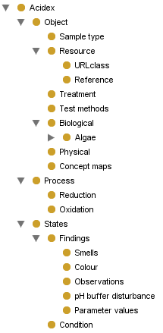
Figure 6.22 Class structure for the ACIDEX knowledge base.

A separate single class holds all the links between concept pairs which are accessed through ACIDEX. These are technically directed binary relationships. Each link holds a number of pieces of information (in slots) which help to describe that relationship. For example, each link has the following slots (the allowed values are in parentheses):

- Condition (sometimes, always, never, usually).
- Relation type (implicated in, needed for, a method for, related to, causes, a component of, a symptom of, a concept of).

These conditions / modifiers are qualitative and are designed to convey commonly anticipated relationships. More can be added as the need arises. They are there to help the user decide on the importance of particular relationships.

Other slots for relationships are available to hold information to help explain the relationship. These are: Assumptions, Reference (where the justification for that link came from) and Text (a slot for notes).

Case studies
Because ACIDEX is a learning tool, a number of case studies are included in the program. These are part of ACIDEX and not the knowledge base. Figure 6.23 shows the interface for the case studies module in ACIDEX.

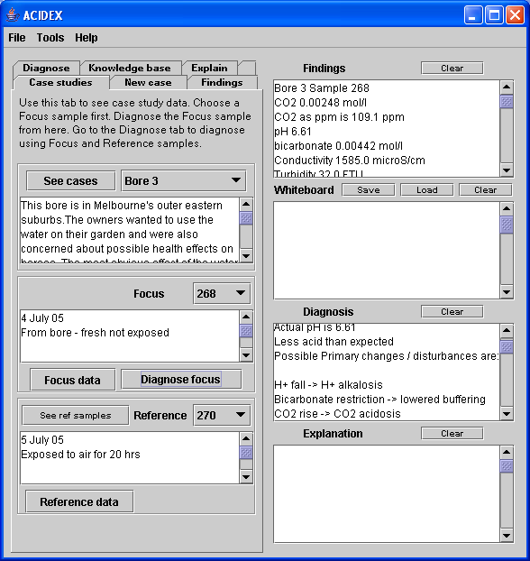
Figure 6.23 Case studies module in ACIDEX showing data and initial diagnosis for Bore 3.
Users start at the Case studies tab by choosing a case study using the See cases button. ACIDEX then automatically shows a description of that case and shows which samples are available. A sample has to be chosen as the Focus sample using the drop down menu. If the case study / samples database contains additional test results for that sample these can be displayed using the Focus data button. These are shown in the Findings window. ACIDEX can perform a buffer system analysis for the Focus sample alone by clicking the Diagnose focus button. The diagnosis is displayed in the Diagnosis window.

If the user wishes to refine the diagnosis by considering differences between two samples then a reference sample has to be chosen. Do this by clicking the See ref samples button. Again choose a reference sample from the drop down menu. Any additional data from test results for this sample may be seen in the Findings window by clicking the Reference data button.

Users must open the Diagnose tab to perform a diagnosis for two samples.

Orientation
The user is able to invoke or establish findings for a particular problem through ACIDEX. This is done via the Findings tab. Here the user is able to ask the knowledge base for a list of findings by category. These findings include a category for buffer system disturbances which is designed to match the buffer system diagnosis provided by ACIDEX. In this way the user is able to establish the buffer system disturbance as part of any subsequent situation specific model.

Findings
Findings include what can be measured or observed about a situation. Some findings may be specific measurements but others may be qualitative. ACIDEX provides guided data collection by accessing the knowledge base in response to user requests to show findings associated with any selected condition. This function is found under the diagnose Tab. The ACIDEX knowledge base also provides a list of Conditions that can be invoked through the Findings Tab. These may include ‘clinical’ conditions or a set of states

The ACIDEX knowledge base contains a list of Findings considered to be relevant to understanding acid-base disturbances in water. This is not exhaustive but includes commonly measured parameters and observations. The user can ask for these to be listed. The user can select and invoke (establish as part of a situation model) any of these. Figure 6.24 shows the interface to the Findings module in ACIDEX.

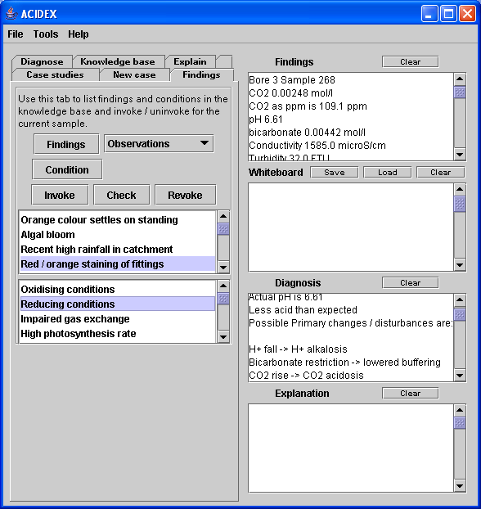
Figure 6.24 Findings module in ACIDEX with findings invoked for Bore 3.
The user has to explicitly invoke any findings or Conditions and therefore has to take into account all available information including that presented in any case studies or available from other tests or observations for the problem being studied.

Findings and Conditions underpin any initial diagnosis and are also available to the Explain module. To invoke a finding the user asks for a list of findings categories by clicking the Findings button. For example to invoke Red / orange staining, select the Observations category then select it in the list box. The user may have to search the Findings categories to get all relevant findings. The Invoke button puts a marker on that concept in the knowledge base assuring it is part of the situation model. The Revoke button is available to remove a finding from the model. The Check button allows the user to see what findings are currently part of the model. To invoke a Condition the user can click the Condition button then select from the list of Conditions presented.

Diagnosis
A diagnosis consists of two parts.

1. Analysis of pH buffer system equilibrium.

2. Finding associations between ‘clinical’ states and findings, for example ‘Red / orange staining’ usually indicates ‘Abnormally high iron’ (an iron problem).

Initial diagnosis
ACIDEX performs an initial diagnosis using values for CO₂, bicarbonate and pH. It does this by calculating if the pH buffer system is in or out of equilibrium then carries out a preliminary diagnosis based on its knowledge of types of buffer system disturbances. A diagnosis can be performed on a single sample. Diagnosis for a single sample is accessed via the Case studies tab. If data from two samples are available then the diagnosis will be clearer because it will reflect differences between the two samples. In this case the user nominates one sample to act as a ‘reference’ sample. The user will then be able to input any information available on other factors which have changed between the two samples to help build up a picture of why changes have occurred.

Figure 6.25 shows the interface for the Diagnose module in ACIDEX. The reasoning component provides some guidance in choice of LHS or RHS models (see p 137 for an explanation of the strategy that ACIDEX uses to choose a disturbance model on which to base a diagnosis). The user makes the final choice of which disturbance model to apply. This is important as it makes the process transparent to users so they can use it as a learning tool. It is important to maintain this flexibility and to recognise that the model is still in the process of evolving.

For any two samples ACIDEX calculates which change (in the three H-H variables) is greatest in absolute terms. It then finds if the greatest change is a decreasing or increasing change. For example, if the change in molar concentration of CO₂ is greater than for the other two factors and the CO₂ concentration increases between initial and final samples, ACIDEX suggests a RHS model. The user chooses to test a RHS or LHS model against the data by clicking the LHS or RHS button. ACIDEX then determines primary and compensating changes and reports these in the Diagnosis window. A summary of the main buffer system disturbances diagnosis is available through the Summary button.

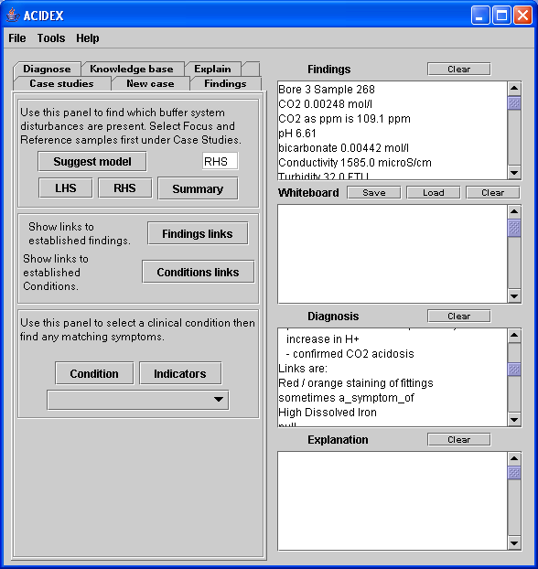
Figure 6.25 Diagnose module of ACIDEX shows expected findings for a condition.

Reasoning
ACIDEX implements a flexible method for obtaining an initial diagnosis. The Findings links button invokes a routine which looks in the knowledge base for any non causal links from any of the previously invoked findings. ACIDEX only reports links up to one level away from established findings. For example, in Figure 6.25 ‘Red – orange staining of fittings’ has been invoked as a finding. ACIDEX has found at least one link to this finding which is that ‘Red – orange staining of fittings’ is sometimes a symptom of ‘High Dissolve iron’. These links are associations only and are non-causal. Similarly the Conditions links button finds non causal links to any previously invoked condition. This feature can help with data collection because the user can assume a condition and then list any linked findings. For example the user could assume ‘Anaerobic’ conditions. The knowledge base will show a likely symptom of this condition is ‘Low ORP’. A check of the ORP value for the sample could at least partly support the existence of the condition.

However the design of ACIDEX supports the view of diagnosis as a form of deductive proof. The goal is to assume a condition, otherwise called an hypothesis, then find how well the findings support the hypothesis. In ACIDEX the user is free to select any condition including buffer system disturbances from the knowledge base, then ask to see any findings from the knowledge base which are an indicator or symptom of that condition. In the present implementation ACIDEX does not use any heuristics or methods to either display alternative hypotheses or to rank a diagnosis based on any measure of best fit.

Explanations

Situation Specific Models
A Situation Specific Model (SSM) can be viewed as a network of concepts and links. ACIDEX helps to build a SSM by tracing connections from invoked concepts and reporting these back to the user. This is initially done under the Diagnose tab.

ACIDEX reports a SSM as a list of established states, conditions, findings, processes or other concepts and the links between them. The user has to take a major role in developing a SSM because some links are implied (not held directly in the knowledge base but must be assumed by the user based on other evidence). An example might be a textual explanation of why REDOX potential has to be considered alongside factors changing pH to understand the impact on soluble iron levels. So it is expected that a SSM will be constructed in some way, perhaps graphically outside of ACIDEX.

Resolving a SSM, that is finding if there is a continuous path between, for example, a condition and any finding, may involve some type of tracing capability. In the original design of ACIDEX provision was initially made for a capability to trace a network path. The goal was to enable a trace from an ultimate cause to any finding to establish in simple terms that the cause was at least partly responsible for the finding. This is a way of testing an hypothesis by establishing to what extent the ultimate cause of a problem can account for all the findings. However at the final implementation the SSMs implemented by ACIDEX do not easily allow for causal path tracing.

The causal model that ACIDEX implements to arrive at SSMs and explanations is relatively formal and is based on object modelling and representation methods. In the ACIDEX model scenarios are made up of concepts divided into Findings (a type of state), Conditions (a composite state) and Processes. Therefore ACIDEX is less able to represent a commonsense view of causality which combines processes and states into composite concepts. Elsewhere (Senyk, Patil et al. 1990), scenarios have been developed from causal links that better capture the intuitive aspects of causality for example that a process causes a condition that then leads to or causes another condition and so on.

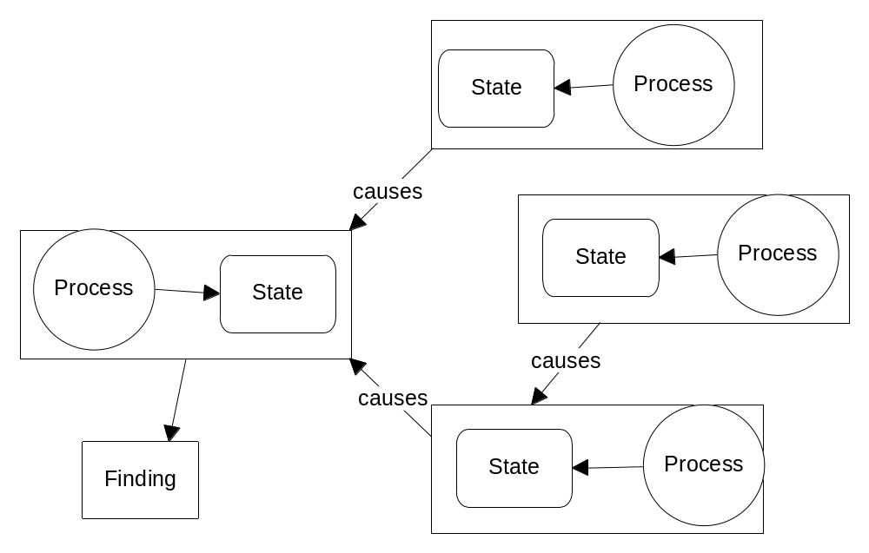
Figure 6.26 A simple explanation system using object representations.

The relationship between the causal model implemented in ACIDEX and the anticipated explanation or scenario constructed by the user is shown in Figure 6.26. ACIDEX provides a number of states that collectively establish a state model. If the user can verify that any two states represent the same quantity (parameter) or information and that their respective processes are linked by a sequence of events then a simple explanation can be constructed. For example a sample may have high carbon dioxide from being underground. If the sample is aerated and carbon dioxide drops then a simple scenario has been created. However for any given problem such a scenario may not provide a complete explanation. For example, some states may have no identifiable cause and others may be isolated because there has been no recognizable linking event.

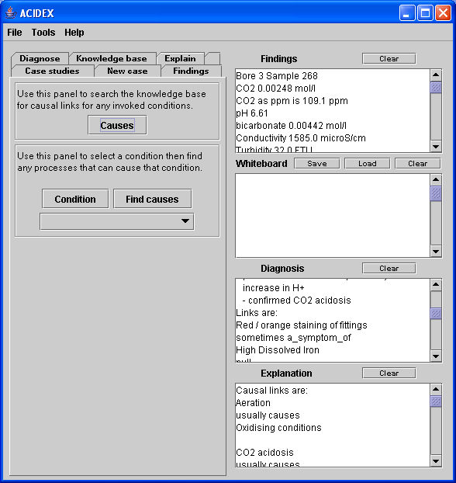
Figure 6.27 Explain module in ACIDEX showing causal links to established conditions.

Figure 6.27 Shows the Explain module in ACIDEX. The module helps the user create a scenario by providing the causal building blocks. The Explain module retrieves causal links to conditions that have been previously established. These causal links are held in the knowledge base in the form, ‘a process’ causes (with assumptions) a ‘condition’. To do this the user clicks the Causes button. Alternatively the user can explore other possibilities by selecting any Condition from the knowledge base then asking ACIDEX to list all processes known to cause that condition.

Functional modeller
A functional modeller fills in gaps in the situation specific model by answering questions like, “assuming that something is true, what would be expected as a consequence”? One of the mechanisms for doing this is to assume a condition even when that condition is not necessarily indicated. Used in this way, the functional modeller invokes further findings or conditions that may then create a more plausible and coherent model. If this approach is successful in creating a more coherent model then the original condition may be tentatively incorporated in the SSM.

As yet a functional modeller component is not implemented formally in ACIDEX. The task lies with the user who has the option of assuming any given state then investigating any possible consequences.

A simple example might be where the user has to account for an increased pH. If the water had high turbidity this might suggest the presence of algae. So invoking algae as a significant factor could result in a coherent explanation. However, then the full consequences of presence of algae would have to be pursued and this would force further questions, perhaps like, what is the chlorophyll content of the water, what is the colour of the water, has a microscopic examination been completed and is there a rise in CO₂ during the night? ACIDEX, for example, could help investigate this problem by finding out what its knowledge base knows about the consequences of high algal populations.

Summary
ACIDEX implements an architecture that encourages interaction between user, program and knowledge base. ACIDEX does not prescribe a sequence of actions but rather allows the user to build a situation specific representation for a problem by accumulating and displaying evidence, results and findings.

The application is deployable over the internet along with its knowledge base. This feature is designed to support the principle that as a decision support tool the application should be easily available.

The knowledge base that accompanies ACIDEX is an independent resource which has the advantage that its information can be updated without changing ACIDEX. The knowledge base is developed using a capable open source ontology editor Protégé that provides a Java API so its contents can be accessed by an independent application. This technology means that in the future the knowledge base could be offered as a shared internet based resource for students and researchers. The knowledge base mainly contains structural concepts related to ‘clinical’ conditions, findings and processes. However some heuristic information is included that attempts to capture associations between observations and conditions and causal relationships linking causes to states. One important aspect of this arrangement is that most of the inferring necessary to create explanations rests with ACIDEX and the user.

ACIDEX provides a low level analysis of buffer system data from inbuilt case studies and from single sample data input by the user. However ACIDEX does not automatically invoke or establish findings or conclusions. This is left to the user who must weigh up the available evidence, for example, to conclude that a particular condition is, or can be assumed to be, present. ACIDEX provides some flexible tools to enable the user to explore some of the relationships held in the knowledge base. Through ACIDEX the user can construct a temporary situation specific model by invoking findings, conditions and causes from the knowledge base as required. This information can be saved to permanent storage for later retrieval and review.

In an application like ACIDEX there is a balance between the capabilities of the application and the completeness and adequacy of the knowledge base. The main outcomes and lessons of this development process mainly concern the way knowledge is represented in the knowledge base and the adequacy and requirements of functions that map user held concepts to knowledge base concepts.

Chapter 7. Conclusions
This section summarises and critiques the supporting evidence, methodologies, advances and limitations in using a model based approach to problem solving in natural waters. There are some clear lessons to be learnt about further directions and implications of these results. The chapter includes a review of the design and capabilities of ACIDEX and educational implications.

Findings
This research project has established a prima facie case for including pH buffer system analysis in any investigative framework such as water quality studies. In addition, a description of buffer system disturbances and a methodology for dealing with computations has been presented. A diagnostic strategy based on an interpretation of buffer system abnormalities has been proposed.

The research project has also explored the feasibility and practicalities of implementing these findings in a tool suitable for management and learning. This includes the steps in adapting available appropriate technologies to make the program available very widely to practitioners, researchers and students via the internet.

The process of developing a prototype application and a supporting knowledge base has acted as a case study for implementing a diagnostic method. As a research tool it has been useful because as a competence model it can be validated against a theory of competency. By its very limitations it has focused attention on those issues in learning systems which are more critical or difficult.

A preliminary knowledge base encompassing an introductory ontology in the field of diagnosing acid-base disturbances has been advanced.

A framework for diagnosing buffer system disturbances
One of the goals of this research project was to establish the principle of using a buffer system analysis to act as the basis for a diagnostic method. There was an established tradition in medicine for using the Henderson-Hasselbalch equation to detect abnormalities in the pH buffer system components of blood. However in natural waters there was no direct evidence that analysis of the CO₂ - bicarbonate system would either be possible or provide useful results. There was however a tradition of using the same buffer system chemistry to perform calculations by assuming that the buffer system chemistry could be applied literally and by assuming static states, to semi-natural systems like swimming pools and aquaria.

However, there was no evidence that any disequilibria could be detected if they existed in any natural waters. In addition the buffering in natural systems was assumed to be more passive and subject to greater variability than for body systems.

The approach used in this research project was to establish a prima facie case built on accumulating a weight of evidence from available samples. Before the application ACIDEX could be developed or any knowledge base development could take place these principles had to be established. Evidence was accumulated from a number of samples. These were chosen to enable progressive exploration of concepts as they emerged. Sampling bias was contained because most of the analysis was focussed on identifying differences between samples and most of the interpretation of cases was based on studying the internal processes and factors which alter water parameters and on constructing consistent models. However the samples and cases did ultimately represent a wide variety of water types.

Preliminary analysis of the buffer system for a number of samples showed that some were more acidic than expected and some less acidic than expected, indicating buffer system disturbances. In addition it appeared that similar disturbance factors may be operating in different environments (raised CO₂ in bores and dams) but also that different factors could be causing the same type of disturbance . This was evidence enough to justify proceeding to the next step – developing a disturbance model to investigate real situations.

Initially, useful confirmation of the model was obtained by simple laboratory tests. In these examples a duplicate sample was left to equilibrate with the atmosphere overnight or for a short period (see for example Bore 2 case study). In this case the model was able to account for and explain the primary, change which was a lowering of CO₂ levels.

The disturbance model was tested on further case study samples through the application ACIDEX which implemented the model. In these studies two samples were compared. These were samples where the primary cause and effects were already well documented. For example, CO₂ is known to build up in bores, is implicated in dams with high organic loadings and is known to occur during dark periods where respiration dominates. The disturbance model was able to attribute pH changes in some samples to changes in CO₂ concentration. Specifically, these samples were bore water from Bore 2, Bore 1 and Bore 3 and water from Dam 1, Dam 2 and Dam 3.

These findings further supported the disturbance model advanced theory. Importantly, they also establish the methodology for taking sample data and performing the buffer system calculations.

In further samples the model was able to distinguish other factors, like input of acidity (Dam 1). Importantly the model was able to distinguish multiple primary causes in some samples. This happened in samples from Dam 1 and Bore 1. This is a major finding because these different factors may not otherwise be obvious.

When these initial findings were instantiated in a simple knowledge base of familiar limnological and chemical concepts some simple diagnoses were possible and even some simple situation specific models were possible.

One of the interesting outcomes of this research is that it has demonstrated how even solving relatively simple problems is a more complicated process than might be originally anticipated. For example, the Bore 3 water case study showed that whilst it was not too difficult to generate a plausible explanation for why iron levels were high in the water, it was difficult to generate a watertight case for iron as the problem and this was only a very simple example. In simple terms this example showed the limitations to the assumptions that are usually accepted when dealing with associations and causes.

ACIDEX as a learning and management tool
The key practical stages of a suitable problem solving methodology have been set out (see page 97). In conclusion, ACIDEX has been able to implement or exemplify these in the following ways:

ACIDEX focuses the user on the analysis of pH buffer system data as an initial step in developing a causal model. ACIDEX makes accessible an ontology / knowledge base
in the domain of acidity in water. The knowledge base can simply be used as a tool to orient the user to relevant issues for a particular problem. For example, if the requirement is disinfection by chlorine then management needs to take into account factors which are determining pH.

ACIDEX flexibly implements a network model which is built on a separate domain ontology / knowledge base. This means the user can not only query the knowledge base independently, for example, by asking ACIDEX to retrieve all links from a particular concept, but can temporarily hold (establish) any findings relevant to the current problem.

The knowledge base is flexible and extensible and is designed so that new concepts and links, and types of links can be added easily. It also provides access to external resources, for example, the eutrophication concept includes a link to an external web page so the user can bring other resources into the problem.

ACIDEX not only offers a direct list of findings held in the knowledge base but if the user wishes to select a concept like ‘High iron in water’, a list of possible indicators, including findings, can be provided. This can help with data collection or at least indicate data which is potentially useful but missing.

ACIDEX supports instantiation of findings as the user requires without proceeding to any diagnostic or explanation phase.

ACIDEX is able to suggest simple causal models to arrive at initial diagnoses based on either some observations, buffer system calculations or a combination of both.

ACIDEX is able to represent simple scenarios but there is still some requirement of the user to fill the gaps by either assuming some states or conditions to make a scenario coherent or by choosing a suitable mapping relation between an observation and a concept in the knowledge base. For example, although ACIDEX may suggest that high CO₂ will cause an acidosis, it is up to the user to invoke this as a cause given any particular conditions.

As yet ACIDEX can only construct simple situation specific models and these mostly consist of the individual components such as links. A functional modeller component has not yet been implemented. ACIDEX does not implement a system for constructing alternative diagnoses, or testing or ranking diagnoses. In the future the ability of programs like ACIDEX to represent causal networks could depend on adoption of more qualitative representations, perhaps including those that allow causal links at a more general level.

Findings in the knowledge base are expressed as relatively well defined concepts. This may narrow the choices too much for the user. It is quite possible that more work in this area to expand some findings into more general concepts may make it easier for a start to be made in any situation. For example, a finding “polluted’ may match more closely to a qualitative appreciation held by a user. Other researchers have addressed this problem by designing expandable nodes that is, concepts having many sub concepts.

At the final implementation ACIDEX provides limited help or support for collecting buffer system data. However there are concepts already in place in the knowledge base relating to measurements and data collection. For example carbon dioxide is a parameter for data collection. It is also a chemical compound with its own properties. Carbon dioxide has a measurement method and this has a procedure. It is quite feasible that this representation could be developed better in the knowledge base. Most published and commercial methods for carbon dioxide and bicarbonate measurements report results in mg/l or ppm. These are not suitable for input to the Henderson-Hasselbalch equation where molar quantities are required. So a useful addition to the knowledge base would be a methodology, including calculations for obtaining the correct data. It is worthwhile noting that the H-H equation is complex to use and calculations need to be automated because they are arduous. A suitable method would be to use a spreadsheet model. Again useful as a resource to be included in the knowledge base.

Perspectives

Reflections on the research strategy
Not many research paradigms exist where the development of a performance support program is both an outcome and a research tool. However in the computing field, prototyping is a software development methodology which acknowledges the need to produce a trial or test version or model. This does not mean that its acceptable to produce a partially correct version. Prototyping means building and testing a program before it is released for general use. It is more usually applied to relatively constrained problems where the testing is more about efficiency, useability, robustness and accuracy of algorithms.

However the current research focuses on types of problems where there may not be a complete understanding of the problem or of all knowledge requirements. The Design-Based Research paradigm supports research where the goal is to study a modelling process particularly where the context has yet to be created, so long as the outcomes of any interaction with the system can be adequately defined. This may not be so where the outcome is construction of a competence model as opposed to a performance model.

ACIDEX was developed so that the theoretical perspectives on problem solving by modelling could be tested in a practical way. The process of developing ACIDEX has revealed a lot about the nature of problem solving in the domain, the construction and the character of the knowledge base necessary to underpin any subsequent reasoning and ways of building an understanding about system behaviour.

Design-Based Research recognises the importance of not only achieving practical results by implementing theory in some form of learning tool, but recognises that any practical program is also a research tool. It requires developers to show all the assumptions on which programs are based.

There were some compelling reasons in this research project to concentrate on a computer based application.

These included:

- A goal that an outcome should be some type of practical performance support and learning tool.
- The perceived trend of students and practitioners towards using internet resources. initiatives in delivering knowledge resources via the internet in the medical field.
- The need for a computer program to perform the complicated calculations needed for buffer system analysis and then to provide initial buffer system diagnosis based on a theoretical framework. This fact alone was probably responsible for holding back advances in the use of this approach in practical and learning settings.
- The need to provide a relatively simple mechanism for students and practitioners to access further internet based and other resources relevant to questions and problems currently in focus. This has been partly achieved in ACIDEX through a simple system of links in the knowledge base which the user can access to open web based URLs.
- The view that some outcomes of the research project are an emergent property of the application and knowledge base. The prototype in this research project was designed to support a situation specific model. This model is not pre-defined and can really be thought of as a type of ‘competence model’ or user’s view of a problem. Therefore the prototype learning environment is a prerequisite for defining a competence model.

Factors which made this possible included:

- A considerable momentum in research and application in the medical field which offered some preliminary results in analysis and interpretation of pH buffer system data.
- The availability of data on relevant water parameters to serve as the basis for learning examples (case studies).

Design-Based Research asserts that results have to be defined for the context of the problem with validation more a question of self checking or looking for internal consistency or coherence. The design methodology in this research project supports the principles of Design-Based Research in this way because the problem solving methodology implemented in ACIDEX is more concerned with internal validity with its main aim to present testable scenarios.

Implementation of a learning support system
Part of a Design-Based Research methodology is to develop an end product. In this way the theory and practice feed back on each other. In addition because of the pressing nature of some environmental problems, including maintaining water supplies and healthy environments, there was no less than a requirement to produce a working learning and performance tool. There were many decisions to be made along the way and many problems to unravel including five particular issues:

1. How should the buffer system disturbances be categorised and reported?

The method had to provide clear results. The method adopted was to compare calculated and actual pH, although other variations were possible. This works well because most people can probably understand ‘more acidic’ or ‘less acidic’ then expected.

2. What terminology should be used to describe buffer system abnormalities?

None were available for natural waters so a scheme based on medical terminology was adopted.

3. How should an application like ACIDEX be linked to a supporting knowledge base?

This means how should concepts be mapped between applications. This was a difficult question to overcome. It would have been possible to simply have ACIDEX automatically invoke corresponding buffer disturbances in the knowledge base but this assumes that 1. the disturbance model is fully developed and 2. the user will want to make any diagnosed condition a part of any situation model without any interpretation. Consideration of this question raised a huge conceptual issue, that of concept ‘mappings’. It may well be that in future versions of ACIDEX and the knowledge base much more attention will be given to understanding how concepts can be mapped.

4. How should the application be deployed?

There were relatively few examples of cross platform internet ready applications. An early commitment was made to Java Web Start. JWS is a robust technology but not mainstream at least in education fields. To use JWS a server needs to recognise that application type and the launcher has to be configured properly. The requirements for this are not always obvious to an average programmer and can potentially delay an application.

A Protégé knowledge base can be accessed directly from a website but this is a compromise solution. A certain amount of experimentation had to be carried out in this research project before ACIDEX could successfully access a knowledge base. The solution essentially is to code the URL to the knowledge base in the application.

The alternative solution to these two problems is to use advanced server technology (which is available) but that then might be impractical for small scale applications.

5. What form should the knowledge base take?

There are many guidelines for developing frame based or object knowledge bases. However this is a complex undertaking not to be underestimated. Tools like Protégé make life much easier but the design for any given application still has to be worked out by the developer and this is a demanding task. One advantage of using a tool like Protégé is that the knowledge base can be reorganised as an application and tested with shortcomings and opportunities identified.

Limitations of the diagnostic method of ACIDEX

Buffer system model
The main limitation of the Henderson-Hasselbalch relationship is that it mostly describes the relationships between the ‘soft’ acid components of the bicarbonate buffer system, that is acidity derived from dissociation of CO₂. It may not be able to adequately account for the contribution of ‘hard’ acids, that is acidic inputs and outputs that do not originate from dissociation of CO₂. It also may not adequately account for carbonate dissolution reactions which serve to further buffer the pH system. The H-H equation has though, been usefully and widely applied to investigating blood disorders (see for example Patil 1981). More recent approaches have attempted to extend the H-H approach to include parameters other than carbon dioxide – particularly relative electrolyte concentration and total weak acid concentration Kellum (2000). However there has been at least prima facie evidence that some disturbances to the pH buffer system of natural waters can be described by the H-H relationship.

Mappings
One of the biggest single problems of using a knowledge base for problem solving is mapping between a knowledge base and the inferring methods of an application. For example, a knowledge base on acid-base disturbances in water may contain a concept called ‘acidosis’ which has a description, some associations and which may be constrained by rules governing how it can be applied. In a real situation a type of acidosis may be diagnosed for a water sample by a program which uses calculations and rules to identify major changes but the initial diagnosis may be based on a limited range of criteria or criteria which are yet to be fully tested. If the mapping was automatic there is a small chance that the knowledge base could start inferring from an invalid proposition.

There are two broad types of solutions.

1. Develop another knowledge base which just defines the mappings.

2. Allow the user to make the decision about how concepts should be mapped according to the situation. This extends the idea of mapping to mean establishing the correspondence between concepts in the formal knowledge base and those informally held by a person as a mental representation or held in another form, for example, textually.

Reasoning
Reasoning about pH disturbances based on the H-H model is made complicated because only net changes in CO₂ or H⁺ can be determined. So any subsequent analysis must consider other causal links when there may be opposing or contributing changes. For example CO₂ may be increasing because of one process but being used or removed at the same time by another process. Both processes are important when building a situation specific model. High CO₂ by itself does not necessarily cause an acidosis, so reasoning must proceed on the basis that it is a situation where CO₂ is rising that can cause an acidosis.

A large number of biochemical reactions are influenced by pH and REDOX potential (see p 141). Therefore reasoning about a clinical state means taking into account pH and REDOX values.

ACIDEX implements a simple, flexible but limited approach to diagnosis. This is a passive method which shows any links to invoked findings or alternatively shows all possible links (from those available in the knowledge base) from assumed conditions. In later iterations of ACIDEX it may be possible to implement a heuristic method which achieves some sort of ranking of hypotheses.

Probably the area where there is most scope for advancement is in the development of situation specific models. ACIDEX is limited currently by lack of a graphical interface to represent an SSM as a form of concept map. Also as yet, ACIDEX does not have the capability to establish and compare different SSMs to explain a situation. In its current form the ACIDEX knowledge base is not structured to support causal network search.

One way to implement an explanation system or, in other words, explain how something has happened, may be to find how well a given system ‘fits’ a generalised view or another specific example. For example, by building a concept map for ‘eutrophication’ using descriptive and causal elements, it may be possible to qualitatively match a new situation to that generalised situation. Alternatively, for a better studied example, a new situation could be matched to provide at least some understanding of processes. This latter view may be similar to what is called ‘case based reasoning’.

Other strategies exist for arriving at a useful hypothesis or explanation. For example Suter, Norton et al. (2005) have outlined a strategy (similar to those seen in the medical field) for determining if and how organisms have been affected by aquatic pollution by using a reasoning method which includes elimination of causes, diagnostic protocols, and analysis of the strength of evidence.

At its present implementation, ACIDEX is not able to directly provide descriptions or predictions of system level behaviour especially where multiple feedback loops and triggers are involved. An example of such a situation could theoretically occur where algal populations build due to phosphate input. If algae deplete CO₂ and pH subsequently rises, as in the Dam 1 example, then the oxidising capacity of the water increases and this may affect phosphorus transformations. In addition algal growth increases turbidity which may limit growth at some stage by reducing light penetration. A dramatic example of a similar effect was noted at Creek 3 where a covering of Duckweed apparently blocked most light at the surface.

Knowledge base
At its last implementation the ACIDEX knowledge base does not have an extensive knowledge of interventions or diagnostic goals. But these aspects are possible given the flexible arrangement of the knowledge base.

Currently no formal facility is available for users to modify the existing knowledge base used by ACIDEX, nor can ACIDEX access any other formal resources such as ontologies (if they existed). However Protégé is supported by a number of tools including specialised servers to allow more flexible knowledge base access via the internet. This is an advanced feature for the current application.

The full potential of object representation is yet to be fully exploited in this research project. For example, there is value in using inherited properties of objects such as treatments and water sources. Some previous studies in the medical field have used object hierarchies to represent anatomical structures, for example Senyk, Patil et al. (1990). As yet the knowledge base does not have much information on states or conditions for types of natural waters or situations. In time the object structure should allow a form of qualitative simulation by linking states in a time series.

The data for the case studies used in this project were coded directly into ACIDEX using an object hierarchy of cases, samples and parameters. This was an expedient solution designed to simplify programming overheads and to make calculations easier. It was also justified in terms of making the prototyping process simpler. The downside is that access to case study information is not so flexible, but significantly it also means that case studies can not easily be extended or new cases added.

In any future implementations of ACIDEX it may be possible to move the case study data into the knowledge base to allow greater flexibility.

Approaches to diagnosis in complex domains
There is a paradox that sometimes the simplest ideas, when well applied, can lead to a greater understanding of the inner workings of otherwise complex systems. This is possibly so for the methods used in this research project to better understand pH buffer system disturbances in water.

Limnology is a well developed field with an extensive literature. For example, the mechanisms of processes like nutrient transformations and solubility behaviour of metals are well known. Processes involving solubility behaviour of carbon dioxide and its effect on acidity are also known. Even recently an understanding of causal mechanisms has been applied to a nutrient problem involving interactions between phosphates, sulphates and iron in a wetland (Dodds 2001, p 262). However there have been few attempts at developing a ‘dysfunction’ model notably in the field of acid-base disturbances, even though the underlying mechanism is accessible through an interpretation of basic chemical equilibria theory. This research project has attempted to show how this can be done.

Environmental issues
The causal diagnostic approach outlined may have application in other areas. In a study related to the effects of increased carbon dioxide in the atmosphere Freeman, Fenner et al. (2004) have explored causal mechanisms to explain increased discharge of dissolved organic matter form peatlands. Experiments have suggested that it is increased primary production caused by increased carbon dioxide levels in the air that are causing the changes. These however have yet to fully explain the mechanism which brings this about.

Previously whilst carrying out a literature search, the researcher identified Miller, Miller et al. (1984) as a key study of system level soil processes. It outlined an extensive investigation into soil-plant process in the Arctic Tundra. This report was extremely useful as at the time there were few comprehensive attempts to model soil processes. The strategy was to model major processes like production, water use, and major nutrient cycling by adopting a number of key environmental variables and by adopting a number of assumptions about the relationships between them. Validation of the model was based on comparing actual to simulated values after defined periods. Although this research established some very sound models it did not focus on establishing causes or controlling factors. In the future it may be possible to take findings from studies of this type and integrate them with causal or system level models.

Further there has been increasing awareness of the sources and fate of carbon dioxide in the environment. Recent studies, for example Freeman, Fenner et al. (2004) have found that sub-Arctic peatlands and Tundra have the potential to release large amounts of carbon dioxide as the Earth warms. There has also been some discussion about the ability of the oceans to absorb this extra carbon dioxide. Causal modelling may be useful here.

Lessons and outcomes

Implications for carrying out and interpreting water tests
Currently the framework most often used to provide interpretation of water test results is the Australian Drinking Water Guidelines (National Health and Medical Research Council and Agriculture and Resource Management Council of Australia and New Zealand 1996). The guidelines mainly set acceptable levels for various contaminants. They are mostly based on criteria assessed for individual substances for example, from toxicology studies. They provide relatively little guidance for managing water supplies because they lack information about interactions between processes and factors causing particular water conditions.

For example, if a person is interested in the amount of iron in a water supply the real questions of interest are more likely to be : Where is the iron coming from, are there abnormal conditions maintaining measured levels, what levels are likely to cause problems, what are equilibrium or normal levels, what treatments are indicated and what is the potential for high levels to return? At the moment interpretations at this level are difficult. However a type of causal approach similar to that outlined in the current research project may help to answer some of these types of questions.

Contribution to educational practice
The mission for the current research project was to develop a type of ‘performance support’ system. As such it has provided an example of a program that can help a student or practitioner to orient to practical problems. For example, one feature the prototype has is the ability to retrieve related concepts and provide technical advice on aspects such as methodology. Where the original concept of performance support emphasised the learner model, the current prototype emphasises a knowledge model.

So by its very existence the prototype forces us to think about what performance support should be like or how it should be defined.

In a practical way this research project has provided an example and described the process of developing an internet based application, grounded in basic chemistry theory but integrated with wider resources. It has demonstrated one approach for accessing a knowledge base. It has also shown one simple example of a way to construct a knowledge base to help users work on particular types of problems. In doing so it has revealed some hurdles that have to be overcome like establishing appropriate mappings or protocols between users and the knowledge base.

The further development of this prototype or of a similar learning support system depends very much on exposure to new and varied problems so its role is very much as a learning tool and a research tool.

The prototype problem solving schema and application support some of the goals of professional education. These have been outlined for the medical field (McWhinney 1989) (see p 66 above). Importantly, the prototype demonstrates a method for accessing key resources in a web based knowledge base. It is also built on the assumption about professional education (of medical doctors) that competence arises through clinical practice supported by a suitable framework through which the (doctor) can assess his / her own learning and competence.

Contribution to domain theory
The modelling approach outlined in this research project provides a way to put commonly held concepts and ideas ‘to the test’. The researcher is of the view that a concept is only useful if it helps to understand a problem or its solution. Take the concept of eutrophication. This term has a meaning in limnology relating to trophic structure and complexity. In essence eutrophication is a process which leads to an maturation and possible extinction of a water body. As such it is a natural process.

The term eutrophication has been used in a more popular context to mean excessive pollution or enrichment. This is probably a misapplication of the concept. Does this matter? It does if a disturbance model is being used to help decide if a water body is undergoing normal or abnormal disturbances. In this research project a significant impediment to progress was a lack of coherent ‘clinical’ type concepts from which to build any type of behavioural model. A situation specific model helps to explicitly define ‘conditions’ of interest because these are models of prototypical concepts. In this research project there was a requirement to define a simple condition ‘Abnormally high iron’ because the situation specific model required it for completeness. So it is possible that some new concepts will emerge through further studies.

Postscript
Two days before finishing the final draft of this research project the researcher had to provide a water analysis for water from another bore in Melbourne’s outer eastern suburbs. Naturally measurements included bicarbonate and dissociated CO₂. By coincidence the prototype for ACIDEX was on the screen so it was just a matter of typing in the test data to obtain a diagnosis. In less than 30 seconds a simple diagnosis was pasted into the report which suggested that elevated carbon dioxide was causing an acidosis and that aeration of the water would probably result in a reduction in the primary problem metal, manganese. The diagnosis was partly confirmed when the carbon dioxide level in a sub sample that was left exposed overnight was measured. The carbon dioxide level did decrease due to equilibration with the atmosphere.

Glossary of key terms and acronyms
ACIDEX – ACIDity EXplainer. A computer application to assist in the analysis of pH buffer system data. Instructions for accessing ACIDEX are found at http://www.appslabs.com.au/acidex.htm.

AI - Artificial Intelligence. Discipline originating in the computing field aimed at understanding decision making and knowledge organisation. Often AI can be seen as representing a computational view rather than a cognitive view of problems.

Bicarbonate – HCO₃⁻ common anion found in natural waters. Bicarbonate builds up over time as more carbonates are dissolved by any acidity in water. If acidity changes then this process is undone as bicarbonate forms H⁺ ions and carbonate ions.

Causal probabilistic network – a cause and effect type network in which links are weighted using an estimate of the probability that the effect has been caused by the “cause’ or starting condition. Resolution is then carried out by an algorithm which tries to draw any conclusions about current conditions given the collection of starting points for example observations. These networks are effective for drawing conclusions for example forming an hypothesis about the cause of an illness in relatively simple problems where both probabilities and links are known. Larger networks suffer from being inflexible and computationally difficult.

CO₂ - carbon dioxide. Inert gas implicated in global warming. A product of respiration and hence decomposition and used by plants in photosynthesis. The reaction in which CO₂ dissolves in water to ultimately form H⁺ ion and bicarbonate ion is the key mechanism for regulating pH in water.

DBR – Design-Based Research. A research methodology that focuses on modelling a learning environment rather than observing it from a distance.

EP/LSS - Electronic Performance / Learning Support System. This definition extends the conventional view of performance support systems to include a capability that supports learning. Usually these systems are implemented using computers hence the qualifier electronic.

Eutrophication – used as a concept or classification of waters that indicates an enrichment or increase in productivity. Evidence implicates excessive nitrate and phosphate inputs as the main causes. The condition generally leads to impaired water quality.

H-H Henderson-Hasselbalch equation. A generalised equation derived for any conjugate acid – base pair. It is directly derived by rearranging the generalised equation for a reaction’s equilibrium constant. The end result is to express the pH in terms of the equilibrium constant and the concentrations of the acid and its conjugate base. In natural waters it can be used to calculate a theoretical pH using figures for bicarbonate (the base) and aqueous carbon dioxide (the acid, also referred to as carbonic acid).

Holarchic - a term derived from hierarchic that emphasises the holistic nature of especially natural systems where the overall behaviour emerges from the multitude of interactions between components.

pH - a measure of the ‘active’ acidity. pH is defined as the negative logarithm of the hydrogen ion concentration. For example, if the hydrogen ion concentration is
1 x 10⁻³ Molar then pH is 3.

ORP – Oxidation Reduction Potential. Measure of electrical potential, usually in mV. Sometimes called REDOX potential and sometimes shown as Eh on phase diagrams. For an explanation of significance see REDOX.

REDOX – REDuction / OXidation. A very large and significant group of chemical reactions are REDOX reactions. They often involve transfer of electrons between participating species (reactants). Many reactions also involve transfer of H⁺ ions therefore they have an impact on pH, meaning that they respond to and contribute to pH status. The tendency of a REDOX reaction to proceed and the direction of the reaction depends broadly on the electrical potential of the environment (often measured as millivolts). However REDOX reactions both change and are changed by the electrical potential. A high REDOX potential in water is usually determined by oxygen levels. However because of the number of reactions occurring and the microsites for each reaction, predicting the behaviour of specific reactions under particular REDOX conditions is difficult.

SSM(s) – Situation Specific Model(s). A localised explanation of how a situation has developed. Initially constructed as a snapshot of the current state which can then be extended by introducing knowledge about causes.

References and Bibliography.

Altieri, M. A. (1987). Agroecology: The Science of Sustainable Agriculture. Boulder, Colorado, Westview Press Inc.

Altman, R. B. (2001). “Challenges for Intelligent Systems in Biology.” IEEE Intelligent Systems Nov-Dec: 14-18.

American Public Health Association (1995). Standard Methods for the Examination of Water and Wastewater. Washington DC.

Australian Heritage Trust (2002). Australian agricultural assessment 2001. ACT, National Land and Water Resources Audit. 1.

Barab, S. and K. Squire (2004). “Design-based research: Putting a stake in the ground.” The Journal of the Learning Sciences 13(1): 1-14.

Bawden, R. and R. Macadam (1991). Action Researching Systems – Extension Reconstructed. Proceedings Agricultural Knowledge Systems and the Role of Extension Workshop, University of Honehein, Stuttgart, Germany.

Bayly, I. A. E. and W. D. Williams (1973). Inland Waters and their Ecology, Longman Australia Pty Ltd.

Beynon-Davies, P. (1993). Knowledge Engineering for Information Systems. London, McGraw-Hill Book Company.

Binkley, D. and D. Richter (1987). “Nutrient cycles and H⁺ budgets in forest ecosystems.” Advances in Ecological Research 16: 2-45.

Borsuk, M. E., C. A. Stow, et al. (2003). “A Bayesian network of eutrophication models for synthesis, prediction, and uncertainty analysis.” Ecological Modelling.

Boshuizen, H. P. A. and H. G. Schmidt (1992). “On the role of biomedical knowledge in clinical reasoning by experts, intermediates and novices.” Cognitive Science 16(2): 153-184.

Brady, N. C. and R. R. Weil (2002). The nature and properties of soils. New Jersey, Prentice-Hall.

Ceccaroni, L., U. Cortes, et al. (2004). “OntoWEDSS: Augmenting Environmental Decision-Support Systems with Ontologies.” Environmental Modelling & Software 19(9): 785-797.

Chang, R. (1981). Physical Chemistry with Applications to Biological Systems. New York, McMillan Publishing Co. Inc.

Clancey, W. J. (1988). Acquiring, representing, and evaluating a competence model of diagnostic strategy. The Nature of Expertise. M. T. H. Chi, R. Glaser and M. J. Farr. Hillsdale, New Jersey., Lawrence Erlbaum Associates.

Clancey, W. J. (1989). “Viewing knowledge bases as qualitative models.” Expert, IEEE 4(2): 9-23.

Clancey, W. J. (1997). The conceptual nature of knowledge, situations, and activity. Expertise in Context: Human and machine. P. J. Feltovich, K. M. Ford and R. R. Hoffman. Menlo Park, Calif., AAAI Press: xviii, 590 p.

Cook, N. J. (1992). Modelling human expertise in expert systems. The Psychology of Expertise: Cognitive Research and Empirical AI. R. R. Hoffman. New York, Springer-Verlag.

Cox, K. (1999). Doctor and patient: exploring clinical thinking. Sydney, UNSW Press.

Department of the Army Headquarters (1986). Swimming pool operation and maintenance. Washington, DC: 75. Retrieved July, 2004, from http://www.usace.army.mil/publications////////////////////armytm/tm5-662/.

Design-Based Research Collective (2003). “Design-based research: An emerging paradigm for educational enquiry.” Educational Researcher 32(1): 5-8.

Deutsch, T., E. Carson, et al. (1994). Dealing with Medical Knowledge: Computers in Clinical Decision Making. New York, Plenum Press.

Dodds, W. K. (2001). Freshwater ecology : concepts and environmental applications. San Diego, Calif. ; London, Academic.

Donahue, R. L., R. W. Miller, et al. (1983). Soils: an introduction to soils and plant growth. New Jersey, Prentice-Hall.

Doyle, R. J. (1987). Creating causal models. Workshop on Qualitative Physics, Massachusetts Institute of Technology.

Evangelou, V. P. (1998). Environmental Soil and Water Chemistry. New York, John Wiley & Sons, Inc.

Freeman, C., N. Fenner, et al. (2004). “Export of dissolved organic carbon from peatlands under elevated carbon dioxide levels.” Nature 430: 195-198.

Gallagher, R. and T. Appenzeller (1999). “Beyond Reductionism.” Science 284(5411): 79.

Gery, G. J. (1991). Electronic Performance Support Systems, Gery Performance Press.

Hochman, Z., S. Braithwaite, et al. (1998). SOILpH - a new APSIM module for management of soil acidification. Proceedings of the Australian Agronomy Conference, Australian Society of Agronomy.

Horn, W. (1989). MESICAR - A medical expert system integrating causal and associative reasoning. Causal AI Models. W. Horn. New York, Hemisphere Publishing Corporation.

Ingham, R. (2005). Aussies' gut feeling wins Nobel prize, Australian Broadcasting Corporation. 2005. Retrieved August, 2005, from http://www.abc.net.au/cgi-bin/common/printfriendly.pl?/science/news/stories/2005/1474064.htm.

Jackson, W. and J. Piper (1989). “The necessary marriage between ecology and agriculture.” Ecology 70(6): 1591-1593.

Jensen, J. N. (2003). A Problem Solving Approach to Aquatic Chemistry, John Wiley & Sons, Inc.

Jørgensen, S. E. and F. Müller (2000). Handbook of ecosystem theories and management. Boca Raton, Lewis Publishers.

Kay, J. J. (2000). Ecosystems as self organising holarchic open systems: Narratives and the second law of thermodynamics. Handbook of ecosystem theories and management. E. Jørgensen S and Müller F. Boca Raton, Lewis Publishers: 135-159.

Kellum, J. A. (2000). “Determinants of blood pH in health and disease.” Crit Care 4: 6-14.

Knublauch, H. (2003). An AI tool for the real world: Knowledge modelling with Protégé. http://www.javaworld.com/javaworld/jw-06-2003/jw-0620-protege.html. Retrieved December, 2003, from http://www.javaworld.com/javaworld/jw-06-2003/jw-0620-protege.html

Kohnke, J., F. Kelleher, et al. (1999). Feeding Horses In Australia, Rural Industries Research and Development Corporation.

Kuipers, B. (1989). Qualitative reasoning with causal models in diagnosis of complex systems. Artificial Intelligence: Simulation and Modelling. L. E. Widman, K. A. Loparo and N. R. Nielsen. New York, Wiley Interscience.

Langley, P. (2004). Computational Discovery of Explanatory Process Models. Colloquium, Computational Learning Laboratory Center for the Study of Language and Information, Stanford University. Retrieved July, 2005, from https://lists.cs.columbia.edu/pipermail/colloquium/2004q3/000326.html

Langmuir, D. (1997). Aqueous Environmental Chemistry. New Jersey, Prentice-Hall, Inc.

Leavesley, G. H. (1994). “Modeling the effects of climate change on water resources - a review.” Earth and Environmental Science 28(1-2): 159-177.

Likens, G. E. (1998). Limitations to Intellectual Progress in Ecosystem Science. Success, Limitations, and Frontiers in Ecosystem Science. M. L. Pace and P. M. Groffman. New York, Springer-Verlag: 247-271.

Long, W. (1989). “Medical Diagnosis Using a Probabilistic Causal Network.” Applied Artificial Intelligence 3: 367-383.

Long, W. J. (1992). “Development of a Knowledge Base for Diagnostic Reasoning in Cardiology.” Computers in Biomedical Research 25: 292-311.

Magdoff, F., L. Lanyon, et al. (1997). “Nutrient cycling, transformations, and flows: Implications for a more sustainable agriculture.” Advances in Agronomy 60: 1-73.

Mahler, S., R. Hoz, et al. (1991). “Didactic use of concept mapping in higher education: applications in medical education.” Instructional Science 20: 25-47.

Martin, L. (1999). All you really need to know to interpret arterial blood gases. Philadelphia, Lippincott, Williams & Wilkins.

McWhinney, I. R. (1989). A textbook of family medicine. New York, Oxford University Press.

Miller, P. C., P. M. Miller, et al. (1984). “Plant-Soil Processes in Eriophorum Vaginatum Tussock Tundra in Alaska: A Systems Modeling Approach.” Ecological Monographs 54(4): 361-405.

Mollison, B. (1988). Permaculture - A Designer's Manual, Tagari Publishers, Australia.

National Health and Medical Research Council and Agriculture and Resource Management Council of Australia and New Zealand (1996). Australian Drinking Water Guidelines.

Patel, V. L., J. F. Arocha, et al. (1999). Medical cognition. Handbook of Applied Cognition. F. T. Durso, R. S. Nickerson, R. W. Schvandeveldt et al. Chichester; New York, Wiley: 663-693.

Patel, V. L. and M. F. Ramoni (1997). Cognitive models of directional inference in expert medical reasoning. Expertise in context: Human and machine. P. J. Feltovich, K. M. Ford and R. R. Hoffman. Menlo Park, Calif., AAAI Press: xviii, 590 p.

Patil, R. S. (1981). Causal Representation of Patient Illness for Electrolyte and Acid-Base Diagnosis. Dept. of Electrical Engineering and Computer Science., MIT.

Patterson, D. W. (1990). Introduction to Artificial Intelligence and Expert Systems. Englewood Cliffs, New Jersey, Prentice-Hall Inc.

Pearson, C. J. and R. L. Ison (1987). Agronomy of Grassland Systems, Cambridge University Press.

Pitman, W. D. (1995). Ameliorating Effects of Alternative Agriculture. Soil Amendments: Impacts on Biotic Systems. J. E. Rechcigl. Boca Raton, Lewis Publishers: 215-249.

Plant, R. E. and N. D. Stone (1991). Knowledge Based Systems in Agriculture. New York., McGraw-Hill, Inc.

Prem, E. (1995). Understanding complex systems: What can the speaking lion tell us? The Biology and Technology of Autonomous Agents. L. Steels. Berlin, Springer-Verlag.

Prevost, G., P. Tranouez, et al. (2004). Methodology for Holarchic Ecosystem Model based on Ontological tool. Le Havre Cedex, France, Laboratoire d'Informatique du Havre. Retrieved April, 2006, from hhttp://www-lih.univ-lehavre.fr/~tranouez/publications/prevost_et_al_esmc2004_V2.pdf

Rakel, R. E. (1993). Essentials of family practice. Philadelphia, W.B. Saunders.

Rapp, M. (1983). Some problems of disturbance on the nutrient cycling in ecosystems. Disturbance and ecosystems - components of response. H. A. Mooney and M. Godron. Berlin, Springer-Verlag: 117-128.

Regier, H. A. and J. J. Kay (1995). “An Heuristic Model of Transformations of the Aquatic Ecosystems of the Great Lakes-St. Lawrence River Basin.” Journal of Aquatic Ecosystem Health 5: 3-21.

Reusser, K. (1993). Tutoring systems and pedagogical theory: Representational tools for understanding, planning, and reflection in problem solving. Computers as Cognitive Tools. S. Lajoie and S. Derry. Hillsdale, New Jersey, Lawrence Erlbaum Associates, Publishers.

Rogers, J. C. and W. S. Biggs (1993). Problem solving in family medicine. Essentials of Family Practice. R. E. Rakel. Philadelphia, W. B. Saunders Company.

Rothenberg, J. (1989). The nature of modelling. Artificial Intelligence: Simulation and Modelling. L. E. Widman, K. A. Loparo and N. R. Nielsen. New York, Wiley Interscience.

Rumbaugh, J., M. Blaha, et al. (1991). Object oriented modelling and design. Englewood Cliffs, New Jersey., Prentice-Hall International, Inc.

Russell, S. J. and P. Norvig (1995). Artificial Intelligence: A Modern Approach. Englewood Cliffs, New Jersey, Prentice-Hall, Inc.

Ruttner, F. (1963). Fundamentals of Limnology. Canada, University of Toronto Press.

Ryder, J. M. and R. E. Redding (1993). “Integrating cognitive task analysis into instructional design systems.” Educational Technology Research and Development 41(2): 75-96.

Seller, R. H. (1993). Differential Diagnosis of Common Complaints. Philadelphia, W. B. Saunders Company.

Senyk, O., R. S. Patil, et al. (1990). Systematic knowledge base design for medical diagnosis. Causal AI Models. W. Horn. New York, Hemisphere Publishing Corporation: 165-190.

Shortliffe, E. H. (1976). Computer-Based Medical Consultations: MYCIN. New York, Elsevier.

Smith, V. H., G. D. Tilman, et al. (1999). “Eutrophication: impacts of excess nutrient inputs on freshwater, marine and terrestrial ecosystems.” Environmental Pollution 100: 179 - 196.

Spector, J. M. and P. I. Davidsen (2000). Designing technology enhanced learning environments. Instructional and Cognitive Impacts of Web-Based Education. B. Abbey. Hershey, USA, Idea Group Publishing: 241.

Stewart, B. A. and C. A. Robinson (1997). “Are agroecosystems sustainable in semiarid regions?” Advances in Agronomy 60: 191-228.

Sticklen, J. and B. Chandrasekaran (1989). Integrating classification-based compiled level reasoning with function-based deep level reasoning. Causal AI Models. W. Horn. New York, Hemisphere Publishing Corporation: 191-220.

Stumm, W. and J. J. Morgan (1996). Aquatic Chemistry: Chemical Equilibria and rates in Natural Waters. New York, John Wiley & Sons, Inc.

Sumner, M. E. (1998). Acidification. Methods for Assessment of Soil Degradation. R. Lal, W. H. Blum, C. Valentine and B. A. Stewart. Boca Raton, CRC Press: 213-228.

Suter, G. W., S. B. Norton, et al. (2005). “A methodology for inferring the causes of observed impairments in aquatic ecosystems.” Environmental Toxicology and Chemistry 21(6): 1101-1111.

Torasso, P. and L. Console (1989). Diagnostic Problem Solving: Combining heuristic, approximate and causal reasoning. London, North Oxford Academic.

Ulanowicz, R. E. (1997). Ecology, the ascendent perspective, Columbia University Press.

Vitousek, P. (1983). Mechanisms of ion leaching in natural and managed ecosystems. Disturbance and ecosystems - components of response. H. A. Mooney and M. Godron. Berlin, Springer-Verlag: 129-144.

Whinney, I. R. (1989). A Textbook of Family Medicine. New York, Oxford University Press.

Whitby, C. (1981). Eco-gardening: The Six Priorities. Adelaide, Rigby Publishers Limited.

White, B. Y. and J. R. Frederiksen (1990). Causal models for intelligent learning environments for science and engineering education. Causal AI models. W. Horn. New York, Hemisphere Publishing Corporation.

Widman, L. E. and K. A. Loparo (1989). Artificial intelligence, simulation, and modelling: a critical survey. Artificial Intelligence: Simulation and Modelling. L. E. Widman, K. A. Loparo and N. R. Nielsen. New York, Wiley Interscience.

Appendix A

Background to chlorination
In broad terms, regardless of the type of chlorine initially used, it will end up as either hypochlorous acid or hypochlorite ions. The relative proportion is strongly pH dependent. At around pH 7.2, approximately half is hypochlorous acid. At higher pH that proportion drops off rapidly. But hypochlorous acid is by far a better disinfectant than hypochlorite ion so more effective disinfection takes place at around pH 7.2 or lower. In addition chlorination efficiency is reduced if the water contains organic or inorganic nitrogen compounds. For example, if inorganic nitrogen is present as ammonia then this will use up the chlorine by forming chloramines. In summary, if pH and organic matter is high the result is a higher need for chlorine, less disinfection efficiency and reduced predictability of disinfection.

ACIDEX is an application which implements the diagnostic methodology advanced in this research project. Instructions for downloading and running it are found at http://www.appslabs.com.au/acidex.htm.
This research project adopts the notation EP/LSS with some conditions to describe the computer based learning environment that is a product of this research. For a discussion of this issue see p 64.
REDuction-OXidation. For a discussion of the importance of REDOX potential and REDOX reactions see Glossary.
For a description of ACIDEX see Glossary or http://www.appslabs.com.au/acidex.htm.

